💧
EcoRain
Automated Rainwater Harvesting Management System
Technical Manuscript & System Documentation

Capstone Project Presentation
March 2026

Table of Contents

1. Executive Summary
EcoRain is a full-stack web application designed to automate the monitoring, management, and analytics of a rainwater harvesting system. Built using PHP (backend), MySQL (database), HTML/CSS/JavaScript (frontend), and packaged as a cross-platform desktop application using Electron.js, EcoRain provides real-time visibility into tank levels, water quality, sensor health, rainfall forecasts, and usage statistics.
The system serves two distinct user roles — Administrators and regular Users — each with a tailored interface and permission set. It is designed to promote water conservation by enabling data-driven decision-making, automating overflow prevention, and providing predictive rainfall collection estimates.

2. System Overview

2.1 Technology Stack
Layer | Technology | Purpose
Frontend | HTML5, CSS3, JavaScript | UI rendering and interactivity
Backend | PHP (Built-in Server) | Server-side processing, session management
Database | MySQL (via XAMPP) | Persistent data storage
Desktop Shell | Electron.js | Cross-platform desktop packaging
Charts | Chart.js | Data visualization
Weather API | OpenWeatherMap API | Live forecast and rainfall data

2.2 Role-Based Access
The system implements a strict two-tier role model:
- Administrator — Full access including Settings configuration, User Management, sensor oversight, and all dashboard features. Identified by the presence of the Settings navigation item.
- User — Access to Dashboard, Usage Statistics, Weather Monitor, and personal Profile management. No access to system configuration or user administration.

3. Functional Features

3.1 Dashboard
The Dashboard is the central hub of the EcoRain system, providing an at-a-glance overview of the entire rainwater harvesting setup. It is the first page users see upon login and auto-refreshes data every 60 seconds.
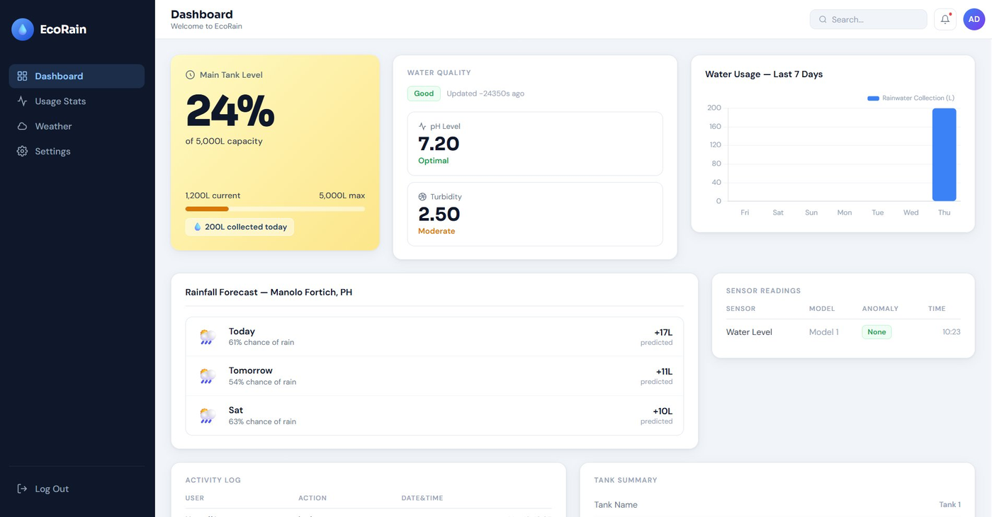
Figure 1: EcoRain Admin Dashboard — Top Section
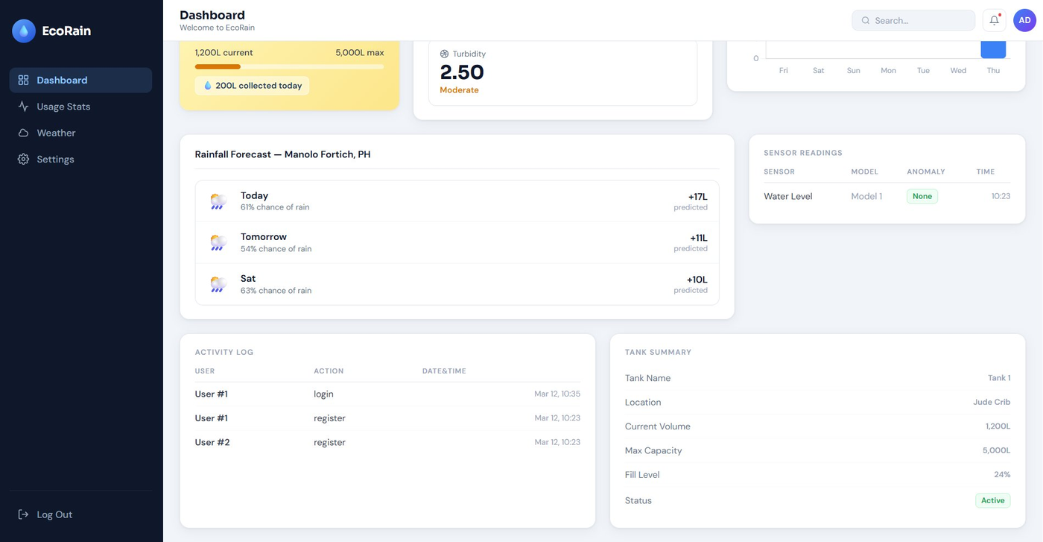
Figure 2: EcoRain Dashboard — Bottom Section (Activity Log & Tank Summary)
3.1.1 Main Tank Level Card
Displays the current fill percentage of the primary rainwater storage tank with dynamic color coding:
- Blue gradient — Tank level above 50% (healthy)
- Yellow/amber gradient — Tank level between 20%–50% (moderate)
- Red gradient — Tank level below 20% (critical/low)
The card also shows the absolute volume in liters (current and maximum), a proportional progress bar, and the total volume collected on the current day.
3.1.2 Water Quality Panel
Displays the most recent water quality reading pulled from connected sensors, including:
- pH Level — Classified as Low (<6.5), Optimal (6.5–8.5), or High (>8.5) with color indicators (green for optimal, red for out-of-range).
- Turbidity — Classified as Excellent (≤1 NTU), Moderate (1–4 NTU), or Poor (>4 NTU) with corresponding color feedback.
- Quality Status badge — A human-readable summary label (e.g., "Good") sourced directly from the database.
- Last updated timestamp — Shown in relative time (e.g., "5m ago") for quick freshness assessment.
3.1.3 Water Usage Chart
A bar chart (powered by Chart.js) showing rainwater collection volumes for each of the last 7 days. Data is aggregated from the water_usage table and labeled by day of week. This allows users to identify collection trends and spot anomalies at a glance.
3.1.4 Rainfall Forecast
Integrates with the OpenWeatherMap API to display a 3-day rainfall forecast for Manolo Fortich, Bukidnon. Each forecast row shows:
- Weather icon (emoji-based: ☀️, 🌤️, 🌦️, 🌧️) derived from cloud cover and precipitation data
- Probability of rain (%) calculated from humidity and cloud cover heuristics
- Predicted water collection in liters (estimated based on rainfall volume × catchment factor)
3.1.5 Sensor Readings Table
Shows the 5 most recent sensor readings from all connected sensors, displaying sensor type, model, anomaly classification (e.g., "None", "Alert"), and the exact timestamp. This gives operators immediate visibility into hardware health.
3.1.6 Activity Log
Displays the 5 most recent user activity events (login, register, settings changes, etc.) with user ID, action type, and timestamp. Supports audit trails and system accountability.
3.1.7 Tank Summary
A structured detail table showing the complete tank profile: tank name, physical location, current volume, maximum capacity, fill percentage, and operational status (e.g., "Active").

3.2 Usage Statistics
The Usage Statistics page provides comprehensive water conservation analytics, helping users and administrators understand consumption patterns and evaluate the environmental impact of rainwater harvesting.
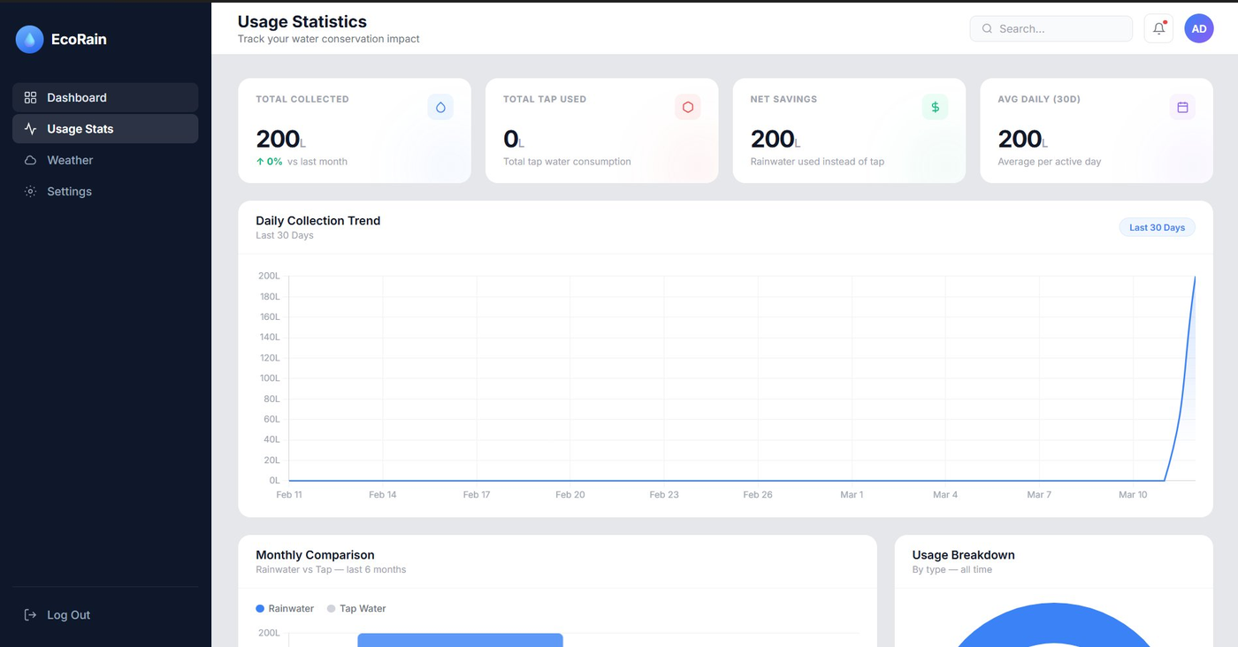
Figure 3: Usage Statistics — KPI Cards and Daily Collection Trend
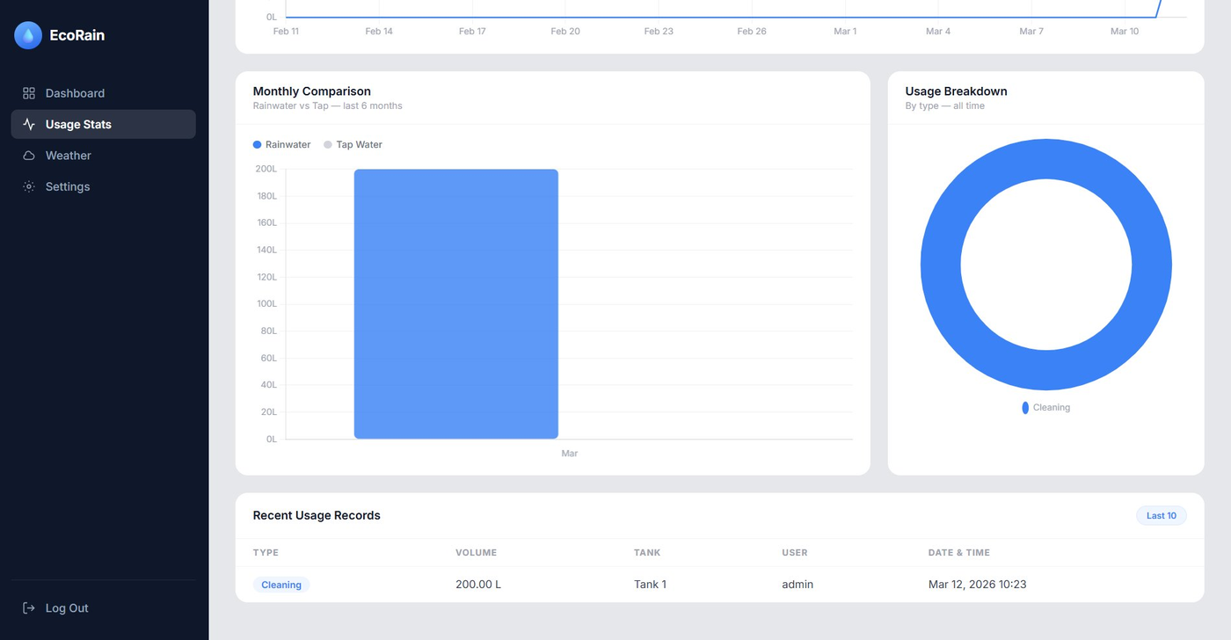
Figure 4: Usage Statistics — Monthly Comparison and Usage Breakdown
3.2.1 KPI Summary Cards
Four top-level metric cards provide instant performance indicators:
- Total Collected — Cumulative rainwater harvested (all time or filtered period), with a percentage change indicator vs. the previous month.
- Total Tap Used — Total conventional water consumption logged in the system. A low value here indicates effective rainwater substitution.
- Net Savings — The volume of tap water avoided due to rainwater usage. Directly reflects environmental and cost impact.
- Avg Daily (30D) — Average daily collection over the past 30 active days, useful for capacity planning.
3.2.2 Daily Collection Trend
A line chart spanning the last 30 days shows daily rainwater collection volumes. The chart uses Chart.js with smooth curves, helping identify seasonal trends, heavy rainfall events, and dry spells.
3.2.3 Monthly Comparison
A grouped bar chart comparing Rainwater vs. Tap Water usage month-by-month over the past 6 months. This visualization is key for demonstrating the system's conservation impact over time.
3.2.4 Usage Breakdown (Donut Chart)
A donut/pie chart categorizing water usage by type (e.g., Cleaning, Irrigation, Drinking) across all recorded data. Helps administrators understand which activities consume the most water.
3.2.5 Recent Usage Records Table
A paginated table showing the last 10 water usage entries, including usage type, volume (liters), tank, responsible user, and exact date/time. Provides full traceability for each water draw event.

3.3 Weather Monitor
The Weather Monitor page provides real-time atmospheric conditions and extended forecasts to help operators anticipate rainfall and manage tank capacity proactively.
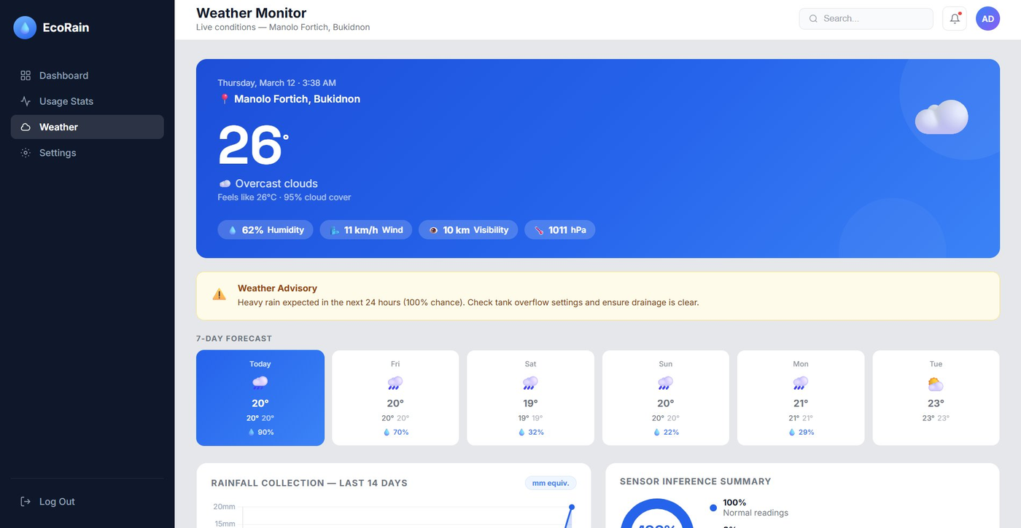
Figure 5: Weather Monitor — Current Conditions and 7-Day Forecast
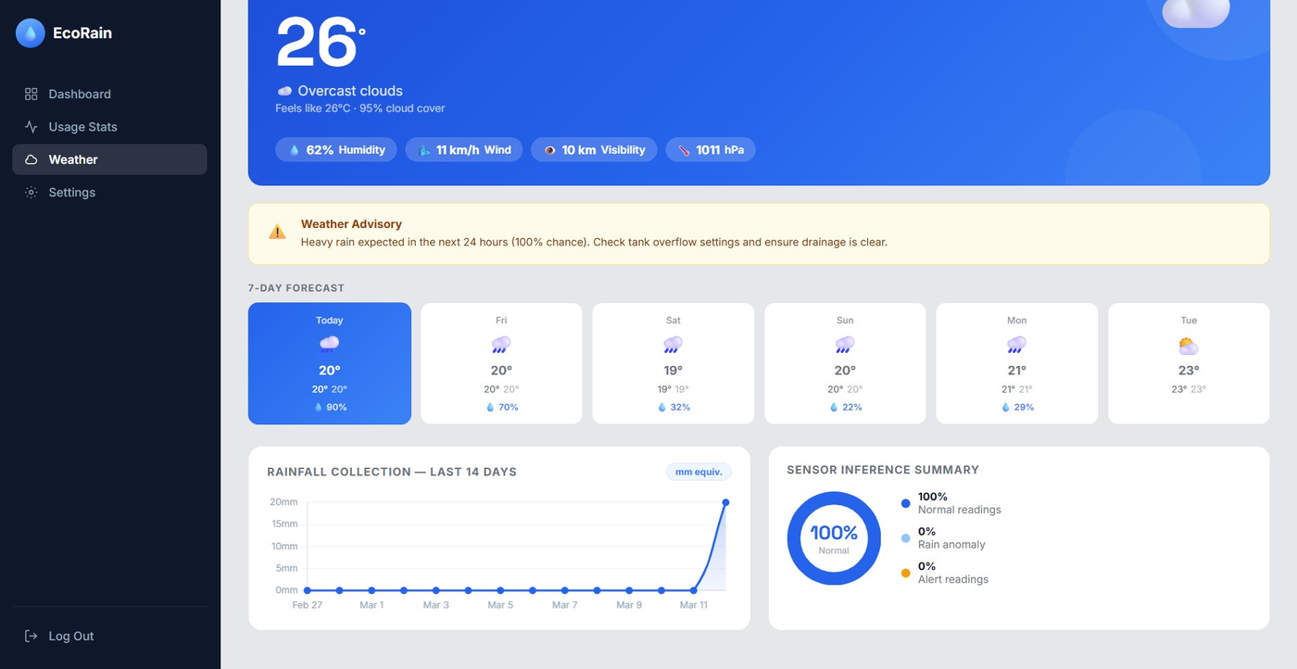
Figure 6: Weather Monitor — Rainfall Collection Trend and Sensor Inference Summary
3.3.1 Current Conditions Hero Card
A prominent card showing live weather data from the OpenWeatherMap API:
- Location header — City, country, and current date/time
- Temperature — Current reading in Celsius with a weather condition emoji animation
- Condition description — e.g., "Overcast clouds", "Clear sky"
- Feels like temperature and cloud cover percentage
- Metric pills — Humidity (%), wind speed (km/h), visibility (km), and atmospheric pressure (hPa)
3.3.2 Weather Advisory
An intelligent alert banner that activates when the rain probability exceeds a configurable threshold (e.g., 80%). It warns operators to check tank overflow settings and ensure drainage is clear, directly linking weather data to operational decisions.
3.3.3 7-Day Forecast Grid
A horizontal row of forecast cards — one per day — each showing the day name, weather icon, high/low temperatures, and rain probability percentage. The current day is highlighted. This enables operators to pre-plan tank management for the week.
3.3.4 Rainfall Collection Trend (14-Day)
An area chart showing historical rainfall data (in mm equivalent) over the last 14 days. This visualization correlates weather events with actual collection volumes, helping validate sensor accuracy.
3.3.5 Sensor Inference Summary
A donut chart and legend showing the breakdown of sensor reading classifications: Normal readings, Rain anomaly detections, and Alert-level readings. This provides a quick health summary of the entire sensor network.

3.4 Settings (Admin Only)
The Settings page is exclusively accessible to administrators and allows full configuration of the EcoRain system parameters. It is organized into four collapsible sections.
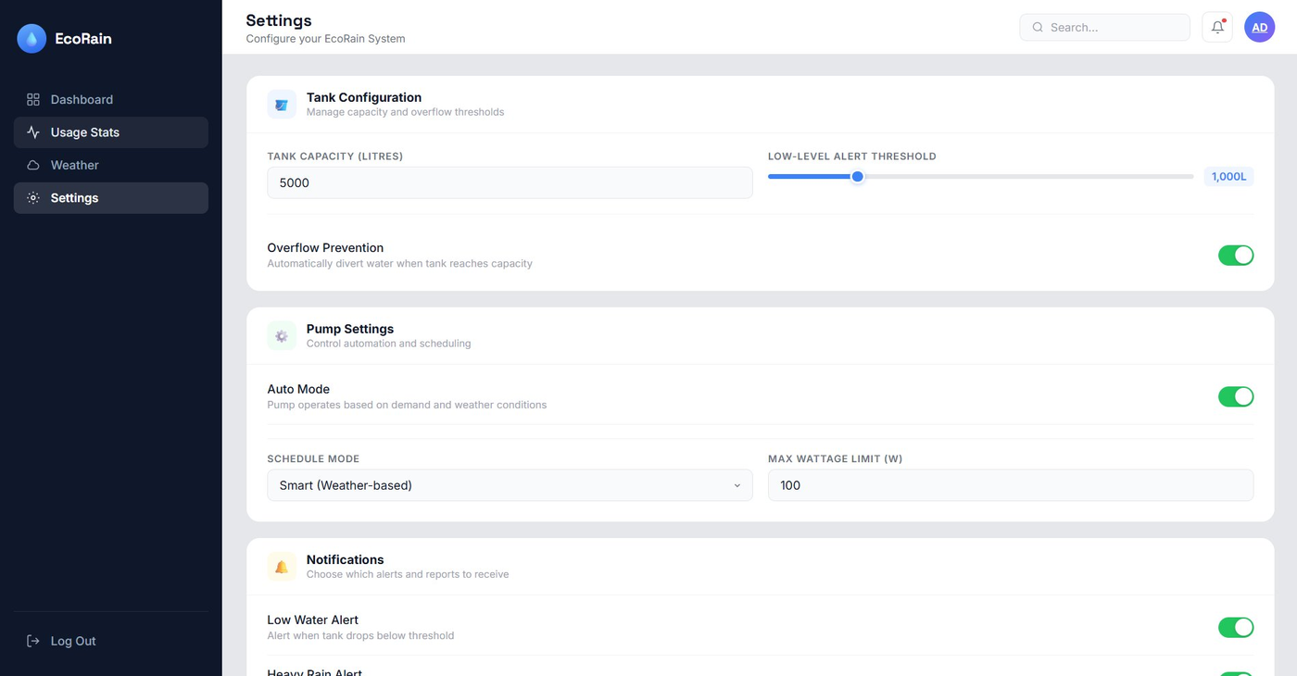
Figure 7: Settings — Tank Configuration and Pump Settings
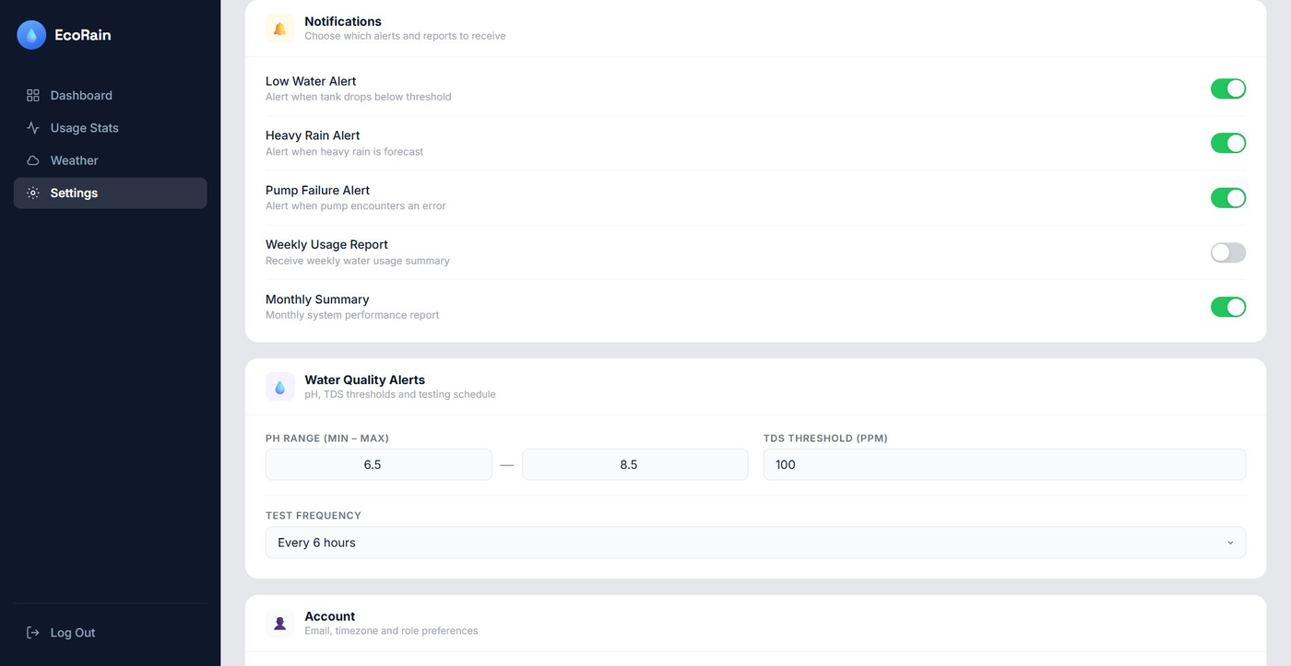
Figure 8: Settings — Notifications Configuration
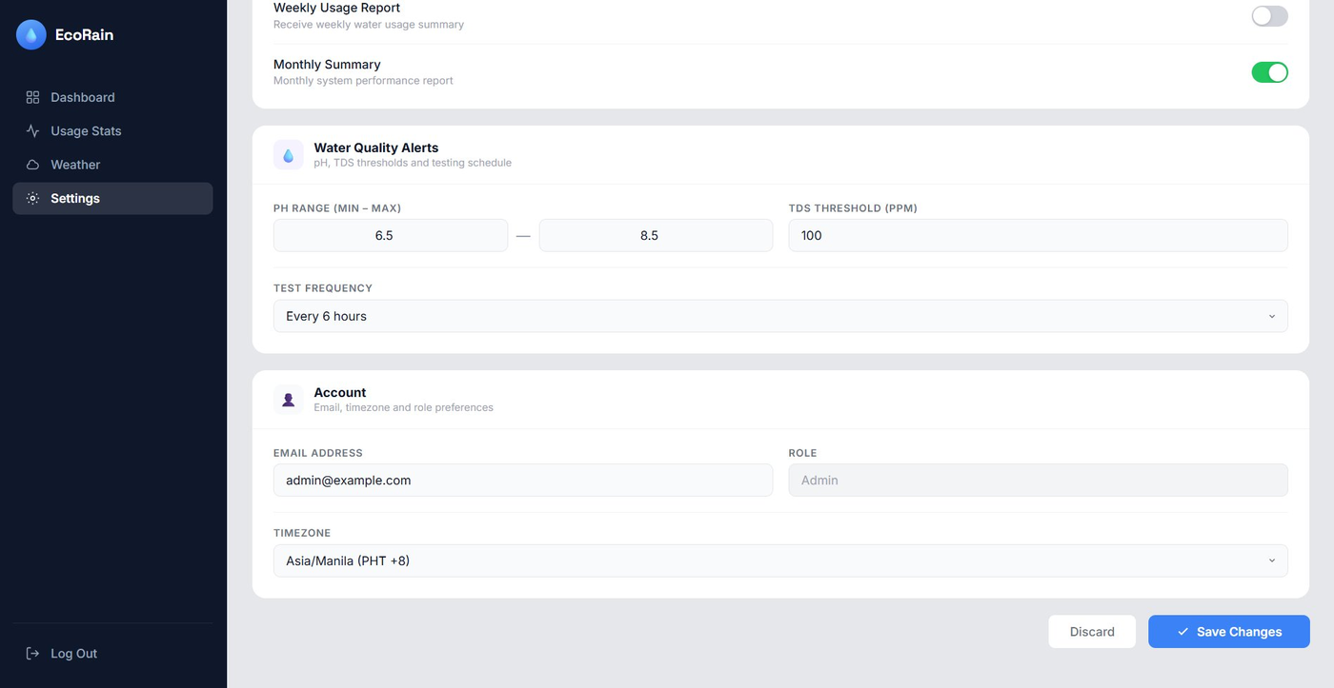
Figure 9: Settings — Water Quality Alerts and Account Preferences
3.4.1 Tank Configuration
- Tank Capacity (Litres) — Editable field to update the maximum storage capacity. Changes reflect system-wide in all percentage calculations.
- Low-Level Alert Threshold — An interactive range slider setting the minimum volume (in liters) before a low-water alert is triggered. Default: 1,000L.
- Overflow Prevention Toggle — When enabled, the system automatically diverts incoming water when the tank reaches full capacity, preventing overflow damage.
3.4.2 Pump Settings
- Auto Mode Toggle — Enables autonomous pump operation based on real-time demand signals and weather forecast inputs.
- Schedule Mode — Dropdown selector for pump timing strategy: Smart (Weather-based), Fixed Schedule, or Manual.
- Max Wattage Limit — Configures the maximum power consumption ceiling for the pump motor, preventing electrical overload.
3.4.3 Notifications
Five toggle switches control which alert types are sent:
- Low Water Alert — Fires when tank drops below the configured threshold
- Heavy Rain Alert — Fires when forecast shows heavy precipitation (overflow risk)
- Pump Failure Alert — Fires when sensor anomalies detect pump errors
- Weekly Usage Report — Optional weekly summary email (default: off)
- Monthly Summary — Monthly system performance report
3.4.4 Water Quality Alerts
- pH Range (Min–Max) — Defines acceptable pH bounds (default: 6.5–8.5). Readings outside this range trigger alerts.
- TDS Threshold (PPM) — Sets the maximum acceptable Total Dissolved Solids concentration.
- Test Frequency — Dropdown to configure how often automated quality checks run (e.g., Every 6 hours).
3.4.5 Account Preferences
- Email Address — Administrator contact for system alerts and reports
- Role — Displayed as read-only (Admin/User)
- Timezone — Dropdown for locale configuration (default: Asia/Manila PHT +8)
A "Save Changes" button commits all settings with a confirmation toast. A "Discard" button reverts all unsaved modifications.

3.5 User Management (Admin Only)
The User Management page gives administrators complete control over system user accounts and provides a centralized audit trail.
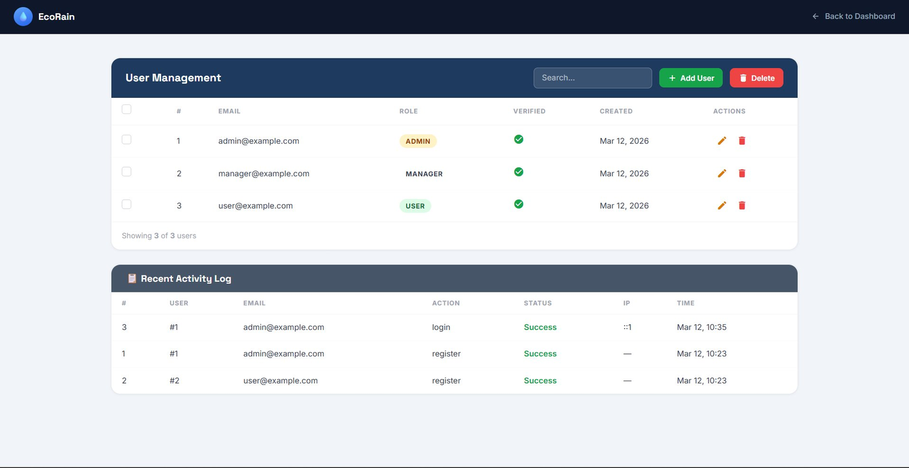
Figure 10: User Management — User Table and Activity Log
3.5.1 User Table
A searchable table listing all registered users with:
- Row number, email address, role badge (Admin / Manager / User) with distinct color coding
- Verification status (green checkmark = verified email)
- Account creation date
- Inline action buttons — Edit (pencil icon) and Delete (trash icon) per row
- Bulk selection via checkboxes for mass deletion
- "Add User" button — Opens a form to create a new account with email, role, and temporary password
3.5.2 Recent Activity Log
Below the user table, a detailed activity log shows recent system events with columns for user ID, email, action type, success/failure status, IP address, and timestamp. This supports security auditing and compliance tracking.

3.6 User Profile
The User Profile page is available to all roles and displays personal account information alongside recent activity.
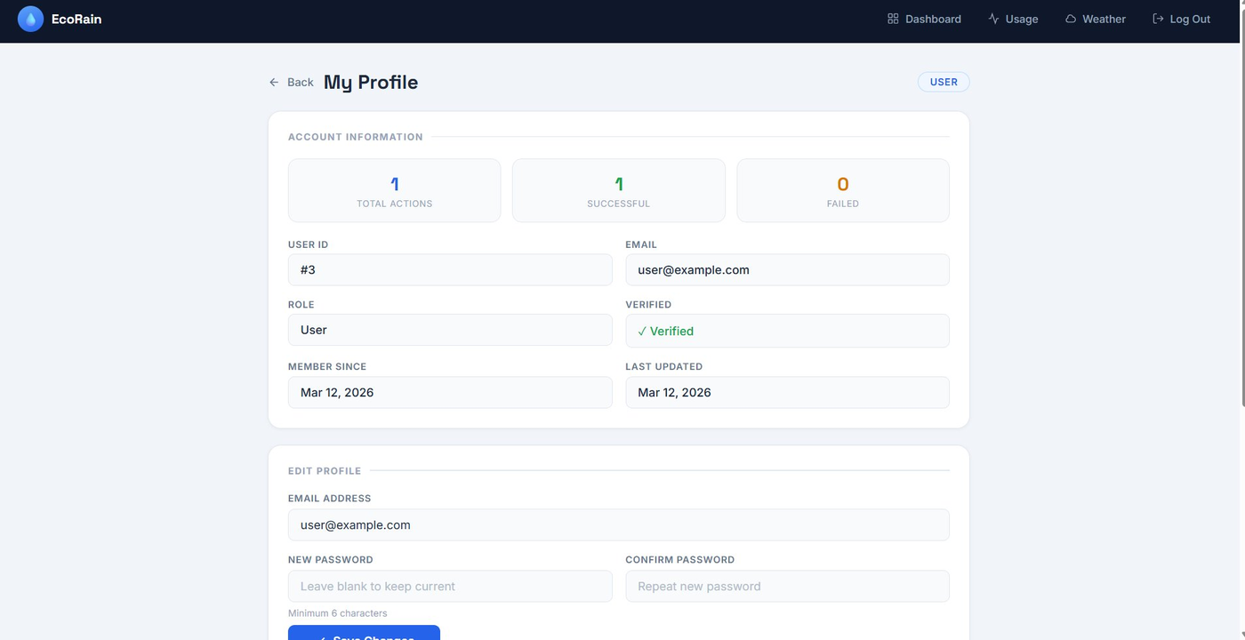
Figure 11: User Profile — Account Information and Edit Form
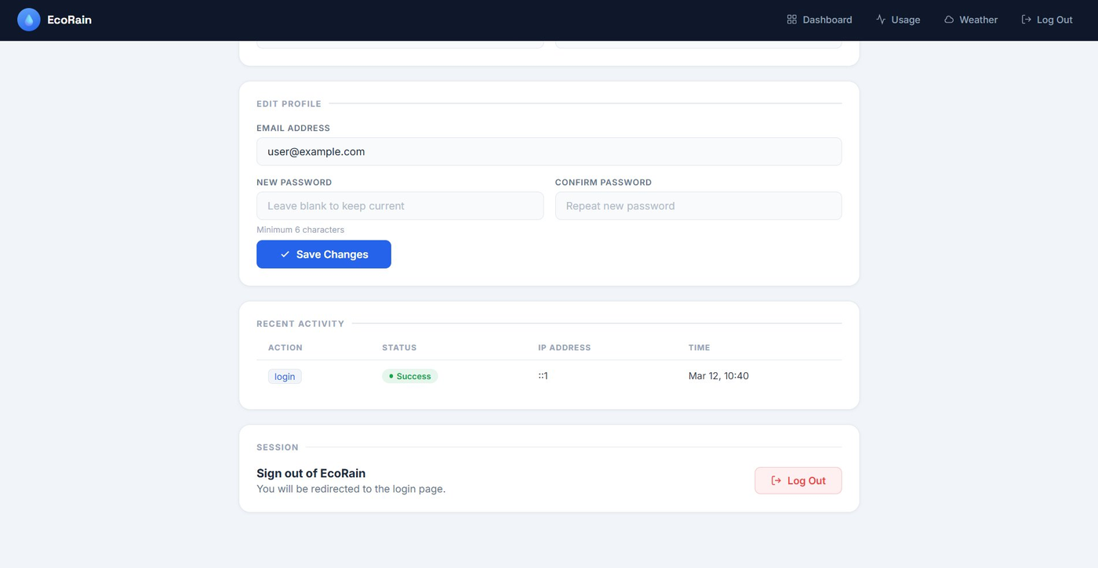
Figure 12: User Profile — Recent Activity and Session Management
3.6.1 Account Information
Three summary stat cards show total actions performed, successful actions, and failed attempts (useful for detecting unauthorized access attempts). Below, a structured grid displays: User ID, email, role, verification status, member since date, and last updated date.
3.6.2 Edit Profile
A form allows users to update their email address and change their password (with confirmation field). Password fields include a minimum 6-character requirement hint. A "Save Changes" button submits the update.
3.6.3 Recent Activity
A table showing the user's own recent actions, including action type (e.g., login, register), success/failure status with color-coded badges, IP address, and timestamp.
3.6.4 Session Management
A clearly visible "Log Out" button in the Session section terminates the current session and redirects to the login page, providing a secure and explicit sign-out pathway.

4. Database Design & Structure
The EcoRain system uses a normalized relational MySQL database named automated_rainwater, designed to Third Normal Form (3NF) to eliminate redundancy and ensure data integrity.

4.1 Entity-Relationship Summary
Table | Primary Key | Description
users | id (INT, AI) | Stores all user accounts with credentials, role, and verification state
user_activity_logs | activity_id (INT, AI) | Audit trail of all user actions, including login, registration, and setting changes
tank | tank_id (INT, AI) | Physical tank specifications — name, location, capacity, current volume, status
sensors | sensor_id (INT, AI) | Sensor registry linked to tanks — type, model, unit, and active state
sensor_readings | reading_id (INT, AI) | Time-series sensor readings with anomaly classification per reading
water_usage | usage_id (INT, AI) | Records every water draw event with volume, type, and responsible user
water_quality | quality_id (INT, AI) | Time-series water quality samples — pH, turbidity, and status label

4.2 Table Definitions & Constraints
4.2.1 users
Central identity table. Stores credentials and role information for all system users.
Column | Data Type | Constraints | Notes
id | INT | PK, AUTO_INCREMENT | Surrogate primary key
username | VARCHAR(255) | NOT NULL | Display name
email | VARCHAR(255) | UNIQUE, NOT NULL | Login identifier; uniqueness enforced
password | VARCHAR(255) | NOT NULL | Bcrypt hashed password
role | ENUM('admin','manager','user') | DEFAULT 'user' | Controls feature access level
is_verified | TINYINT(1) | DEFAULT 0 | Email verification status flag
verification_token | VARCHAR(64) | NULL | One-time email verification token
email_verification_expires | DATETIME | NULL | Token expiry for time-limited verification
created_at | TIMESTAMP | DEFAULT CURRENT_TIMESTAMP | Account creation time
updated_at | TIMESTAMP | ON UPDATE CURRENT_TIMESTAMP | Automatic update tracking

4.2.2 user_activity_logs
Append-only audit log. Records every significant user action for security and compliance purposes.
Column | Data Type | Constraints | Notes
activity_id | INT | PK, AUTO_INCREMENT | Unique log entry ID
user_id | INT | FK → users(id), NULL | SET NULL on user deletion preserves logs
role | ENUM('admin','user') | DEFAULT 'user' | Role at time of action
email | VARCHAR(255) | NULL | Snapshot of email for audit persistence
action | VARCHAR(50) | NOT NULL | Action descriptor: login, register, etc.
status | ENUM('success','failed') | NOT NULL, DEFAULT success | Outcome of the action
ip_address | VARCHAR(45) | NULL | Supports IPv6 addresses (up to 45 chars)
user_agent | VARCHAR(255) | NULL | Browser/client identifier
created_at | TIMESTAMP | DEFAULT CURRENT_TIMESTAMP | Event timestamp

4.2.3 tank
Stores physical tank specifications. Designed for a single primary tank (LIMIT 1 query) with extensibility for multi-tank setups.
Column | Data Type | Constraints | Notes
tank_id | INT | PK, AUTO_INCREMENT | Surrogate key
tankname | VARCHAR(255) | UNIQUE, NOT NULL | Prevents duplicate tank names
location_add | VARCHAR(255) | NOT NULL | Physical installation address
current_liters | INT | NOT NULL, DEFAULT 0 | Live volume; updated by sensors
max_capacity | INT | NOT NULL, DEFAULT 5000 | Design capacity in liters
status_tank | VARCHAR(255) | NOT NULL | Operational status: Active, Maintenance, etc.

4.2.4 sensors
Registry of physical sensors attached to the system. Each sensor belongs to exactly one tank (CASCADE delete ensures referential integrity).
Column | Data Type | Constraints | Notes
sensor_id | INT | PK, AUTO_INCREMENT | Unique sensor identifier
tank_id | INT | FK → tank(tank_id) | CASCADE delete — removes sensors if tank deleted
sensor_type | VARCHAR(255) | NOT NULL | e.g., Water Level, pH, Turbidity
model | VARCHAR(255) | NOT NULL | Hardware model identifier
unit | VARCHAR(255) | NOT NULL | Measurement unit: L, NTU, pH, etc.
is_active | VARCHAR(255) | NOT NULL | Active/Inactive status of the sensor

4.2.5 sensor_readings
Time-series table storing every sensor data event. The anomaly field classifies each reading to support automated alerting.
Column | Data Type | Constraints | Notes
reading_id | INT | PK, AUTO_INCREMENT | Unique reading entry
sensor_id | INT | FK → sensors(sensor_id) | CASCADE — readings removed with sensor
user_id | INT | FK → users(id), NULL | Optional: who triggered reading (manual override)
anomaly | VARCHAR(255) | NOT NULL | None / Alert / Critical classification
recorded_at | TIMESTAMP | DEFAULT CURRENT_TIMESTAMP | Auto-stamped event time

4.2.6 water_usage
Every water draw or collection event is recorded here. Supports full usage analytics including volume, type, and user attribution.
Column | Data Type | Constraints | Notes
usage_id | INT | PK, AUTO_INCREMENT | Surrogate key
tank_id | INT | FK → tank(tank_id) | Which tank the usage belongs to
user_id | INT | FK → users(id), NULL | SET NULL — preserves usage records if user deleted
usage_liters | DECIMAL(10,2) | NOT NULL | Precise volume with 2 decimal places
usage_type | VARCHAR(255) | NOT NULL | Cleaning, Irrigation, Drinking, etc.
recorded_at | TIMESTAMP | DEFAULT CURRENT_TIMESTAMP | Event timestamp

4.2.7 water_quality
Stores periodic water quality test results. Supports trend analysis for pH and turbidity over time.
Column | Data Type | Constraints | Notes
quality_id | INT | PK, AUTO_INCREMENT | Unique quality entry
tank_id | INT | FK → tank(tank_id) | Quality tied to specific tank
user_id | INT | FK → users(id), NULL | Technician who recorded the reading
turbidity | DECIMAL(10,2) | NOT NULL | NTU value; DECIMAL for precision
ph_level | DECIMAL(4,2) | NOT NULL | pH range 0.00–14.00; DECIMAL(4,2) sufficient
quality_status | VARCHAR(255) | NOT NULL | Derived label: Good, Poor, Acceptable
recorded_at | TIMESTAMP | DEFAULT CURRENT_TIMESTAMP | Auto-stamped test time

5. Database Design Evaluation

5.1 Clear Table Structure (2 pts)
All six tables are clearly defined with well-chosen names that reflect their domain purpose. Every table has an INT AUTO_INCREMENT PRIMARY KEY (id, tank_id, sensor_id, etc.) serving as a surrogate key, ensuring each row is uniquely identifiable regardless of business data changes. Column names follow a consistent snake_case convention, and table names use singular nouns for clarity.

5.2 Correct Data Types (2 pts)
Data types are chosen to match the semantic requirements of each field precisely:
- DECIMAL(10,2) is used for usage_liters — ensuring accurate fractional liter measurements without floating-point errors
- DECIMAL(4,2) is used for ph_level — correctly bounds the pH range (0.00–14.00) with no wasted storage
- ENUM is used for role and status fields — enforcing a fixed vocabulary at the database level, preventing invalid values
- VARCHAR(45) for ip_address — correctly sized to accommodate full IPv6 addresses (39 characters max)
- TINYINT(1) for is_verified — standard MySQL boolean representation
- TIMESTAMP with DEFAULT CURRENT_TIMESTAMP — auto-populates audit columns without application-level code

5.3 Relationships Defined (2 pts)
All inter-table relationships are enforced with foreign key constraints:
- sensors.tank_id → tank.tank_id (CASCADE DELETE) — when a tank is removed, all its sensors are automatically removed
- sensor_readings.sensor_id → sensors.sensor_id (CASCADE DELETE) — readings are cleaned up when their source sensor is deleted
- sensor_readings.user_id → users.id (SET NULL) — reading history is preserved even if the associated user account is deleted
- water_usage.tank_id → tank.tank_id (CASCADE DELETE) — usage data tied to tank lifecycle
- water_usage.user_id → users.id (SET NULL) — usage history retained after user deletion for auditing
- water_quality.tank_id and water_quality.user_id — same pattern ensures data integrity across quality records
- user_activity_logs.user_id → users.id (SET NULL) — audit trail preserved even after account deletion

5.4 Normalization (2 pts)
The schema satisfies at least Third Normal Form (3NF):
- 1NF — All columns hold atomic values; no repeating groups or multi-valued fields
- 2NF — All non-key attributes are fully functionally dependent on the entire primary key (all tables use single-column surrogate keys, so partial dependency is impossible)
- 3NF — No transitive dependencies exist. For example, quality_status in water_quality may appear denormalized, but it serves as a stored classification label that is not derivable from other columns without application logic — it is a legitimate attribute of the quality reading itself. Similarly, email in user_activity_logs is a deliberate audit snapshot (not a transitive dependency) to preserve the email at the time of the event, even if it later changes.
Redundant storage is minimized: user details are stored once in users and referenced by ID elsewhere. Tank specifications are not duplicated across sensor_readings or water_usage.

5.5 Constraints & Integrity (2 pts)
The schema applies constraints comprehensively:
- NOT NULL — Applied to all columns that must always have a value: email, password, username, action, anomaly, usage_liters, ph_level, turbidity, quality_status, tankname, location_add, status_tank
- UNIQUE — Applied to users.email (prevents duplicate accounts) and tank.tankname (prevents duplicate tank entries)
- DEFAULT values — Sensible defaults applied: role = 'user', is_verified = 0, current_liters = 0, max_capacity = 5000, status = 'success', all timestamps set to CURRENT_TIMESTAMP
- ENUM constraints — role, status fields restricted to specific valid values at the database engine level
- ON DELETE behaviors — Carefully chosen per relationship: CASCADE for tight ownership (sensors → tank), SET NULL for audit preservation (logs → users)
- ENGINE=InnoDB — All tables use InnoDB, which is required for foreign key enforcement in MySQL

6. Presentation Rubric Guide
This section provides talking points aligned to the capstone presentation evaluation criteria to assist presenters in delivering an effective, well-structured demonstration.

6.1 Delivery (3 pts)
Clarity of speech, appropriate pacing, volume and tone.
Talking Points:
- Open with a clear problem statement: "Rainwater harvesting is underutilized due to lack of real-time monitoring tools. EcoRain solves this."
- Use the live dashboard to anchor the presentation — it is visually rich and immediately demonstrates value
- Speak to each section purposefully: "This tank card updates in real time and changes color based on fill level — here you can see it is currently in the warning zone at 24%"
- Pace the demo by section: ~2 minutes per major feature (Dashboard → Usage → Weather → Settings → DB)
- Make eye contact with the audience during transitions between screens, not while typing
- Use confident assertive language: "The system does X" rather than "The system can do X" or "we tried to make it do X"

6.2 Design Quality (1 pt)
Design is well thought out, aesthetically pleasing, and functionally efficient.
Talking Points:
- The dark sidebar navigation provides immediate visual hierarchy — administrators see Settings, regular users do not
- Color semantics are intentional: red/yellow/blue tank card communicates urgency at a glance without reading numbers
- All data-heavy sections use cards with subtle shadows and border separators to maintain visual breathing room
- The responsive layout collapses gracefully on smaller screens, making it usable on tablet-sized devices
- Typography uses two complementary font families: Sora (display/headings) and DM Sans (body) — readable and modern

6.3 Functionality (3 pts)
Prototype performs all intended tasks flawlessly and efficiently.
Demonstrate live:
- Login as Admin → show full navigation (Dashboard, Usage Stats, Weather, Settings)
- Show Dashboard: tank level card color, water quality metrics, 7-day chart, sensor readings, activity log
- Navigate to Usage Stats: explain KPI cards, point out daily trend chart and monthly comparison
- Navigate to Weather: show live temperature, 7-day forecast grid, and the weather advisory banner
- Navigate to Settings: toggle overflow prevention, adjust threshold slider, show Save/Discard flow
- Show User Management: search a user, explain role badges and verification checkmarks
- Log out and log back in as a regular User — demonstrate that Settings is absent from the navigation
- Show User Profile: activity log, edit email/password form, session logout button

6.4 Maintainability (1 pt)
Prototype can be maintained over an extended period.
Talking Points:
- Codebase is organized into separate concerns: PHP handles backend logic, HTML structures content, CSS manages styles, JavaScript handles interactivity — each file has one responsibility
- The database uses surrogate integer primary keys (not business data), meaning any field can change without breaking foreign key chains
- ON DELETE behaviors (SET NULL vs CASCADE) are deliberately chosen so historical audit data (activity logs, usage records) is preserved even when users or tanks are removed
- The .env configuration file externalizes all sensitive settings (DB credentials, API keys) so they can be updated without touching source code
- Chart.js and OpenWeatherMap are industry-standard libraries with long-term support — not custom-built fragile code
- Adding a new sensor type requires only inserting a row in the sensors table — no schema changes needed

7. Conclusion
EcoRain successfully demonstrates a complete, production-quality automated rainwater harvesting management system. The platform integrates real-time IoT sensor data, weather API forecasts, and comprehensive usage analytics into a single, role-aware web application delivered as a cross-platform desktop app via Electron.
The database schema reflects careful application of relational design principles — clear primary keys, appropriate data types, enforced foreign key relationships, Third Normal Form normalization, and comprehensive constraints — ensuring long-term data integrity and maintainability.
The system achieves its primary goals:
- Real-time visibility into tank health and water quality
- Predictive rainfall integration for proactive tank management
- Role-based access ensuring secure, appropriate feature exposure
- Comprehensive audit trails supporting accountability and security
- A clean, maintainable codebase that can scale with additional tanks, sensors, and users

EcoRain represents not just a functional prototype, but a deployable foundation for sustainable water management in resource-constrained environments.

EcoRain — Automated Rainwater Harvesting Management System
Technical Manuscript | March 2026

