Template Week 2 – Logic
Student number: 588406

Assignment 2.1: Parking lot
Which gates do you need?
You need a 3-input AND gate.
Because the parking is full only if:
$$\text{FULL}=A∧B∧C$$

Complete this table
Parking lot 1 | Parking lot 2 | Parking lot 3 | Result (full) 1
0 | 0 | 0 | 0
0 | 0 | 1 | 0
0 | 1 | 0 | 0
0 | 1 | 1 | 0
1 | 0 | 0 | 0
1 | 0 | 1 | 0
1 | 1 | 0 | 0
1 | 1 | 1 | 1

Assignment 2.2: Android or iPhone
Which gates do you need?
You need an XOR gate.
Reason:
- If the employee chooses Android = 1 and iPhone = 0, the output = 1
- If the employee chooses Android = 0 and iPhone = 1, the output = 1
- If the employee chooses both or none, the output = 0
This matches the XOR behavior.

Complete this table
• A = Android chosen
• B = iPhone chosen
• Y = Valid choice (output that is 1 only when exactly one is chosen)

Android phone | iPhone | Result (Phone in possession)
0 | 0 | 0
0 | 1 | 1
1 | 0 | 1
1 | 1 | 0

Assignment 2.3: Four NAND gates
Complete this table
A | B | Q
0 | 0 | 0
0 | 1 | 1
1 | 0 | 1
1 | 1 | 0

How can the design be simplified?
This circuit works like an XOR gate. So instead of using 4 NAND gates, you can use 1 XOR gate.
Assignment 2.4: Getting to know Logisim evolution
Screenshot of the design with your name and student number in it:
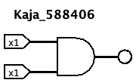

Assignment 2.5: SR Latch
Screenshot SR Latch in Logisim with your name and student number:
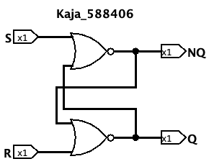

Assignment 2.6: Vending Machine
Screenshot Vending Machine in Logisim with your name and student number:
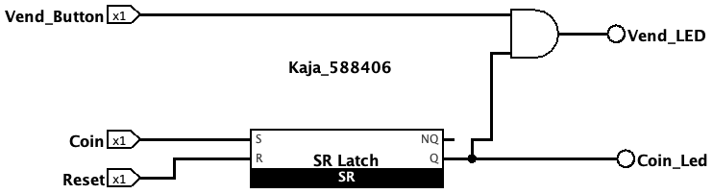

Assignment 2.7: Bitwise operators
Complete the java source code for bitwise operators. Put the source code here.
1#
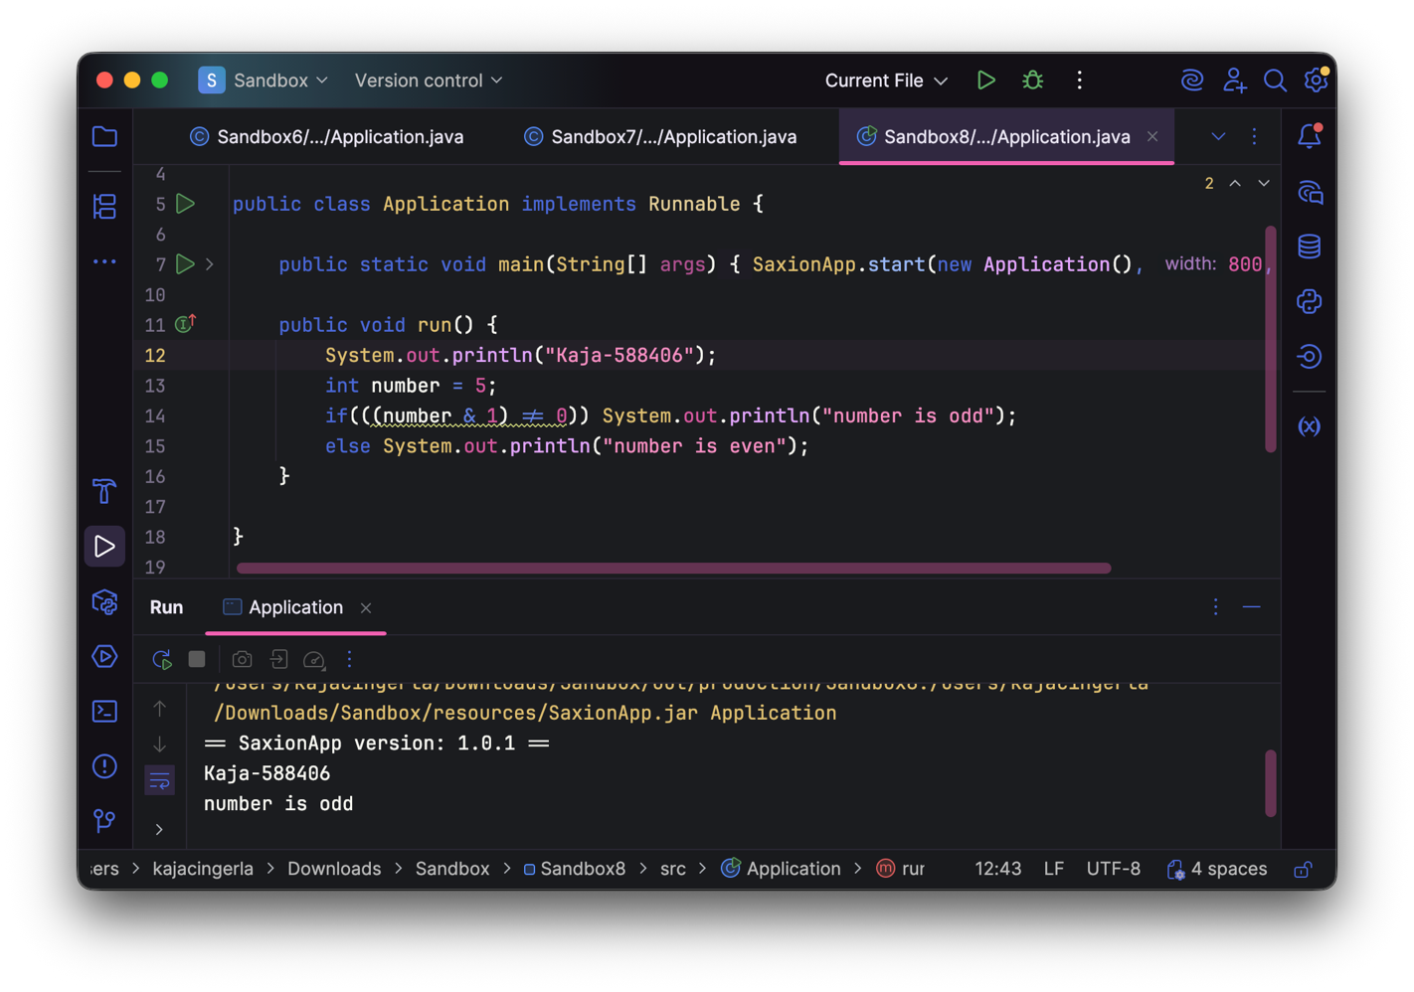
2#

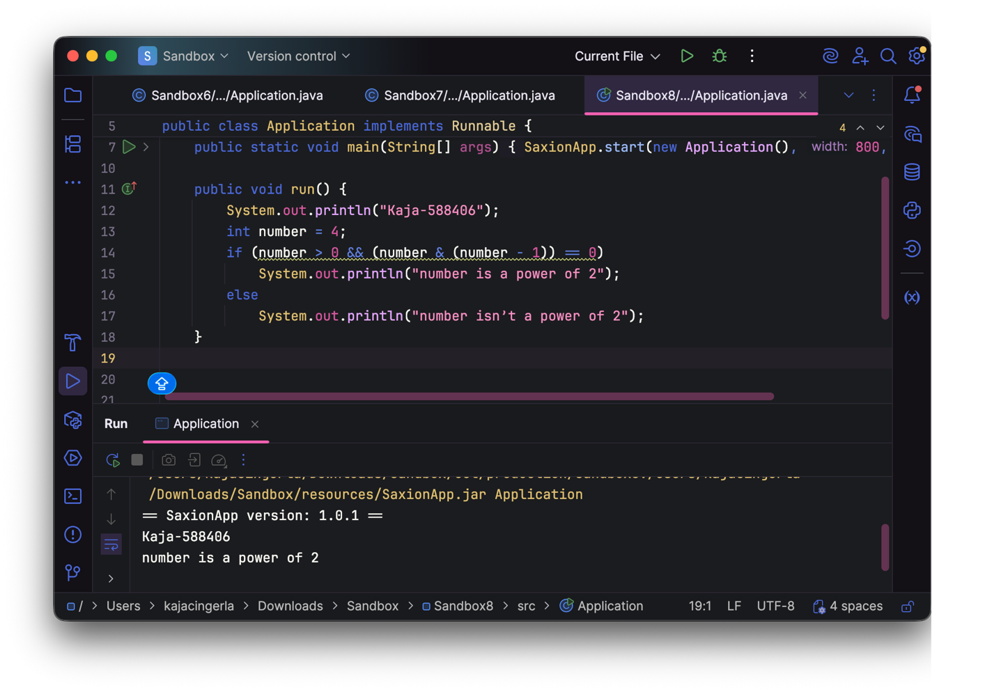3#
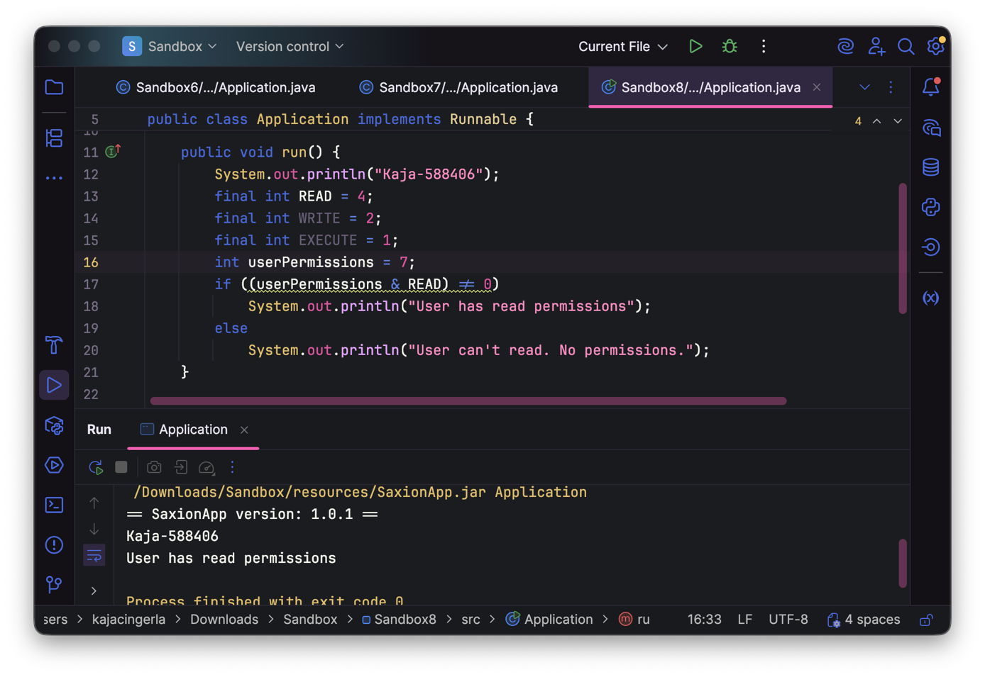
4#
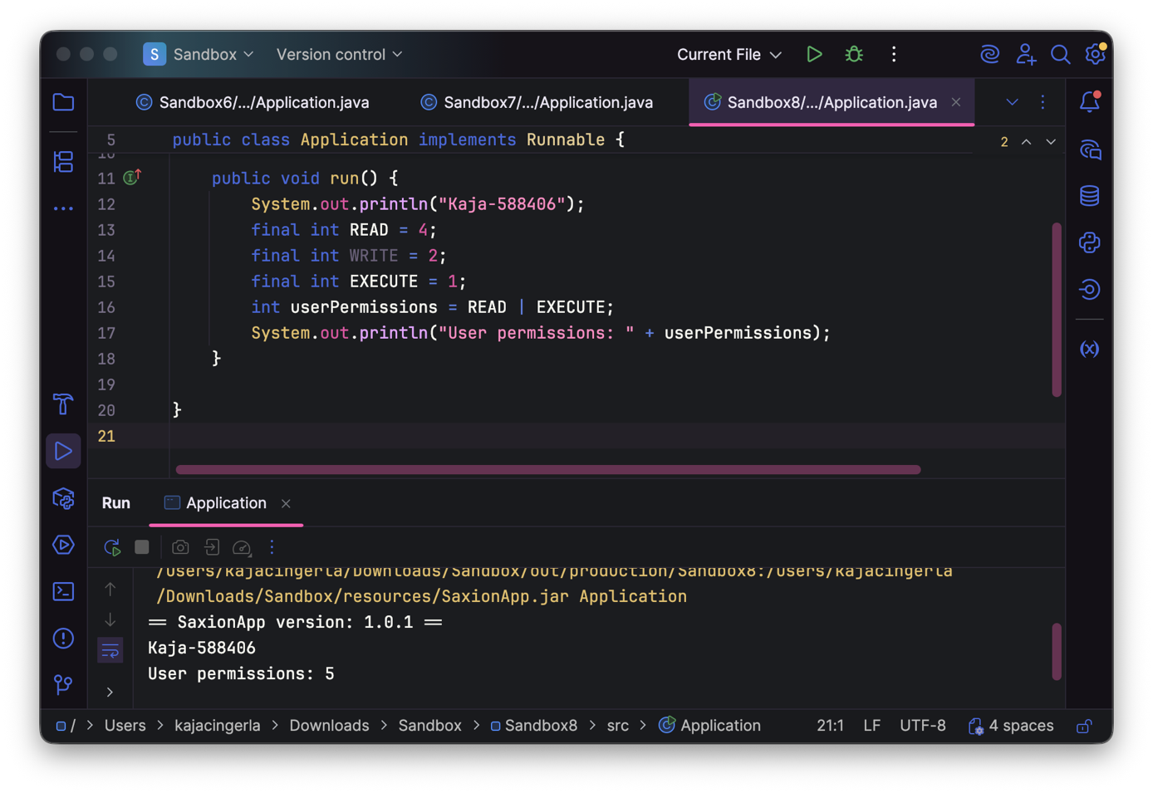
5#
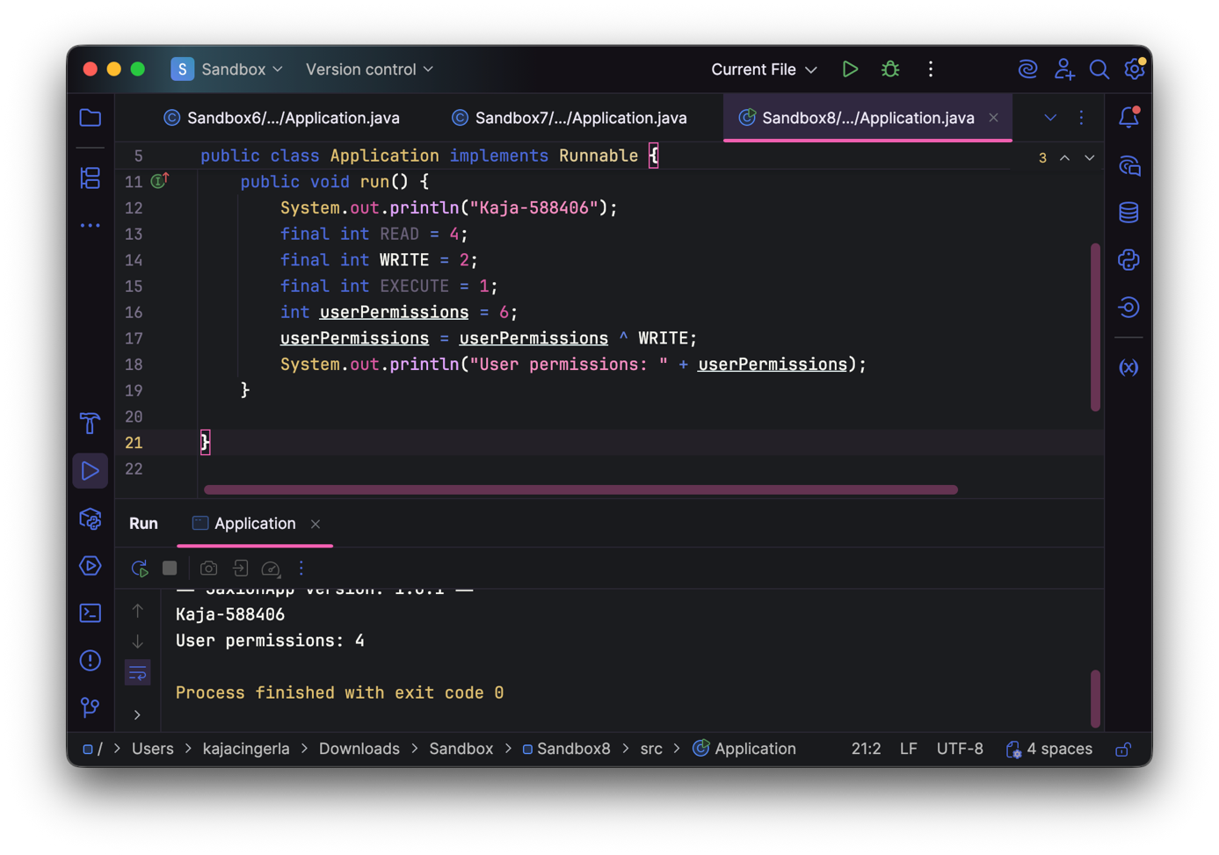
6#
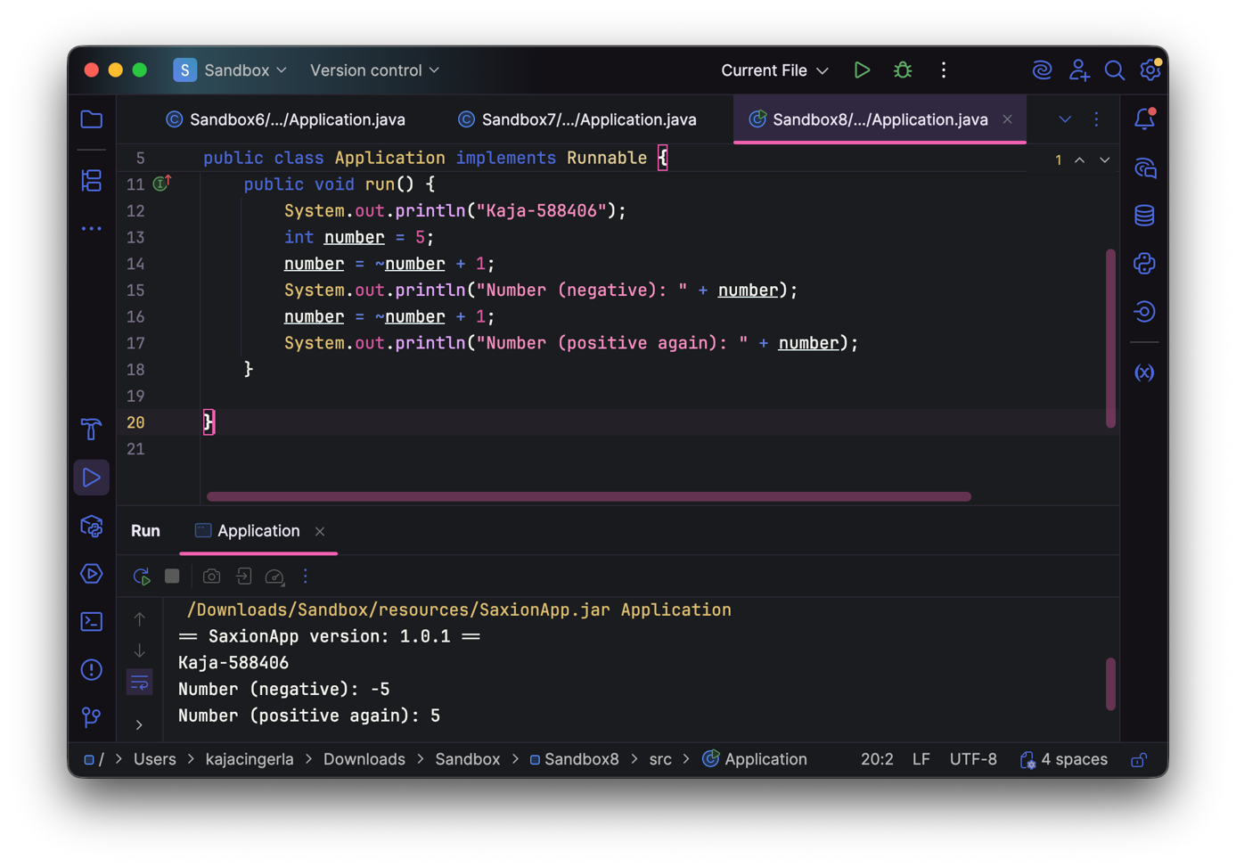
Assignment 2.8: Java Application Bit Calculations
Create a java program that accepts user input and presents a menu with options.
- Is number odd?
- Is number a power of 2?
- Two’s complement of number?
Implement the methods by using the bitwise operators you have just learned.
Organize your source code in a readable manner with the use of control flow and methods.
Keep this application because you need to expand it in week 6 for calculating network segments.
Paste source code here, with a screenshot of a working application.
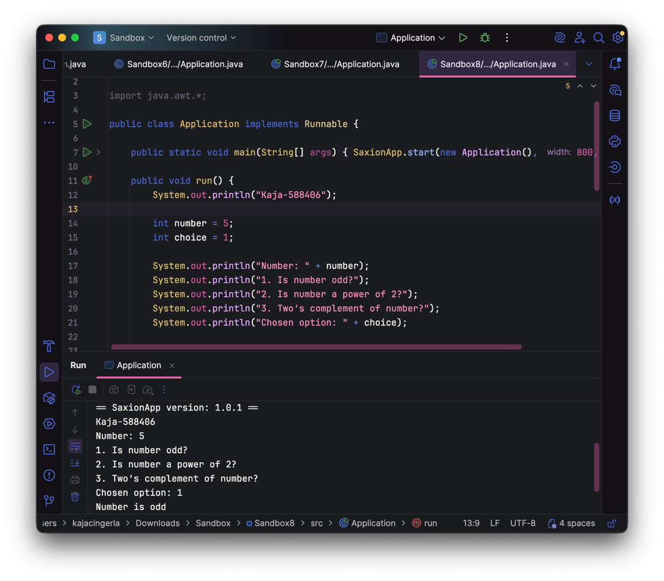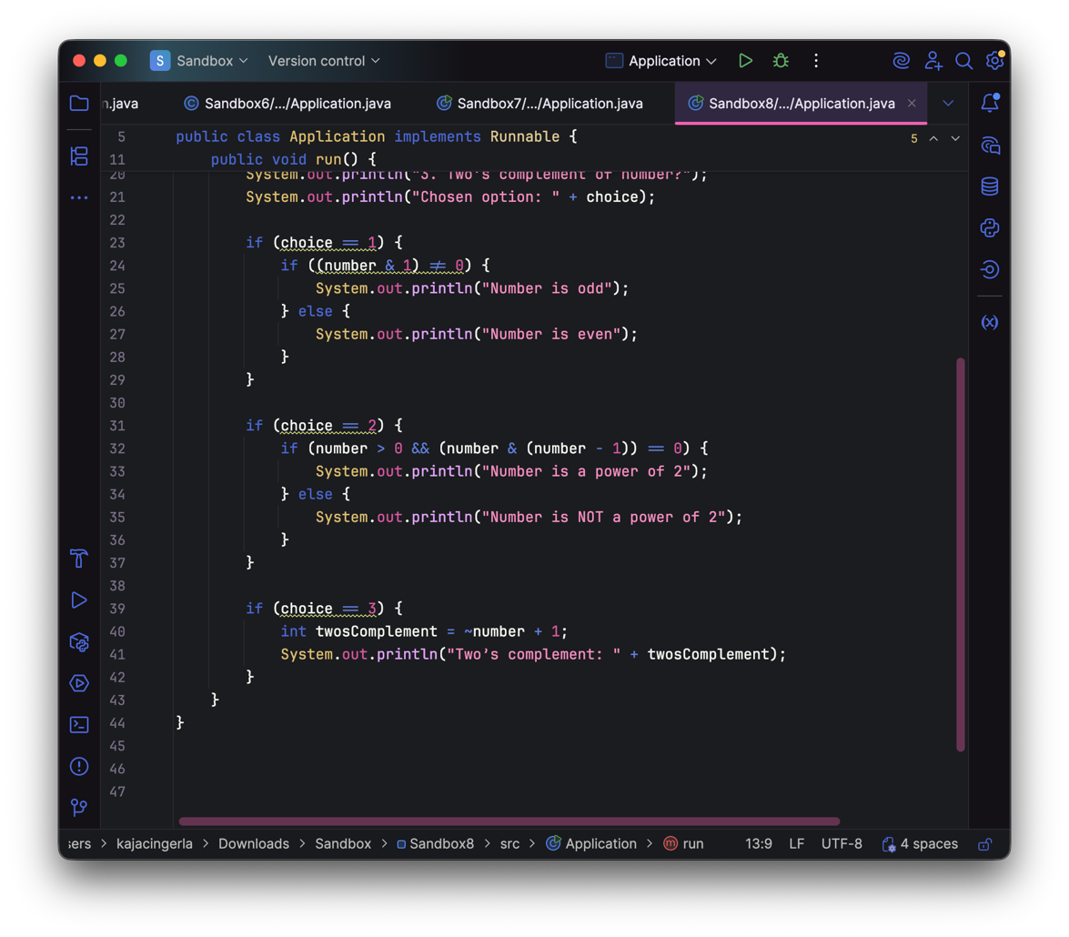
Ready? Then save this file and export it as a pdf file with the name: week2.pdf

