Template Week 3 – Hardware
Student number: 588406

Assignment 3.1: Examine your phone
- What processor is in your phone?
  - My phone (iPhone 13) uses the Apple A15 Bionic chip.
- To which architecture family does this processor belong? In other words, which Instruction Set Architecture (ISA) is used?
  - The A15 Bionic uses ARM architecture, specifically ARMv8-A (64-bit).
So the ISA is ARM64.
- How much RAM is in it?
  - The iPhone 13 has 4 GB of RAM.
- How much storage does your phone have?
  - My phone has 128 GB of internal storage.
- What operating system is running on your phone?
  - It runs iOS (currently most iPhone 13 devices run iOS 17 or iOS 18, depending on updates).
- Approximately how many applications do you have installed?
  - Around 120 apps installed.
- Which application do you use the most?
  - I use the most WhatsApp.
- Can your phone be charged with what type of plug?
  - The iPhone 13 charges with a Lightning connector.
- Which I/O ports can you visually see on your phone?
  - On the iPhone 13, you can visually see:
    - Lightning port (charging + data)
    - Speaker grills
    - Microphone holes
      - The phone does not have a headphone jack or USB-C port.

Assignment 3.2: Examine your laptop
- What processor is in your laptop?
  - My laptop uses the Apple M2 chip.
- To which architecture family does this processor belong? In other words, which Instruction Set Architecture (ISA) is used?
  - The Apple M2 chip uses the ARM architecture, specifically ARM64 / AArch64.
- How much RAM is in it?
  - My laptop has 16 GB of RAM.
- How much storage does your laptop have?
  - My laptop has 994.66 GB of internal storage (1 TB class SSD).
- Which operating system is running on your laptop?
  - It is running macOS (latest version)
- Approximately how many applications do you have installed?
  - I have around 100 applications installed.
- Which application do you use the most?
  - I use Safari the most.
- Can your laptop be charged with what type of plug?
  - The 13-inch MacBook Pro (M2, 2022) is charged with USB-C.
- Which I/O ports can you visually see on your laptop?
  - On this model, I can see:
    - Two USB-C / Thunderbolt 3 ports (left side)
    - One 3.5 mm headphone jack (right side)

Assignment 3.3: Power to the laptop
- What is the input voltage?
  - For Apple USB-C power adapters, the input voltage is: 100–240 V
- What is the output voltage?
  - USB-C power adapters output variable voltage depending on what the device requests. Typical Apple USB-C outputs include:
    - 5 V
    - 9 V
    - 15 V
    - 20 V
  - Your MacBook usually uses 20 V for charging.
- How many watts can your power adapter deliver?
  - The MacBook Pro 13-inch (M2) typically comes with a 67 W USB-C Power Adapter.
- Is the input voltage AC or DC?
  - The input voltage is AC (Alternating Current).
- Is the output voltage AC or DC?
  - The output voltage is DC (Direct Current).
- AC/DC what is that?
  - AC = Alternating Current
    - The direction of electrical flow switches back and forth many times per second.
    - This is what comes from wall outlets.
  - DC = Direct Current
    - Electricity flows in one constant direction.
    - All electronic devices (phones, laptops, tablets) need DC to run.
  - The power adapter converts AC → DC so your laptop can use it.
- If you reverse the polarity of the output voltage, is that bad for your laptop?
  - Yes, very bad.
  - Reversed polarity can:
    - Short-circuit internal components
    - Permanently damage the charging circuitry
    - Potentially destroy the battery or logic board
  - USB-C chargers prevent this electronically, but traditional barrel chargers can be destroyed by reversed polarity.
- You forgot your power adapter, your laptop normally needs 15 watts. You will be loaned a power adapter that can deliver 50 watts. Voltage, polarity, etc. are all the same compared to the original power adapter. You can connect the borrowed power adapter to your laptop. What will happen? Also explain why you think that.
  - Nothing bad happens. Your laptop will charge normally.
  - Why?
  - Because power adapters do not “push” wattage into the device.
Instead, the laptop pulls only the amount of power it needs.
    - Your laptop needs 15 W
    - The charger can supply up to 50 W, but only if asked
    - Since the voltage and polarity are correct, the laptop safely draws the amount it needs
  - This is exactly how USB-C Power Delivery works.
  - Analogy:
    - A 50 W charger is like a big water tank — it can supply a lot of water, but your laptop opens the tap just enough for 15 W, so it only takes what it needs.

Assignment 3.4: Build your dream PC
Screenshots PC configuration + motivation:
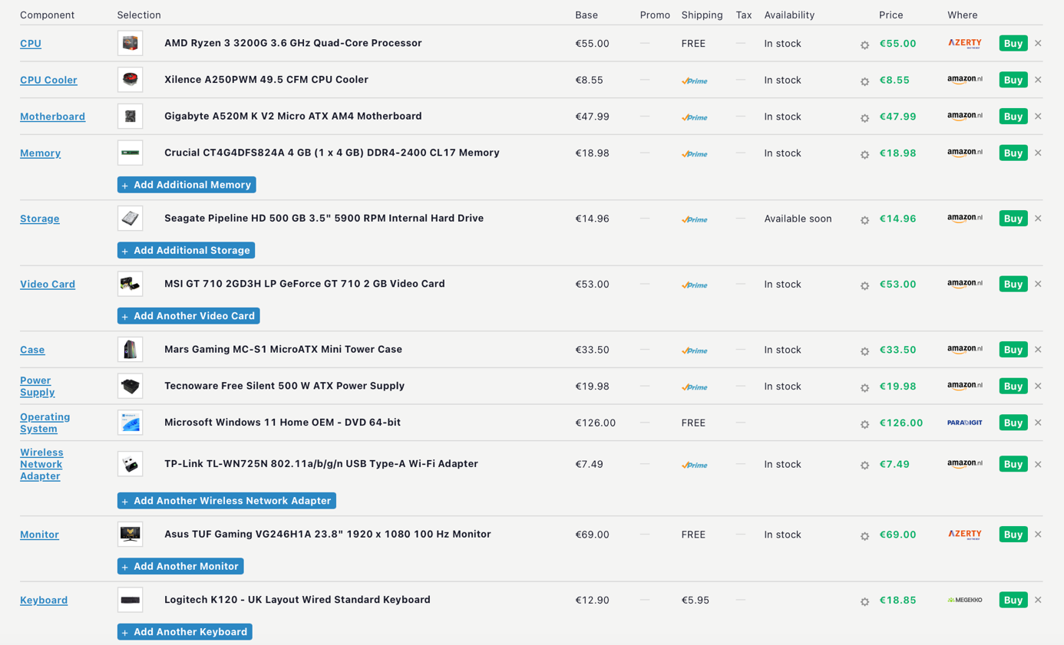
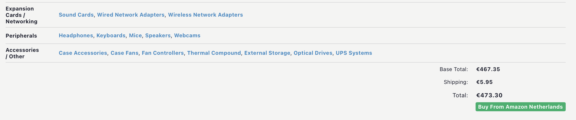
Motivation:
I selected these components due to the low cost and remaining functionality. This computer can be utilized for study work, internet browsing, video viewing, and casual games. The objective is to prove that it is possible to make a functional computer with a very limited budget.
Comparison with my current laptop:
My personal laptop is a MacBook. My laptop has an Apple M2 chip that it's much faster and more power-efficient than this PC. The PC is more affordable to upgrade, while on the other hand, my laptop is more portable, quiet, and easier to use.
Assignment 3.5: Adders
Complete the half adder, full adder and 4-bit adder assignment as described in the PowerPoint slides of week 3 in Logisim. Save the chip design and also export three PNG pictures of the separate finished designs. See the PowerPoint slides of week 3.
Paste the three exported PNG pictures in here.
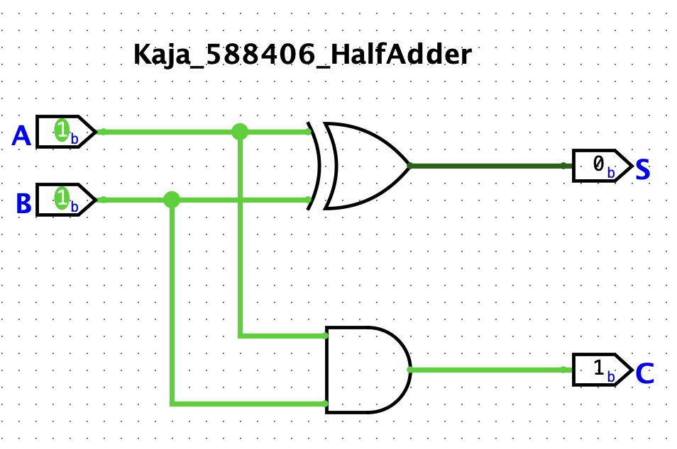



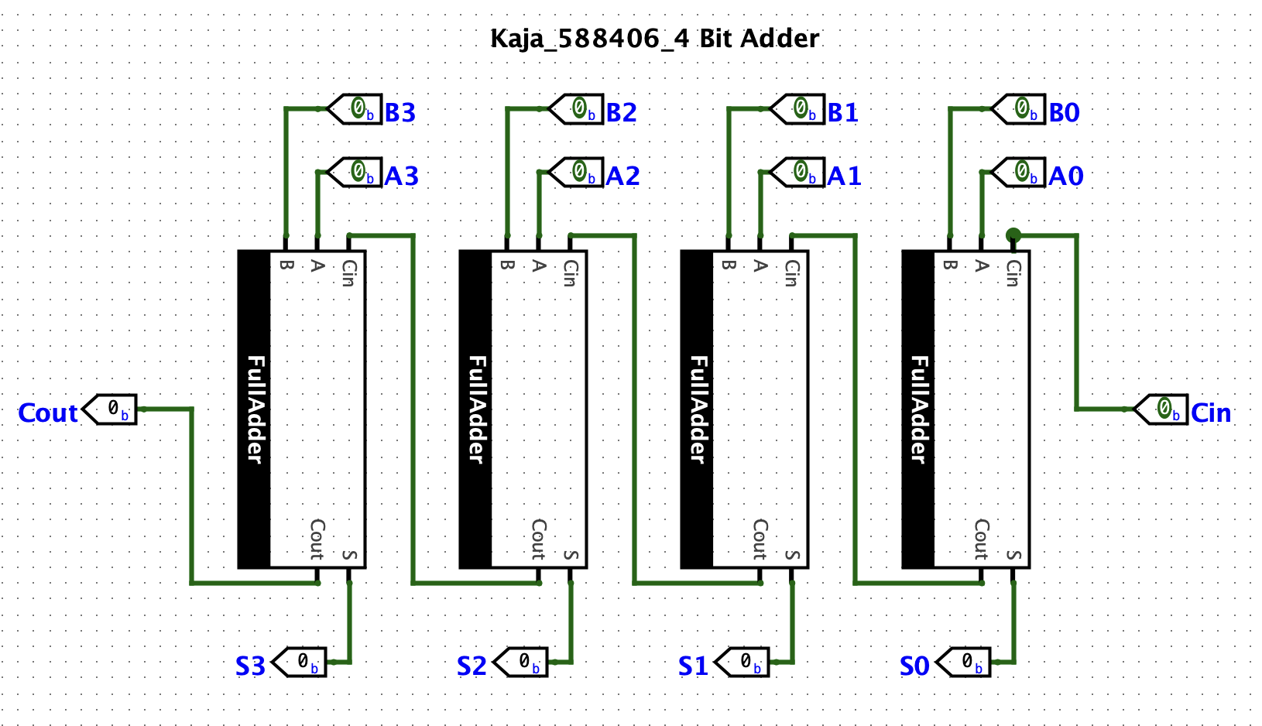
Ready? Save this file and export it as a pdf file with the name: week3.pdf

