**Practical 3:Demonstrate to INSERT ,UPDATE,and DELETE Records in Table**

**Name: vinayak khushal borse Roll No: 24 DATE:10/2/24**

**Div: A Batch : B1**

select * from employee;

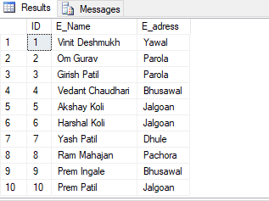

update employee set E_Name='Prem' where ID='3';

update employee set E_adress='Bhusawal' where ID='6';

**OUTPUT**:

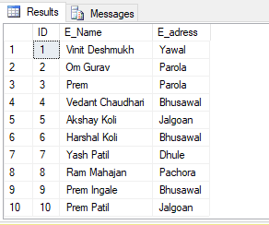

delete employee where ID='4';

delete employee where ID='7';

delete employee where ID='2';

delete employee where ID='9';

**OUTPUT:**

