**Roll No:142**

**Name:Ashwini manohar supe.**

**Pratical No:142**

**Title: Use git pull to get your partners change into your repository.**

**------------------------------------------------------------------------------------------------------------**

comp@comp143 MINGW64 ~ (master)

$ git clone https://github.com/ashusupe/home.git

Cloning into 'home'...

remote: Enumerating objects: 6, done.

remote: Counting objects: 100% (6/6), done.

remote: Compressing objects: 100% (3/3), done.

remote: Total 6 (delta 0), reused 3 (delta 0), pack-reused 0

Receiving objects: 100% (6/6), done.

comp@comp143 MINGW64 ~ (master)

$ cd home

comp@comp143 MINGW64 ~/home (main)

$ git pull https://github.com/ashusupe/home.git

remote: Enumerating objects: 4, done.

remote: Counting objects: 100% (4/4), done.

remote: Compressing objects: 100% (2/2), done.

remote: Total 3 (delta 1), reused 0 (delta 0), pack-reused 0

Unpacking objects: 100% (3/3), 950 bytes | 50.00 KiB/s, done.

From https://github.com/ashusupe/home

* branch HEAD -> FETCH_HEAD

Updating 7f073d3..99dab5c

Fast-forward

masterfile.txt | 1 +

1 file changed, 1 insertion(+)

create mode 100644 masterfile.txt

comp@comp143 MINGW64 ~/home (main)

$ git pull https://github.com/ashusupe/home.git

remote: Enumerating objects: 5, done.

remote: Counting objects: 100% (5/5), done.

remote: Compressing objects: 100% (3/3), done.

remote: Total 4 (delta 1), reused 0 (delta 0), pack-reused 0

Unpacking objects: 100% (4/4), 1.80 KiB | 102.00 KiB/s, done.

From https://github.com/ashusupe/home

* branch HEAD -> FETCH_HEAD

Updating 99dab5c..8f3c7c4

Fast-forward

newbrachfile.txt | 1 +

1 file changed, 1 insertion(+)

create mode 100644 newbrachfile.txt

* Before full

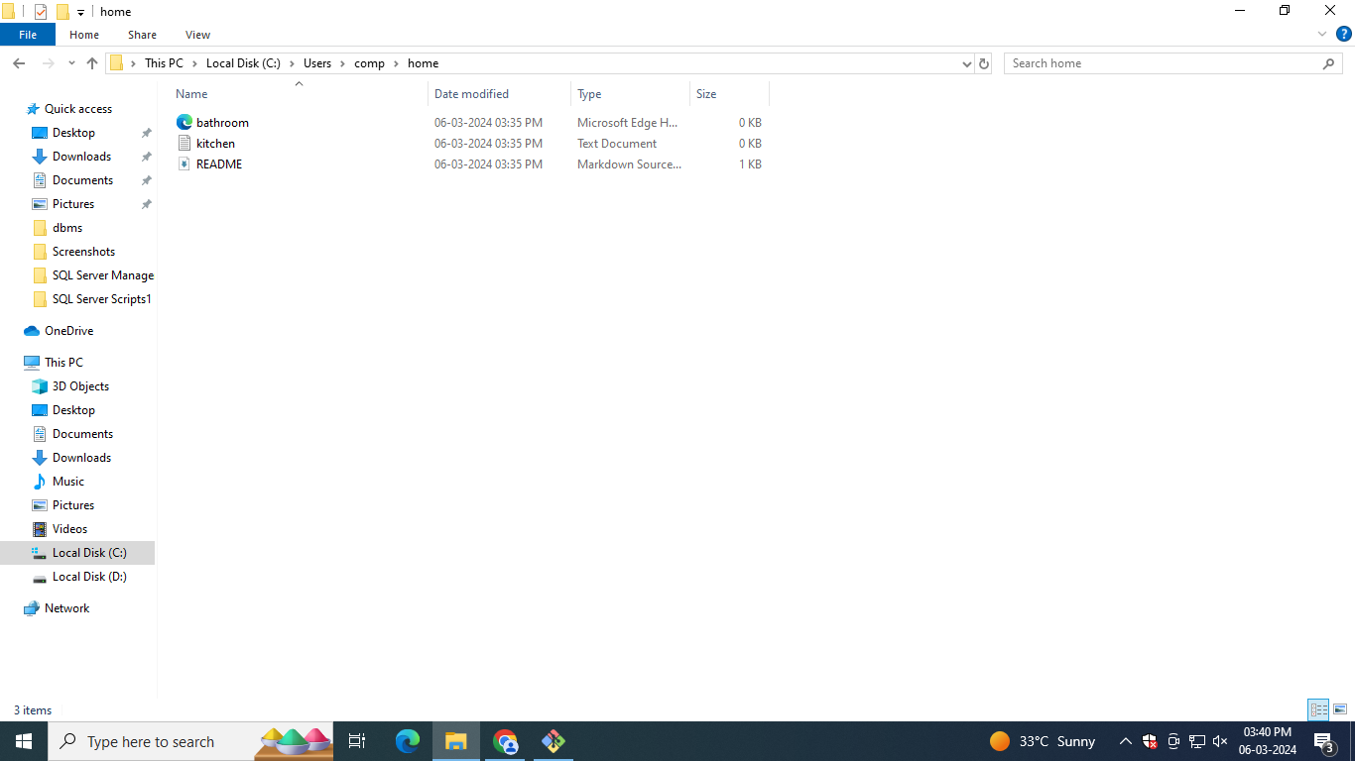

* After full

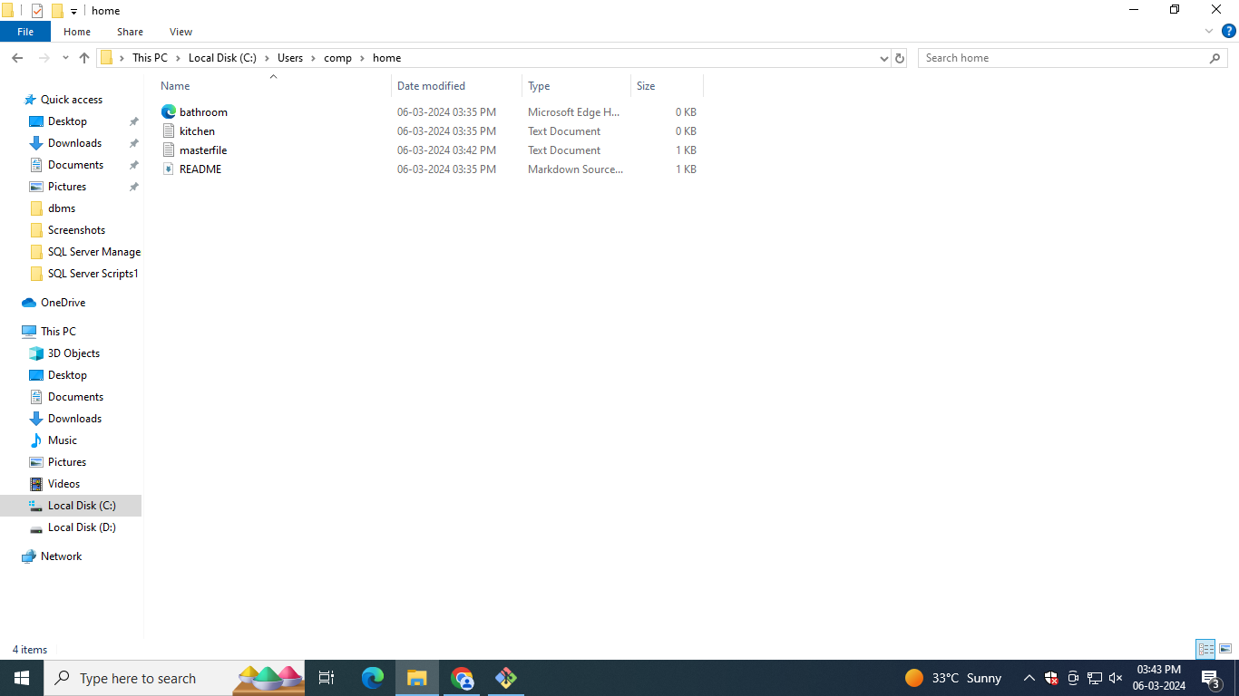

* Before Pull and merge on remote repository

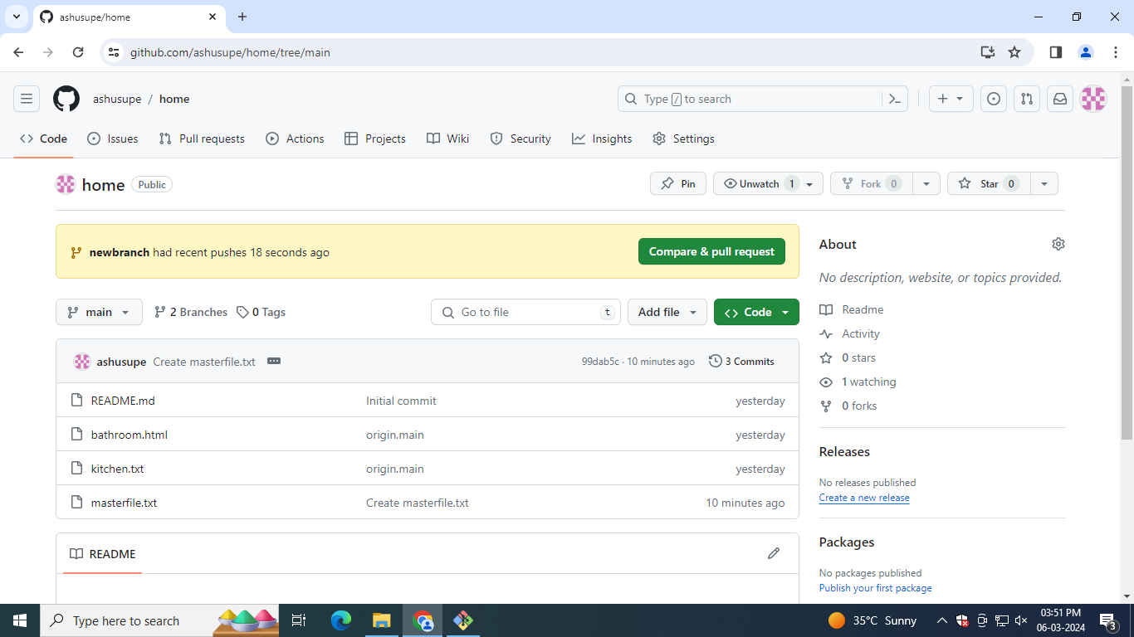

* Performing full request

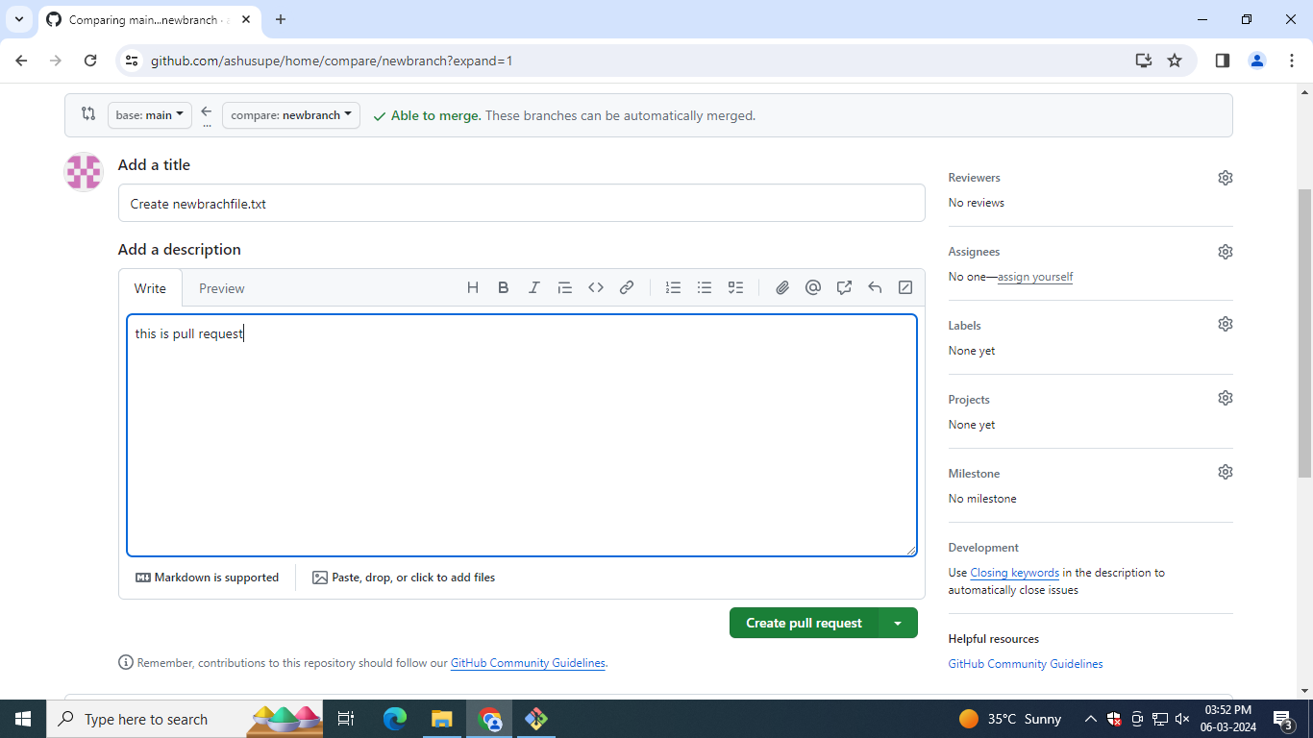

* After full performing merge on remote repository at primary branch(master):

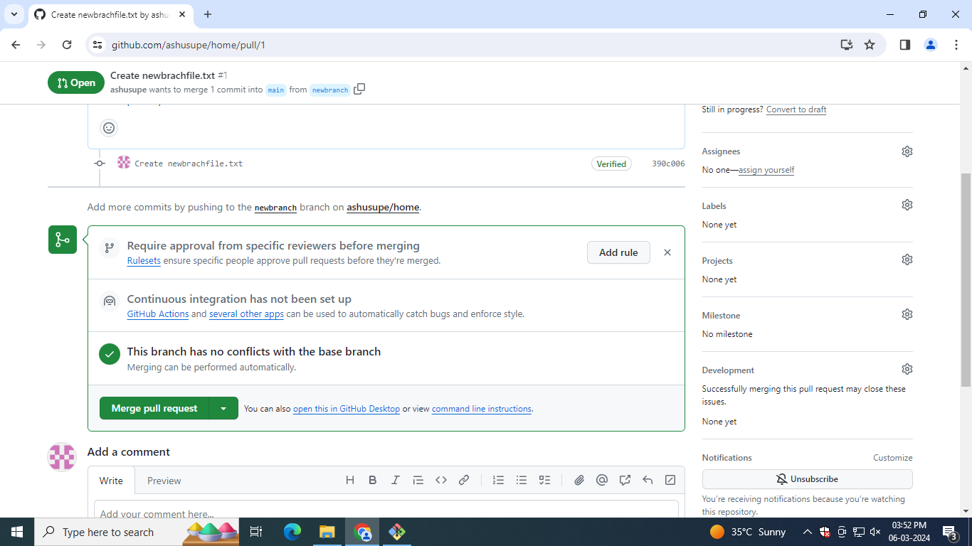

* After merge from branch 2 primary (main) on remote repository

