**Module (JAVASCRIPT BASIC & DOM) – 4**

1. What is JavaScript?

Ans. JavaScript is a computer programming language used to make websites and applications dynamic and interactive. It’s unique because it can run directly in your browser, not just on a server. JavaScript is the electrical and plumbing systems. JS brings dynamism and interactivity to the website. For example, pop-ups, animations, video and social media embeds, drop-down menus, and many other website components are created using JavaScript.

2. What is the use of isNaN function?

Ans. The JavaScript **isNaN()**Function is used to check whether a given value is an illegal number or not. It returns true if the value is a NaN(Not-a-Number)else returns false.

3. What is negative Infinity?

Ans. NEGATIVE_INFINITY is a special numeric value that is returned when an arithmetic operation or mathematical function generates a negative value greater than the largest representable number in JavaScript (more negative than -Number. MAX_VALUE). JavaScript displays the NEGATIVE_INFINITY value as -Infinity.

4. Which company developed JavaScript?

Ans. Javascript was developed by Netscape communication corporation with Brendan Eich being the original creator. It was first realised in 1995.

5. What are undeclared and undefined variables?

**Undeclared variables:**It occurs when we try to access any variable that is not initialized or declared earlier using the *var* or *const keyword*. If we use *typeof* operator to get the value of an undeclared variable, we will face the *runtime error* with the return value as **undefined**. The scope of the undeclared variables is always global.

**Undefined variables:**It occurs when a variable has been declared but has not been assigned any value. Undefined is not a keyword.

6. Write the code for adding new elements dynamically?

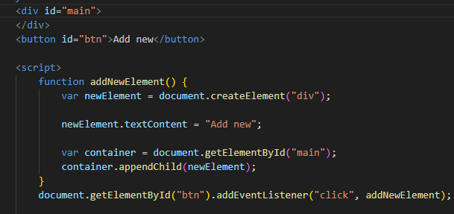

7. What is the difference between ViewState and SessionState?

ViewState is used for retaining the state of controls on a single web page across postbacks, while SessionState is used for storing data across multiple requests from the same user within a web application session.

8. What is === operator?

Ans. The === operator is a Comparison operator. It is used to compare two values for equality. It checks both the value and the type of the operands. It returns true if both the value and the type of the operands are the same. If they are different in either value or type, it returns false.

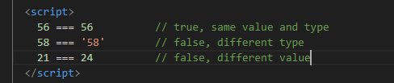

9. How can the style/class of an element be changed?

Ans. You can change the style or class of an HTML element using JavaScript. Here's how you can do it:

Changing Style: We can directly manipulate the style of an element using its style property. This property allows you to access and modify individual CSS properties of the element.

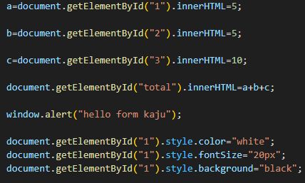

10. How to read and write a file using JavaScript?

Ans. readFile() and rs. writeFile() methods are used to read and write of a file using javascript. The file is read using the fs. readFile() function, which is an inbuilt method.

11. What are all the looping structures in JavaScript?

Ans. JavaScript provides several looping structures for iterating over arrays, objects, or executing a block of code repeatedly. Here are the main looping structures:

for loop: A basic loop that iterates over a block of code a specified number of times.

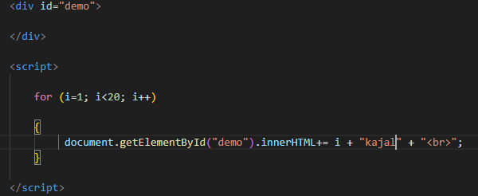

while loop: Executes a block of code as long as a specified condition is true.

do...while loop: Similar to a while loop, but the code block is executed at least once, even if the condition is false.

12. How can you convert the string of any base to an integer in JavaScript?

Ans. To convert a string from any base to an integer in JavaScript, you can use the “parseInt” function. This function takes two arguments: the string you want to convert and the base (or radix) of that string.

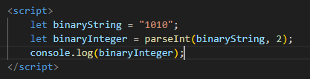

13. What is the function of the delete operator?

Ans. The  delete operator in JavaScript is used to delete an object’s property.

If it is used to delete an object property that already exists, it returns true and removes the property from the object. However, deleting an object property that doesn’t exist will not affect the object, but will still return true.

The only time false will be returned is when the delete operator is used to delete a variable or a function.

**Syntax**

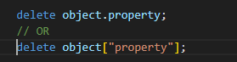

14. What are all the types of Pop up boxes available in JavaScript?

Ans. JavaScript has three kind of popup boxes

* Alert box

This is the simplest type of popup box, and it is used to display a message to the user. The user can only click OK to close the box.



* Confirm box

This type of popup box is used to ask the user a question and get their confirmation. The user can click OK or Cancel to close the box.

* Prompt box

This type of popup box is used to ask the user for input. The user can enter text into the box and click OK to submit it.

15. What is the use of Void (0)?

Ans. The **void** keyword in JavaScript is an operator that evaluates the expression that follows it and then returns **undefined**. When used with the expression **void(0)**, it essentially means "execute nothing and return **undefined**". This construct is often used in the context of HTML anchor tags (**<a>** elements) to create "empty" or non-navigating links.



16. How can a page be forced to load another page in JavaScript?

Ans. In [JavaScript](https://www.geeksforgeeks.org/introduction-to-javascript/), you can force a page to load another page by using the window.location object. There are a few methods to achieve this. To force a page to load another page in JavaScript

Using window.location.replace

The **replace** function is used to navigate to a new URL without adding a new record to the history.

window.location.replace(<https://www.nextpage.com>);

## Using **[window.location.assign Property](https://www.geeksforgeeks.org/html-location-assign-method/)**

* The **assign** function is similar to the href property as it is also used to navigate to a new URL.
* The assign method, however, does not show the current location, it is only used to go to a new location.
* Unlike the replace method, the assign method adds a new record to history (so that when the user clicks the “Back” button, he/she can return to the current page).
* window.location.assign(<https://www.nextpage.com>/”);

17. What are the disadvantages of using innerHTML in JavaScript?

Ans. Inner HTML is slow because when we use the inner HTML property in the code it allows us to change using the JavaScript language. It is very slow because as inner HTML already parses the content even we have to parse the content again so that’s why it takes time.

When we have used the event handlers then the event handlers are not automatically attached to the new elements created by innerHTML. To change that, we have to track the event handlers and manually attach them to a new element.

It means that first, we have to fetch the element property through innerHTML, and then we have to attach them to a new element.