**Module (Bootstrap Basic & Advanced) – 6**

1. What are the advantages of Bootstrap?

Ans. Bootstrap is very easy and quite simple to use for designing and development.

* Responsive design - The built-in grid system ensures websites adapt seamlessly to diverse screen sizes and devices.
* Speedy Development - Bootstrap’s ready-made components accelerate development, enabling faster project completion.
* Customizable – It helps to fit the specific design needs.
* JavaScript Components - It provides a variety of JavaScript components, such as modals, tooltips, carousels, and accordions, which enhance the functionality of web pages without the need for extensive coding.
* Consistency – It maintains a uniform design across the project.

1. What is a Bootstrap Container, and how does it work?

Ans. The **container class** is used to create boxed content.

Container is used to set the content's margins dealing with the responsive behaviors of your layout. It contains the row elements and the row elements are the container of columns

There are two container classes in Bootstrap:

* Container
* container-fluid



1. What are the default Bootstrap text settings?

Ans. Bootstrap 5 uses a default font-size of 1rem (16px by default), and its line-height is 1.5. In addition, all <p> elements have margin-top: 0 and margin-bottom: 1rem (16px by default).

1. What do you know about the Bootstrap Grid System?

Ans. The Bootstrap Grid System is a powerful tool for creating responsive, flexible, and well-structured web layouts.

The grid system is based on a 12-column layout, allowing for a wide range of combinations for creating complex layouts. The basic structure involves rows (<div class="row">) and columns (<div class="col">). Rows are used to create horizontal groups of columns.

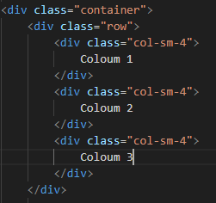

1. What is the difference between Bootstrap 4 and Bootstrap 5

Ans. BOOTSTRAP 4

* Dependent on jQuery for some functionalities
* Bootstrap 4 has less collection of colors.
* Mobile responsiveness is good but not the primary focus.
* Limited utility classes for spacing, etc.
* We cannot modify utilities in bootstrap 4

BOOTSTRAP 5

* Removed jQuery dependency
* Has vibrant and more colors available.
* Prioritizes mobile-first design, ensuring optimal layout and functionality on smaller screens.
* Expanded utility classes for better control
* Bootstrap 5 gave freedom to modify and also create our own utility

1. What is a Button Group, and what is the class for a basic Button Group?

Ans. A Button Group is a component in Bootstrap that groups a series of button and allowing them to be visually connected and organized. This component is useful for presenting related actions or options in a cohesive manner. The class for a basic Button Group is ‘’.btn-group’’.

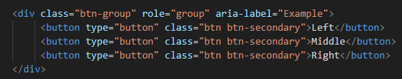

1. How can you use Bootstrap to make thumbnails?

Ans.

* *.*humbnailclass is used to show linked images in grids ([grid system](https://www.geeksforgeeks.org/bootstrap-4-grid-system/)), a thumbnail is created using class *.* thumbnail *l* within the element [<a>](https://www.geeksforgeeks.org/html-a-tag/#:~:text=HTML%20Tag,-Difficulty%20Level%20%3A%20Basic&text=The%20tag%20(anchor,as%20its%20%E2%80%9Chref%E2%80%9D%20value.).
* Add “col-sm-6” and “col-md-3” to four div sections which creates webpage responsive.

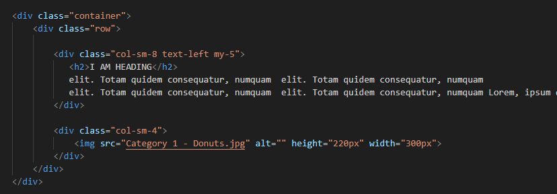

1. In Bootstrap 4, what is flexbox?

Ans. In Bootstrap 4, flex box is used to control the layout and alignment specification of Bootstrap 4 components. This box makes it easier to design flexible responsive layout structures without using float or positioning attributes.

1. How can one create an alert in Bootstrap?

Ans. These alert messages are highlighted text that should be taken into account when executing a task. Using preset classes in Bootstrap, these alert messages can be displayed on the website.

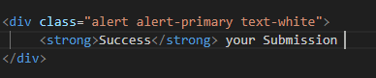

1. What is a bootstrap card and how would you create one?

Ans A Bootstrap card is flexible and extensible content container. It’s a versatile component used for displaying various types of content, such as images, text, links, buttons and more in a structured and visually appealing manner.

