An Internship Report
Of
Product Engineering

Submitted
To
School of Computer Science and Engineering
IILM University, Greater Noida, U.P.

In partial fulfilment of the requirement for the degree of
B. Tech (CSE)

By
Roll Number of Student: 2410031725
Name of Student: KAJAL KIRAN
Batch: 2024-28
Internship Completion Certificate

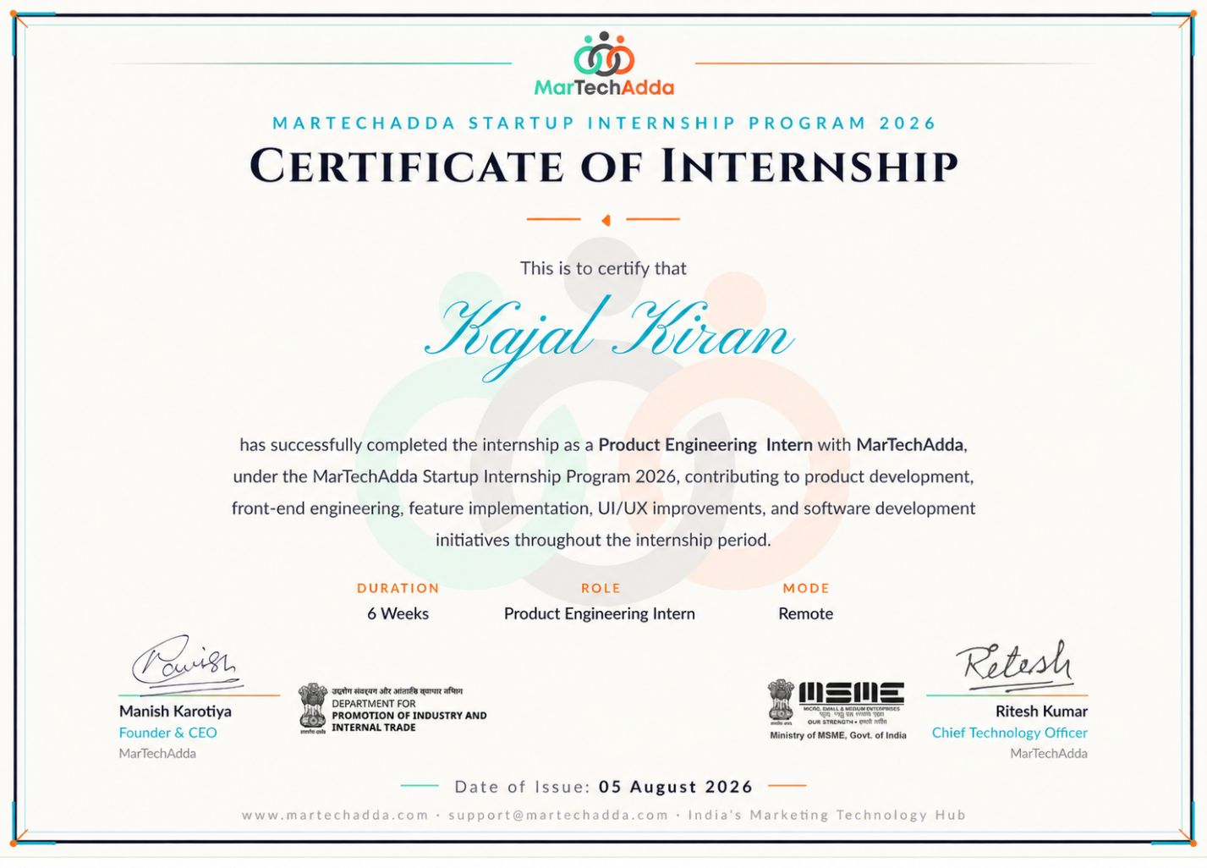

CANDIDATE'S DECLARATION

I, Kajal Kiran , hereby declare that this internship report titled “Product Engineering” is entirely my own work, completed in fulfilment of the requirements for the degree of Bachelor of Technology in Computer Science and Engineering. Wherever I have used material from other sources, I have given proper credit, and I have not presented anyone else's work as my own. This report has not been submitted, in part or in full, to any other institute for any other degree or diploma, and I take complete responsibility for any copyright issue that may arise in connection with it.

Student Name: Kajal Kiran
Roll No.: 2410031725

ACKNOWLEDGEMENT

Completing this internship would not have been possible without the help and encouragement of a number of people, and I would like to use this space to thank them.
I am especially grateful to MarTechAdda Pvt. Ltd. for giving me the opportunity to work in a real, structured product-development environment and gain hands-on experience in Product Engineering, supported along the way by AI-assisted UI tools that made a lot of the day-to-day work easier. I would also like to thank IILM University, Greater Noida, and the faculty of the School of Computer Science and Engineering, for their continued support and encouragement throughout this internship.
Finally, I want to thank my parents for their blessings and constant support.

Student Name: Kajal Kiran
Roll No.: 2410031725

ABSTRACT

The internship at MarTechAdda Pvt. Ltd. provided an opportunity to gain practical exposure to the field of Product Engineering and understand how software products are planned, developed, improved, and delivered in a real-world environment. The internship was completed as part of the MarTechAdda Startup Internship Program 2026 for a duration of six weeks in remote mode.
During the internship, I gained hands-on experience in different aspects of product development, including front-end engineering, feature implementation, UI/UX improvements, software development, and the use of AI-assisted tools. The internship provided an understanding of how technical development is connected with product requirements and user needs.
The work carried out during the internship helped in developing practical problem-solving skills and understanding the software development process beyond academic learning. It also provided exposure to working in a structured development environment, implementing features, improving user interfaces, and using modern tools to make development workflows more efficient.
Overall, the internship helped bridge the gap between theoretical knowledge and practical application. It enhanced my technical understanding, development skills, teamwork, and ability to approach software product development in a systematic manner. The experience gained during this internship will serve as a valuable foundation for further learning and professional growth in the field of Product Engineering and Software Development.

TABLE OF CONTENTS

1 Internship Completion Certificate 2
2 Candidate's Declaration 3
3 Acknowledgement 4
4 Abstract 5
5.1 Introduction 7
5.2 Organization Profile 7
5.3 Problem Statement 7
5.4 Project Objectives 8
5.5 Scope of the Project 8
5.6 Technologies and Tools Used 9
5.7 System Architecture 9
5.8 Methodology 10-11
5.9 Expected Outcomes 12
6 Bibliography/References 13

5 Project Description

5.1 Introduction
This report covers the work I did during my Product Engineering internship at MarTechAdda, completed as part of my B.Tech programme in Computer Science and Engineering. During the internship, I worked on a Customer Relationship Management (CRM) platform and contributed to different tasks related to its development and improvement.
During the internship, I gained practical exposure to product development by working with the existing application, understanding its features, making required changes, and testing the implemented functionality. The experience helped me understand how development work is carried out in a team and how different features are integrated into an existing product.

My main project involved working on the CRM's Finance module, which was designed to provide structured visibility into transactions, revenue, refunds, and payouts.

5.2 Organization Profile
MarTechAdda is a technology and product company that builds software for client engagement, financial workflows, CRM operations, and other related business processes.
During the internship, I worked within a product-development team and followed collaborative development practices used across the organisation. This involved working with other team members on CRM development, financial modules, and general application improvements.
My internship was supervised by Ritesh Kumar, who guided me throughout the internship period.

5.3 Problem Statement
As MarTechAdda's client base and product requirements kept growing, it became clear that financial operations such as transaction tracking, revenue management, refunds, and payouts needed a more structured and auditable approach.
Before this work was taken up, the CRM did not present financial information through a single unified workflow, which left gaps in visibility around transaction status, refunds, and payouts. Refunds specifically needed a clearly defined lifecycle so that every stage of a refund request could be tracked in a consistent, systematic way rather than handled case by case.
This is essentially what the internship focused on — building and improving software modules that could offer structured financial workflows and better data visibility.

5.4 Project Objectives
The main objectives of the internship were:
- Gain practical, hands-on experience in product-oriented software engineering.
- Build stronger working knowledge of React.js, TypeScript and Tailwind CSS.
- Learn to design and implement frontend interfaces for real-world business applications.
- Contribute to the development of the CRM's Finance module.
- Build interfaces for managing transactions, revenue, refunds, and payouts.
- Design a refund lifecycle that is structured and easy to audit.
- Develop interfaces for client management and financial information.
- Use Git and GitHub effectively as part of a collaborative development process.
- Gain practical experience in debugging, testing, and improving frontend features.

5.5 Scope of the Project
The internship covered several different areas of product engineering, described below.

CRM Finance Module
The CRM Finance module I was exposed to during the internship included the following pieces:
- Transaction Dashboard
- Revenue Dashboard
- Refund Tracking
- Payout Tracking
- Cash-flow and expenditure tracking
- Customer credit tracking
- Refund lifecycle management
The Refund Tracking module followed a defined lifecycle:
Requested → Under Review → Approved → Processing → Completed
with a separate Rejected branch for refund requests that did not move forward.

5.6 Technologies and Tools Used
Here are the main technologies and tools I used during the internship:

Frontend Development
- React.js
- TypeScript
- Tailwind CSS
- HTML/CSS principles
- Responsive UI development

Development and Collaboration
- Git
- GitHub
- Debugging and integration workflows

Development Assistance
- LLM-based development tools, used for code generation, debugging, refactoring, and general development assistance.

5.7 System Architecture

The project I worked on during the internship followed a layered, product-development style architecture, described below.

Presentation Layer
The frontend was built using React.js and TypeScript, with Tailwind CSS used to create responsive, reusable user interfaces.

Application Layer
This layer handled the core business workflows, including:
- Transactions
- Revenue
- Refunds
- Payouts
- Client management

Version Control Layer
Git and GitHub were used for version tracking and collaborative development.

5.8 Methodology
The internship was structured as a six-week learning and development experience, providing practical exposure to product development and CRM-based applications.
Week | Module | Description
1 | Development Foundations | Learning Git/GitHub workflows, repository structure, branch management, pull requests, and getting familiar with the overall development process.
2 | Frontend Development | Strengthening knowledge of React.js, TypeScript, and Tailwind CSS while working on frontend interfaces.
3 | UI Development | Working on responsive user interfaces and improving the design and usability of application pages.
4 | CRM Finance Module | Working with the Transaction, Revenue, Refund, and Payout screens and understanding the refund workflow.
5 | CRM Development | Working on CRM-related features, making required interface changes, and understanding how different features work together.
6 | Testing and Improvement | Testing implemented features, debugging issues, making required improvements, and gaining practical experience with the development workflow..

Week 1–2: Learning Phase
The first two weeks were mainly about strengthening the basics and getting used to a consistent development workflow.
I used Git and GitHub to understand repository organisation and how collaborative development works. Alongside this, I strengthened my understanding of React.js, TypeScript, and Tailwind CSS through practical frontend work.I also started using LLM-based tools during this phase as development assistance — mainly for code generation, debugging, refactoring, and understanding different implementation approaches.

Week 3: UI Development
The third week focused on developing responsive frontend interfaces and improving the design and usability of application pages.
During this phase, I worked on frontend components and practiced creating clean, responsive interfaces using React.js, TypeScript, and Tailwind CSS.

Week 4: CRM Finance Module
The fourth week focused on the CRM Finance module and its main features.
I worked with the following screens:
- Transaction Dashboard
- Revenue Dashboard
- Refund Tracking
- Payout Tracking
I gained practical exposure to the Transaction Dashboard, including information related to cash flow, expenditures, and customer credit.
The Refund Tracking system followed the following lifecycle:
Requested → Under Review → Approved → Processing → Completed
with a Rejected branch for refund requests that did not move forward. This provided a structured workflow for tracking refund requests.

Week 5: CRM Development
The fifth week focused on working with CRM-related features and understanding how different parts of the application worked together.
During this phase, I worked on required interface changes, tested the implemented features, and made improvements based on the project requirements.
I also gained practical experience in debugging issues and understanding the development workflow used by the team.

Week 6 Testing and Improvement
The final week focused on testing the implemented features and making required improvements based on the project requirements.
I worked on identifying and debugging issues in the frontend interfaces and checked whether the implemented features were working as expected.
This phase helped me gain practical experience in testing, debugging, and improving the overall usability of the application.

5.9 Expected Outcomes
By the end of the internship, I was able to gain practical experience in:
- Product-oriented software development.
- React.js and TypeScript development.
- Responsive user-interface development.
- CRM financial workflow development.
- Transaction and revenue management.
- Refund lifecycle implementation.
- Payout tracking.
- Client management and financial information.
- Git/GitHub-based collaborative development.
- Debugging and improving frontend features.
- Testing implemented features and improving application usability.
Overall, this internship gave me practical exposure to software product development and helped me understand how frontend features are designed, implemented, tested, and improved as part of a CRM-based application.

6. Bibliography / References
- React Documentation — React.js documentation and core development concepts.
- TypeScript Documentation — TypeScript language reference.
- Tailwind CSS Documentation — Utility-first CSS framework.
- HTML and CSS Documentation — Basic concepts for creating and styling web interfaces.
- Git Documentation — Version control and Git workflows.
- GitHub Documentation — Repository management and collaborative development.

