Problem :Count Divisors
Problem link: https://www.hackerearth.com/practice/basic-programming/input-output/basics-of-input-output/practice-problems/algorithm/count-divisors
C source code:
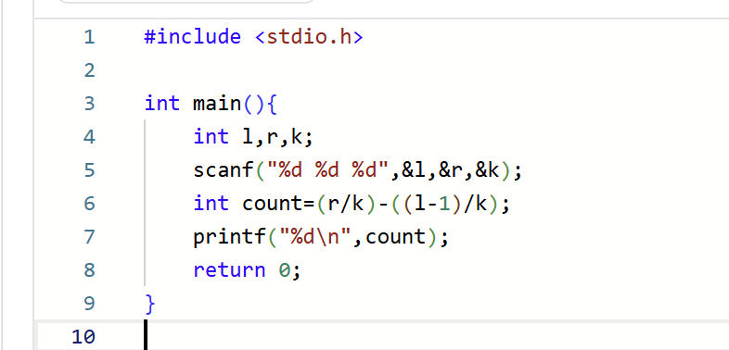
Screenshot of successful submission:


