Problem: Digit Sum
Problem link: https://www.hackerearth.com/problem/algorithm/digit-sum-4
C source code:
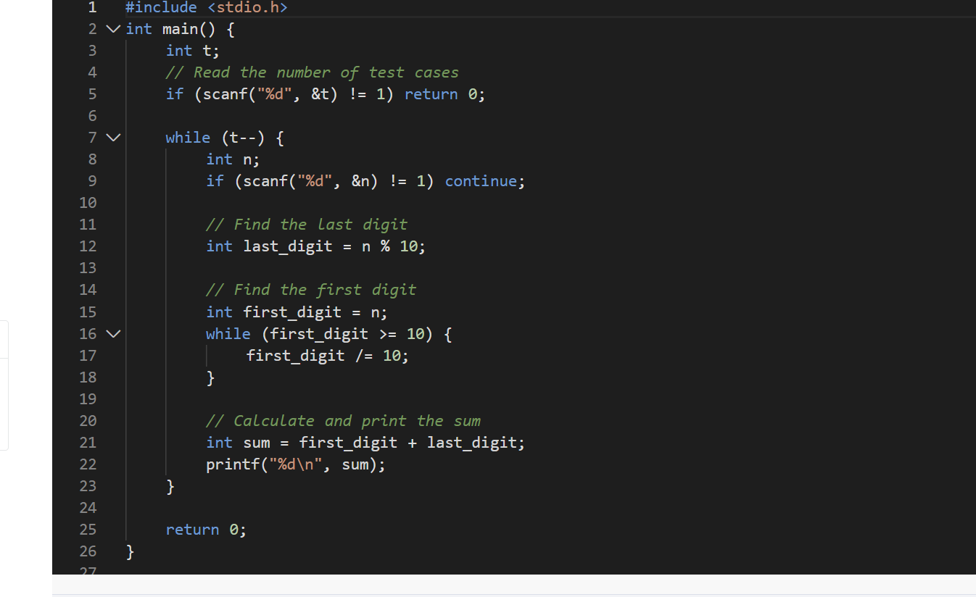
Screenshot of successful submission:


