Problem :Factorial!
Problem link: Factorial! | Basics of Input/Output & Basic Programming Practice Problems
C source code:
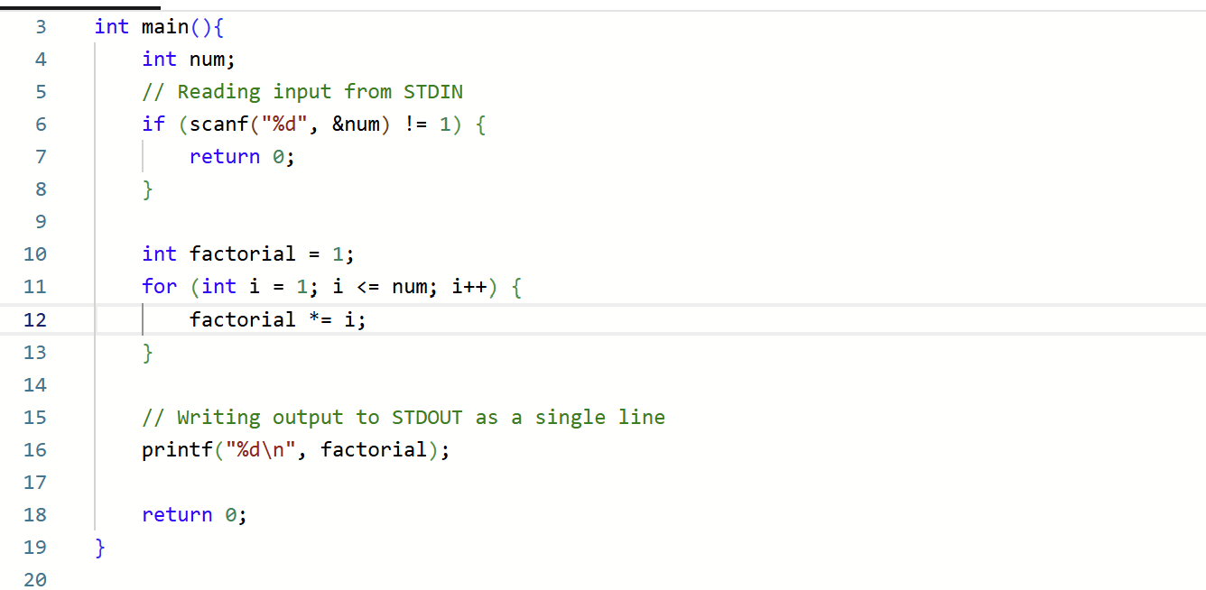
Screenshot of successful submission:


