Problem: Prime Numbers
Problem link: https://www.hackerearth.com/problem/algorithm/prime-numbers
C source code:
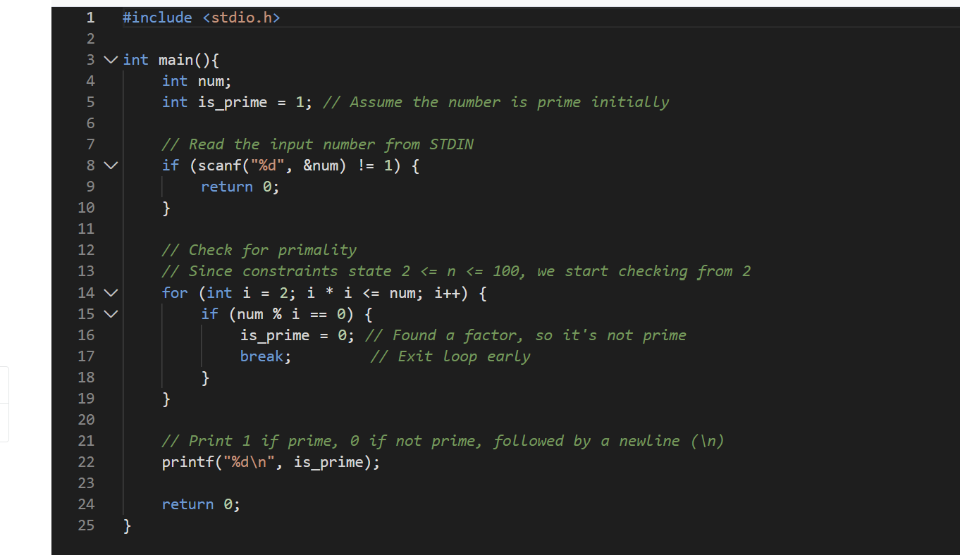
Screenshot of successful submission:


