Problem: Read from STDIN, Write to STDOUT
Problem Link: https://www.hackerearth.com/practice/basic-programming/input-output/basics-of-input-output/practice-problems/algorithm/io-exercise/
C Source Code:
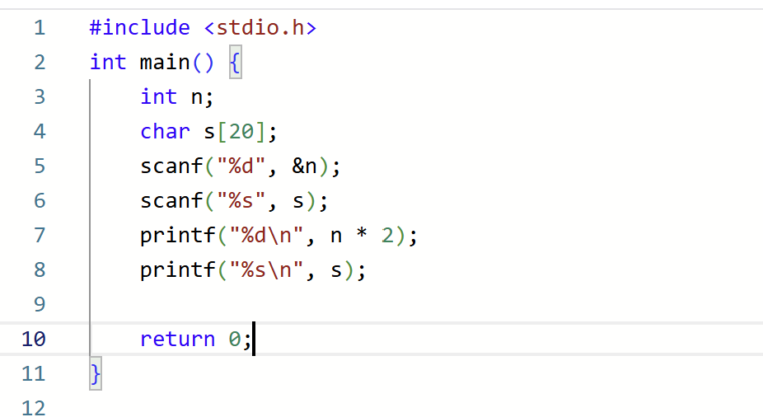
Screenshot Of Successful Submission:


