Problem :Roy and Profile Picture
Problem Link: Roy and Profile Picture | Basics of Input/Output & Basic Programming Practice Problems
C source Code:
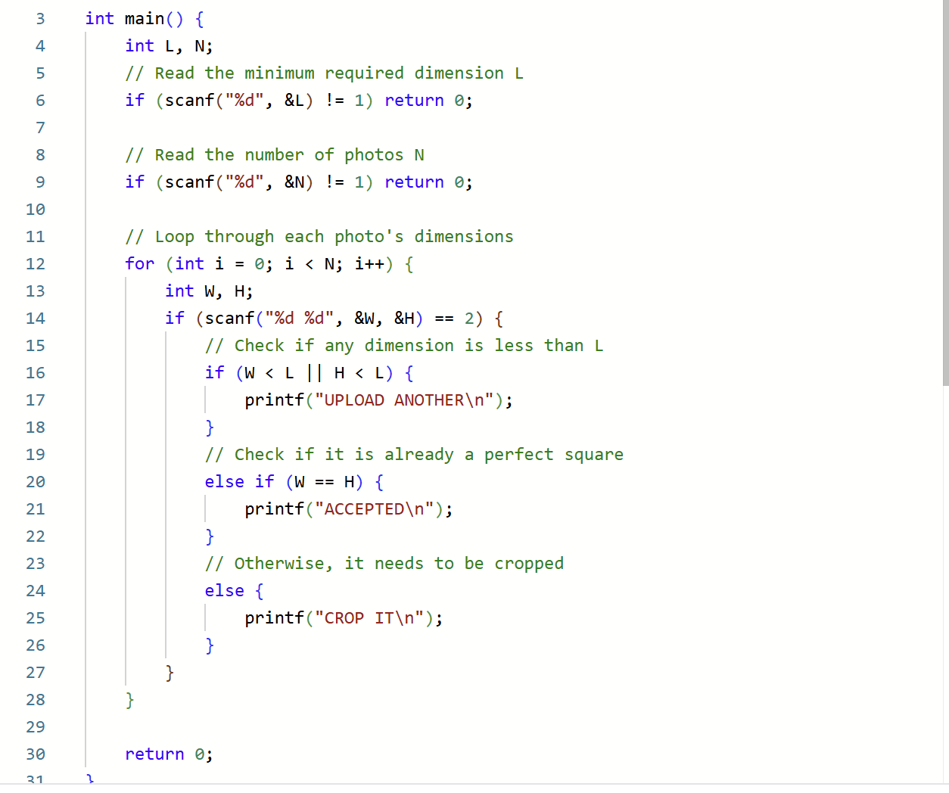
Screenshot of successful submission:


