Problem : Conditional Statements in C
Problem link : https://www.hackerrank.com/challenges/conditional-statements-in-c/problem?isFullScreen=false
C Source Code:
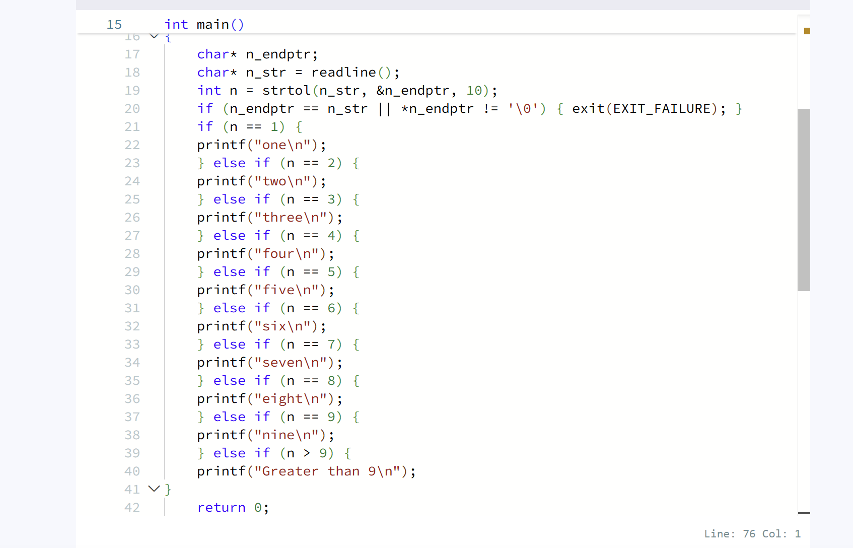
Screenshot of successful submission:


