Problem: Find digits
Problem link: https://www.hackerrank.com/challenges/find-digits
C source Code:
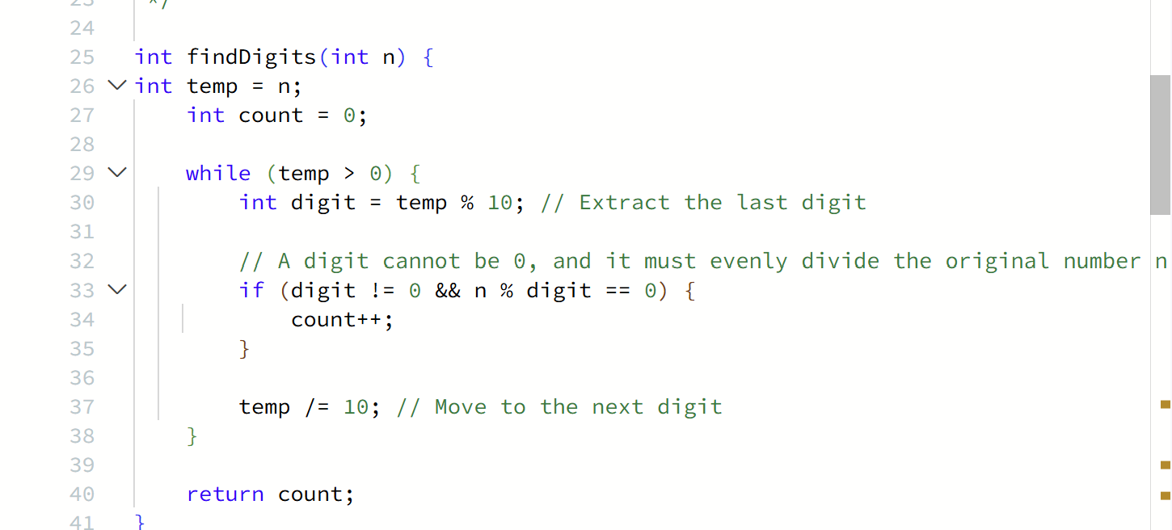
Screenshot of successful submission:


