Problem: FizzBuzz
Problem link: FizzBuzz | HackerRank
C source code: 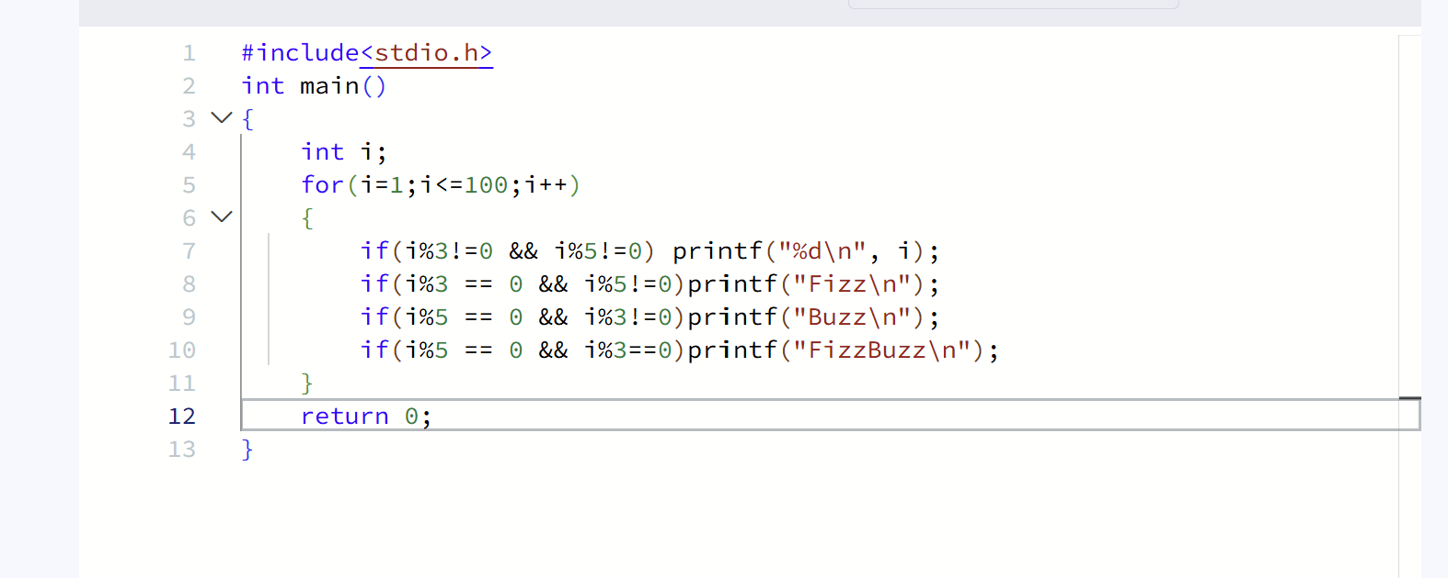

Screenshot of successful submission:


