Problem :For Loop in C
Problem link: https://www.hackerrank.com/challenges/for-loop-in-c/
C source code: 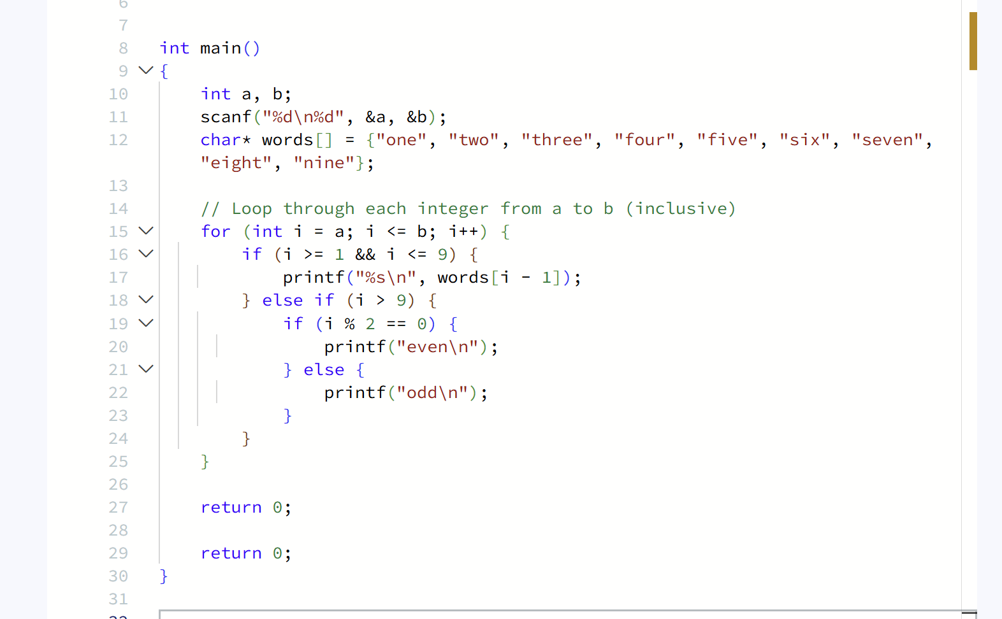

Screenshot of successful submission:


