Problem :Grading Students
Problem link: Grading Students | HackerRank
C source Code: 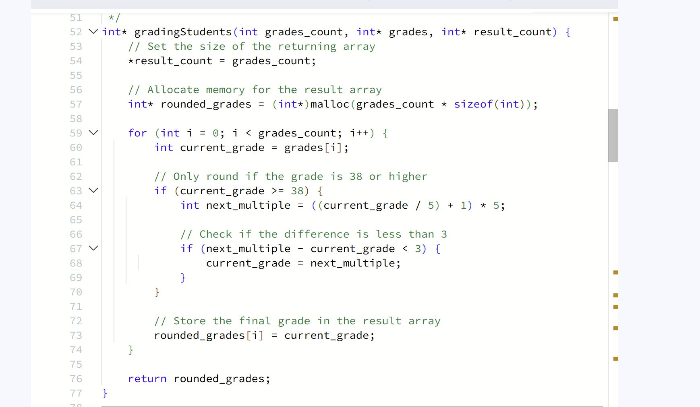

Screenshot of successful submission:


