Problem: Number line jumps
Problem link: Number Line Jumps | HackerRank
C source code: 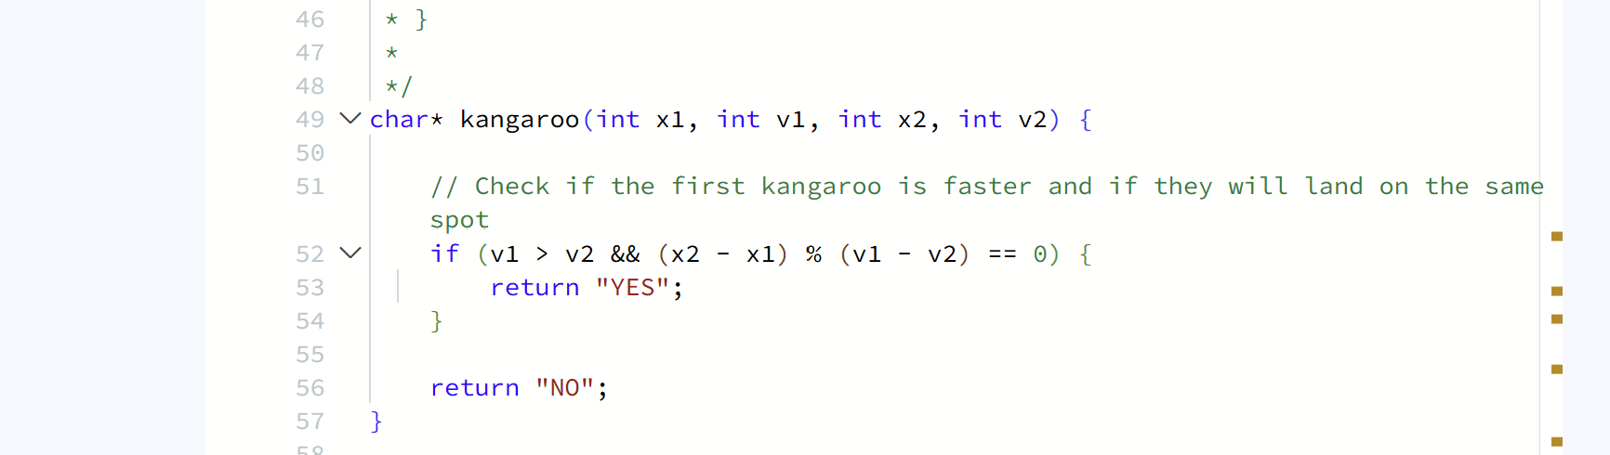
Screenshot of successful submission:


