Problem : Printing Pattern Using Loops
Problem link: https://www.hackerrank.com/challenges/printing-pattern-2/problem
C Source Code:
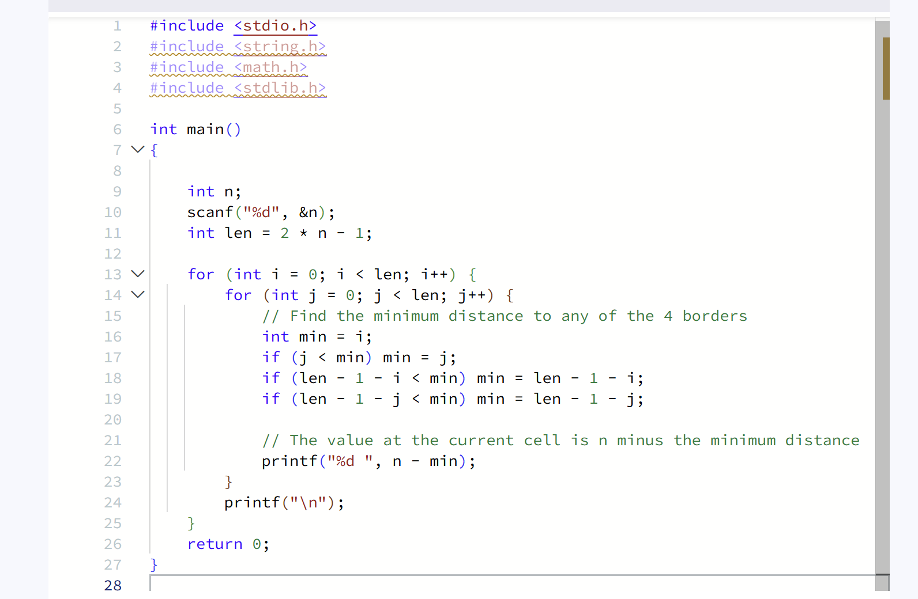
Screenshot of Successful Submission:


