Problem : Solve Me First
Problem Link: https://www.hackerrank.com/challenges/solve-me-first/problem
C Source Code:
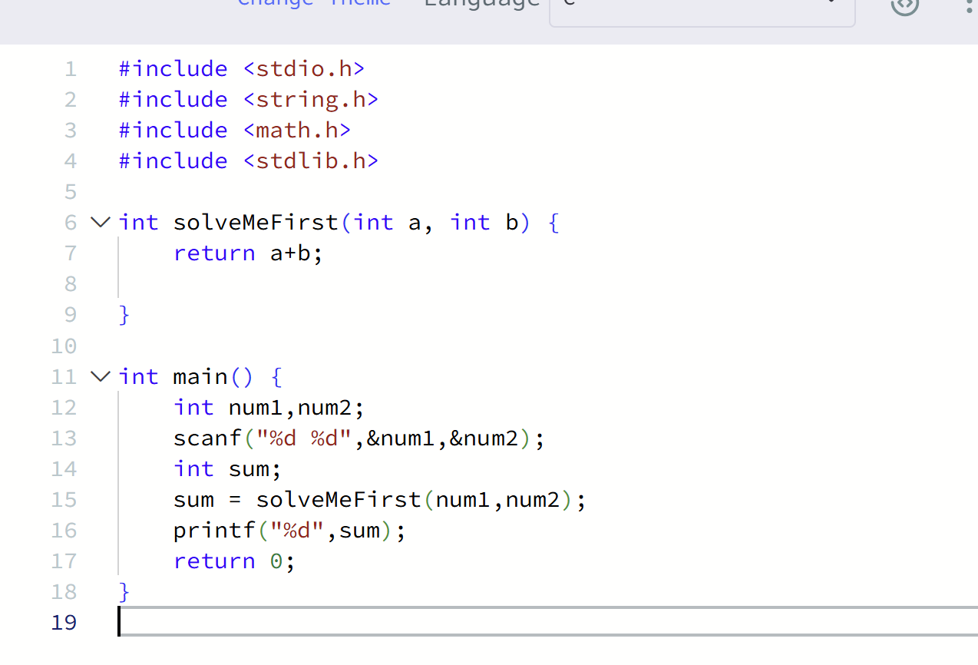
Screenshot Of Successful Submission:


