Problem :Staircase
Problem link :https://www.hackerrank.com/challenges/staircase/problem?
C Source Code:
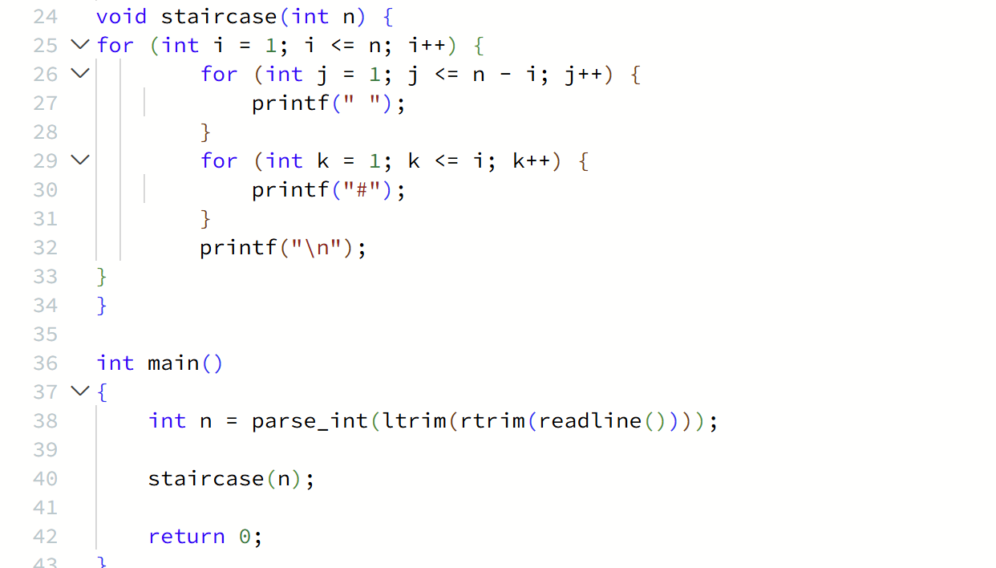
Screenshot of Successful Submission:


