Problem: Number of steps to reduce a number to zero
Problem link: https://leetcode.com/problems/number-of-steps-to-reduce-a-number-to-zero
C source code:
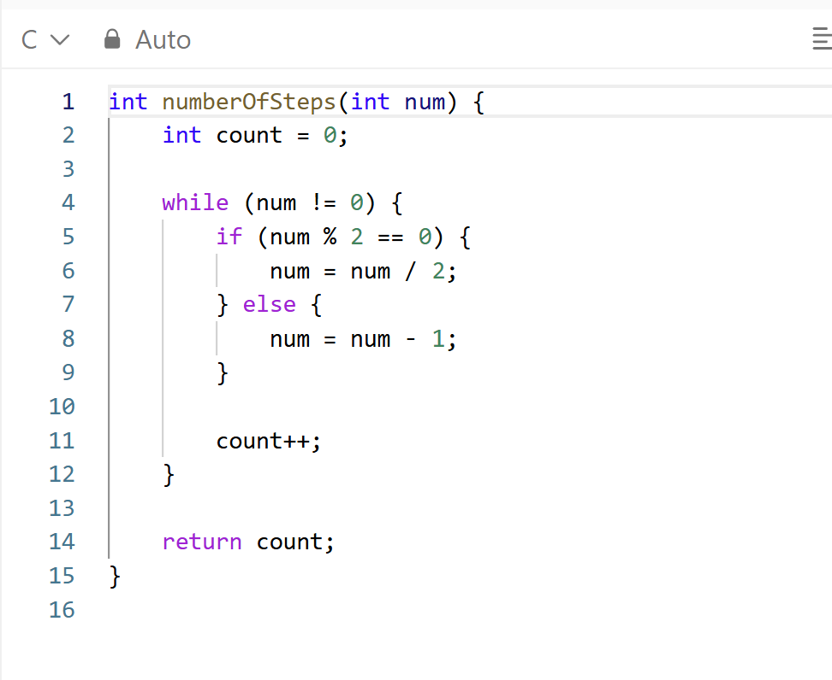
Screenshot of successful submission:


