Problem: Count Operators to Obtain zero
Problem link: https://leetcode.com/problems/count-operations-to-obtain-zero
C source code:
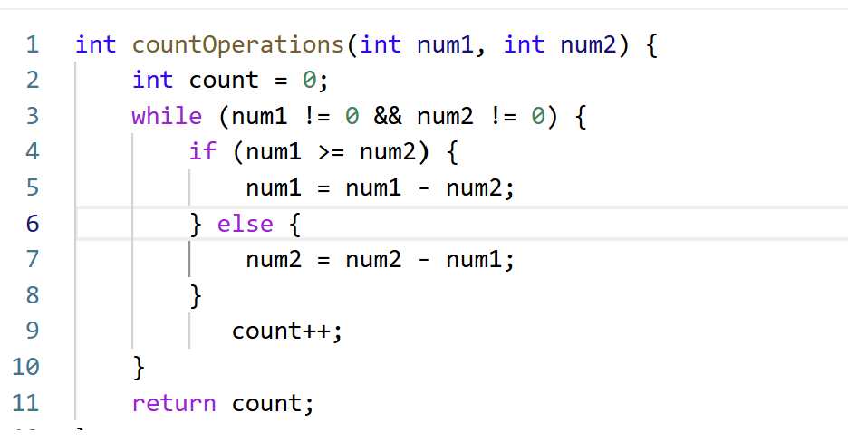
Screenshot of successful submission:


