Problem : Add two integers
Problem Link: https://leetcode.com/problems/add-two-integers/
C Source Code:
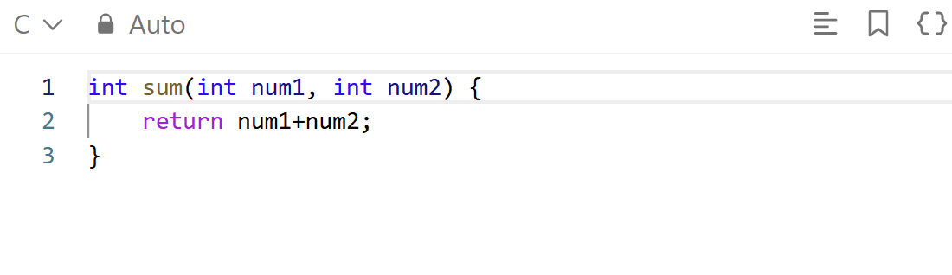
Screenshot of Successful Submission:


