Problem :Power of Two
Problem link: https://leetcode.com/problems/power-of-two
C source Code:
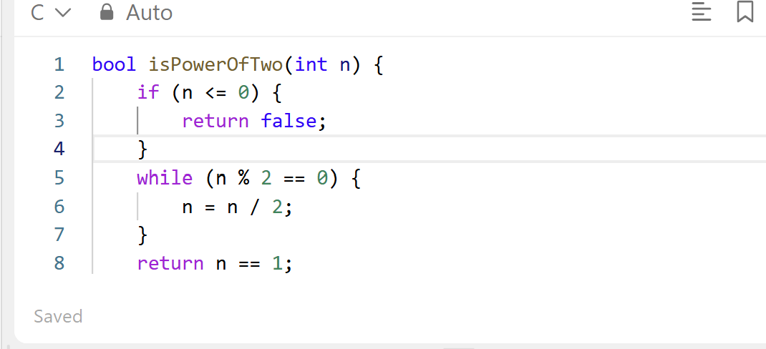
Screenshot of Successful submission:


