Problem :Smallest Even Multiple
Problem link: Smallest Even Multiple - LeetCode
C source Code:
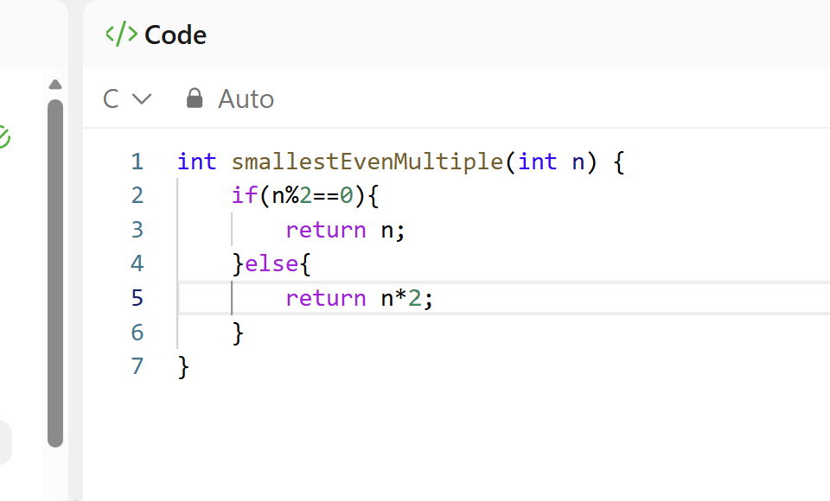
Screenshot of successful submission:


