Problem : Count the digit that divide a number
Problem link : https://leetcode.com/problems/count-the-digits-that-divide-a-number/submissions/
C source code :
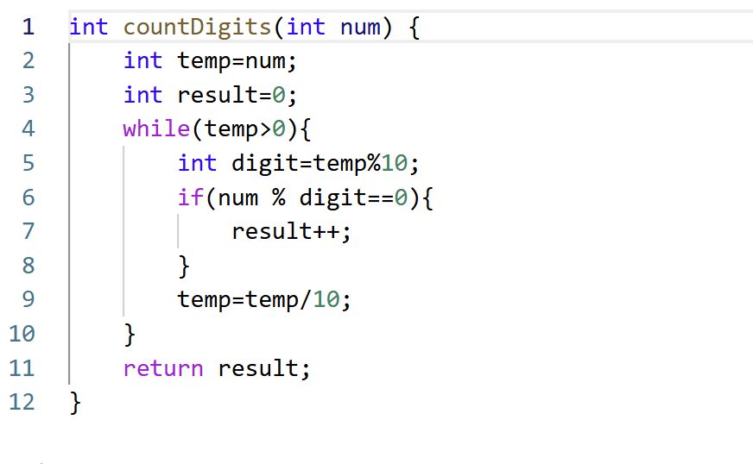
Screenshot of successful submission:


