Problem: Calculate Delayed Arrival Times
Problem Link:https://leetcode.com/problems/calculate-delayed-arrival-time/submissions/2192690762/
C Source Code:
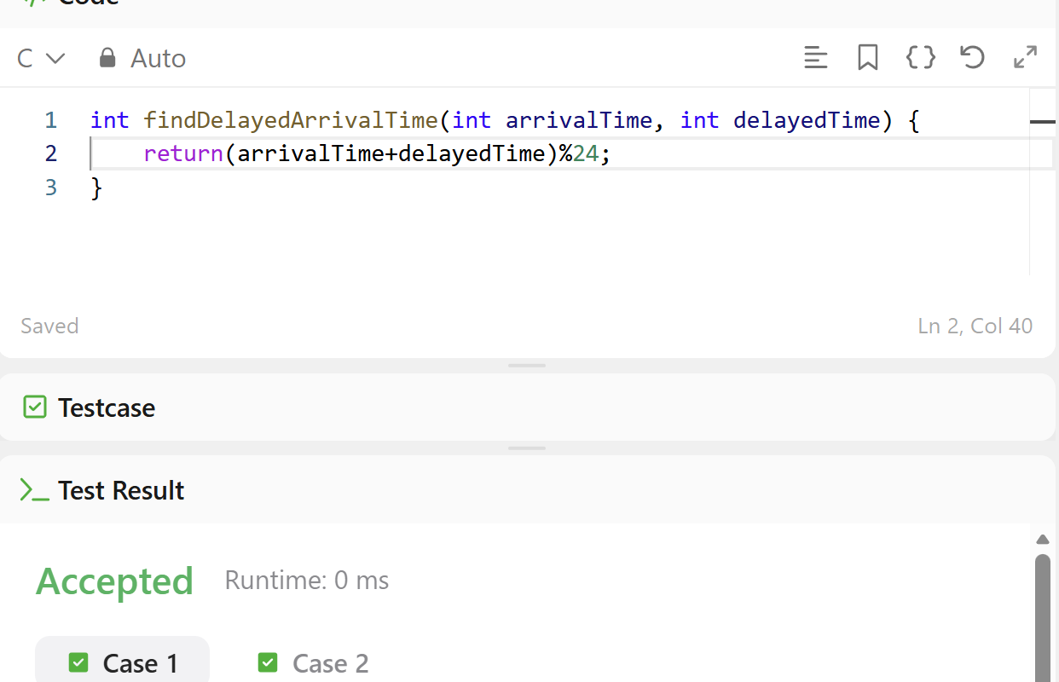
Screenshot of Successful Submission:


