Problem : Sum multiples
Problem link: https://leetcode.com/problems/sum-multiples/
C source code: 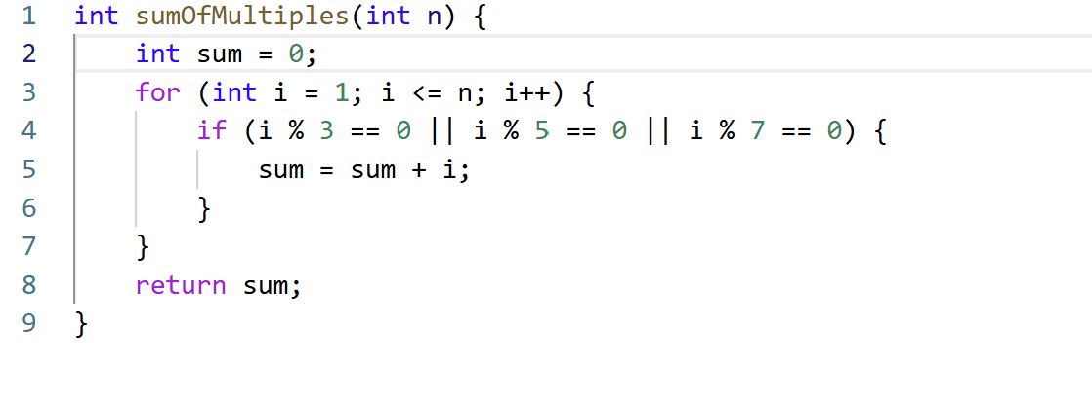
Screenshot of successful submission:


