Problem : Total Distance Travelled
Problem Link: https://leetcode.com/problems/total-distance-traveled/
C Source Code:
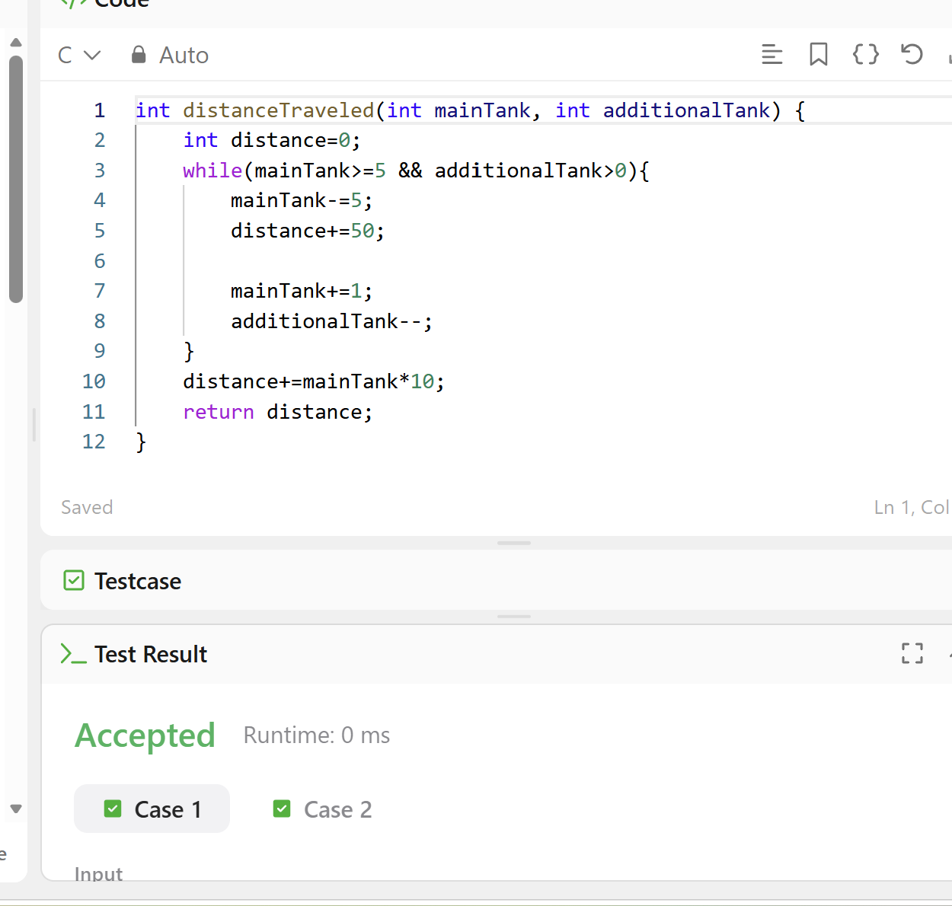
Screenshot of Successful Submission:


