Problem : Power of three
Problem link: https://leetcode.com/problems/power-of-three/submissions
C source code :
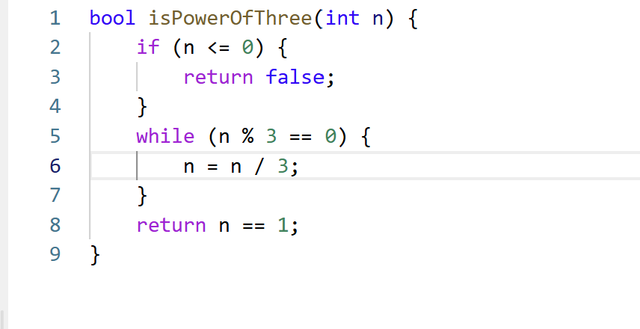
Screenshot of successful submission:


