Problem: Perfect Numbers
Problem link: https://leetcode.com/problems/perfect-number
C Source code:
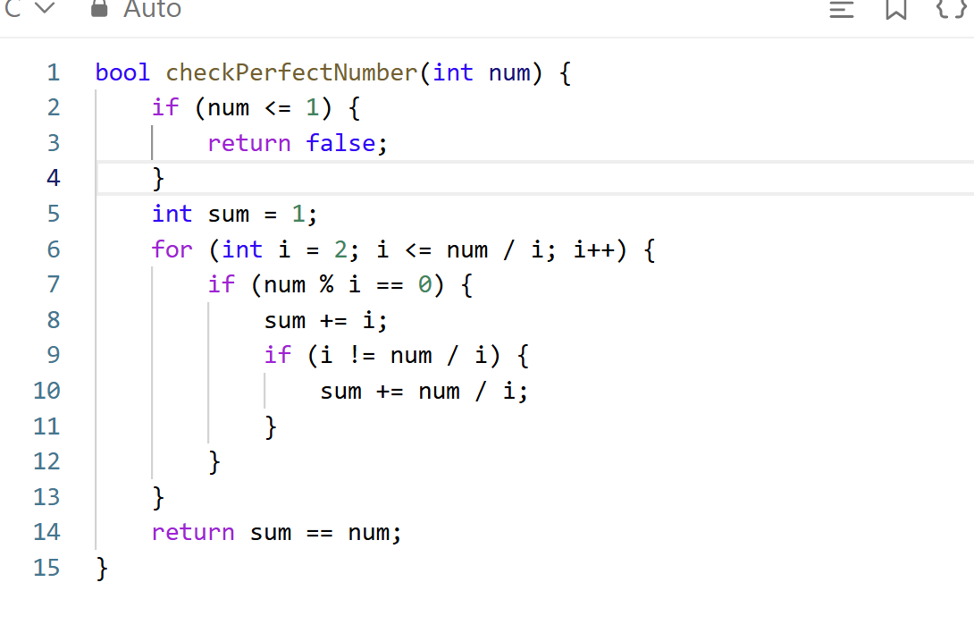
Screenshot of successful submission:


