Problem : Reverse integer
Problem link:
C source code:
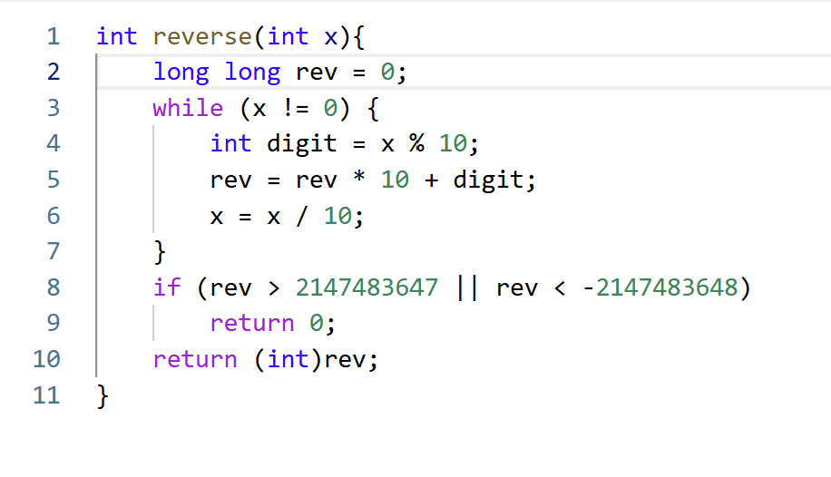
Screenshot of successful submission:


