Problem : Palindrome number
Problem link: https://leetcode.com/problems/palindrome-number
C source code :
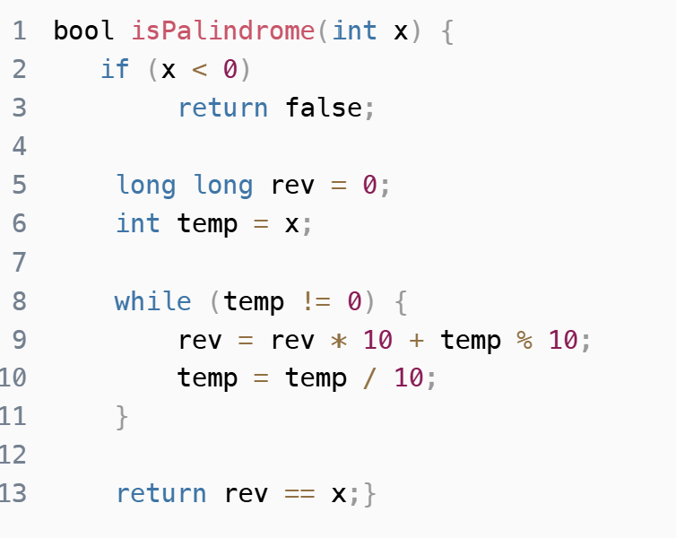
Screenshot of successful submission :


