Problem name: 1.Print a solid square
Platform : VS code
Problem statement: Given a positive integer N, print a square containing N rows and N columns of asterisks. Don’t print spaces between the asterisks.
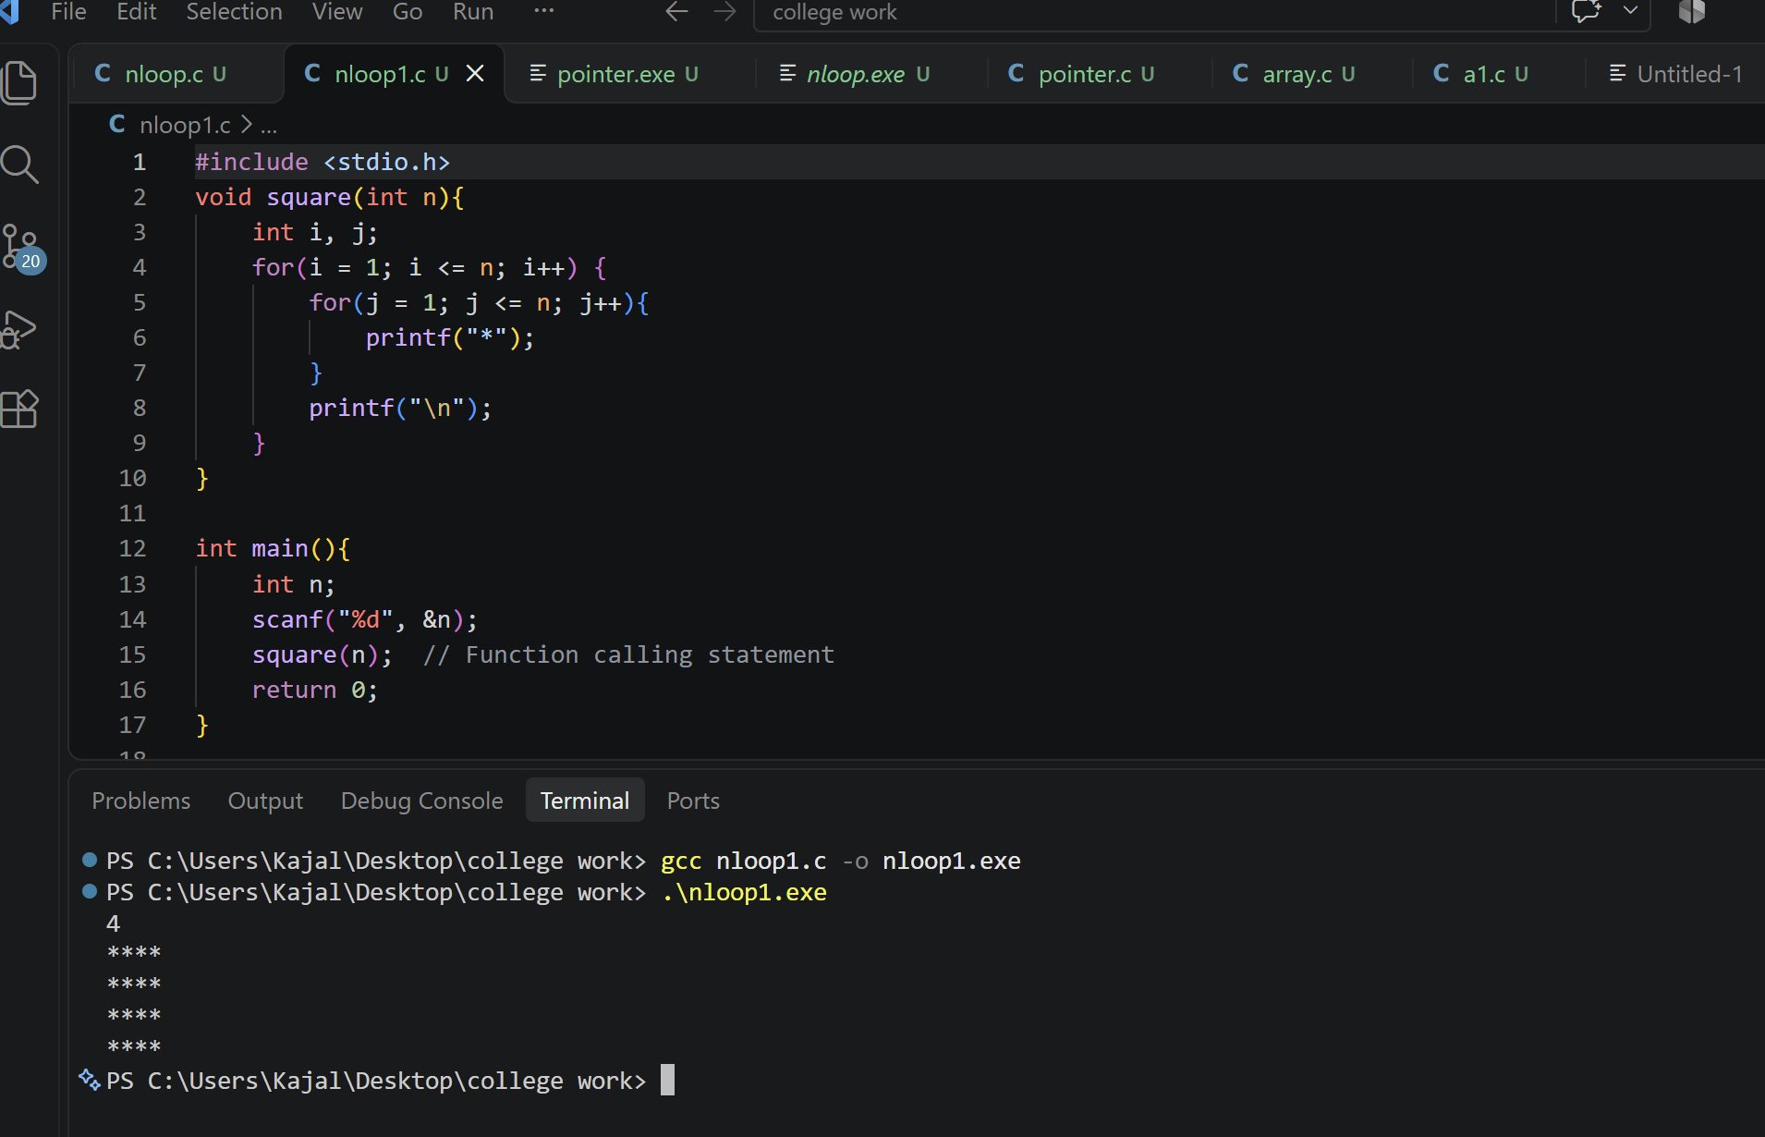
Problem name:2. Print a right-angled triangle
Platform :VS code
Problem statement: Given n, print a left aligned triangle .Row i must contain exactly i asterisks , for i from one to n.
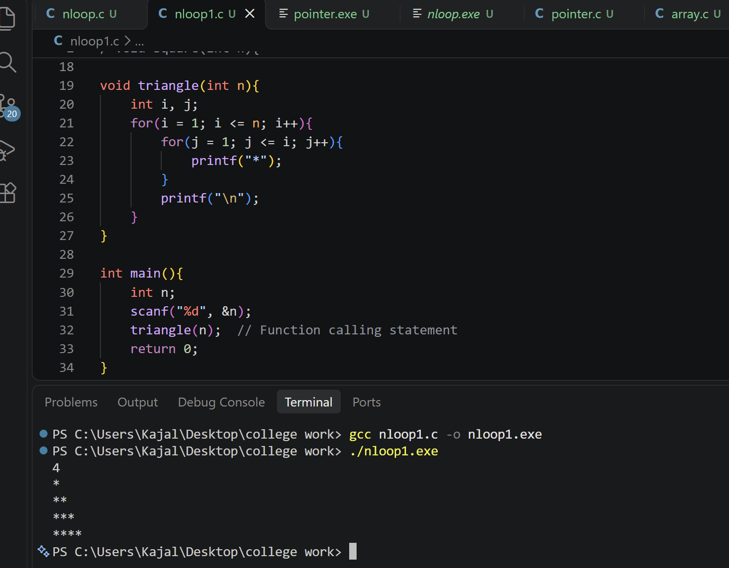
Problem name:3. Print an inverted triangle
Platform :VS code
Problem statement: Given n, print a left aligned inverted triangle. The first row contains n asterisks; each following row contains one fewer.
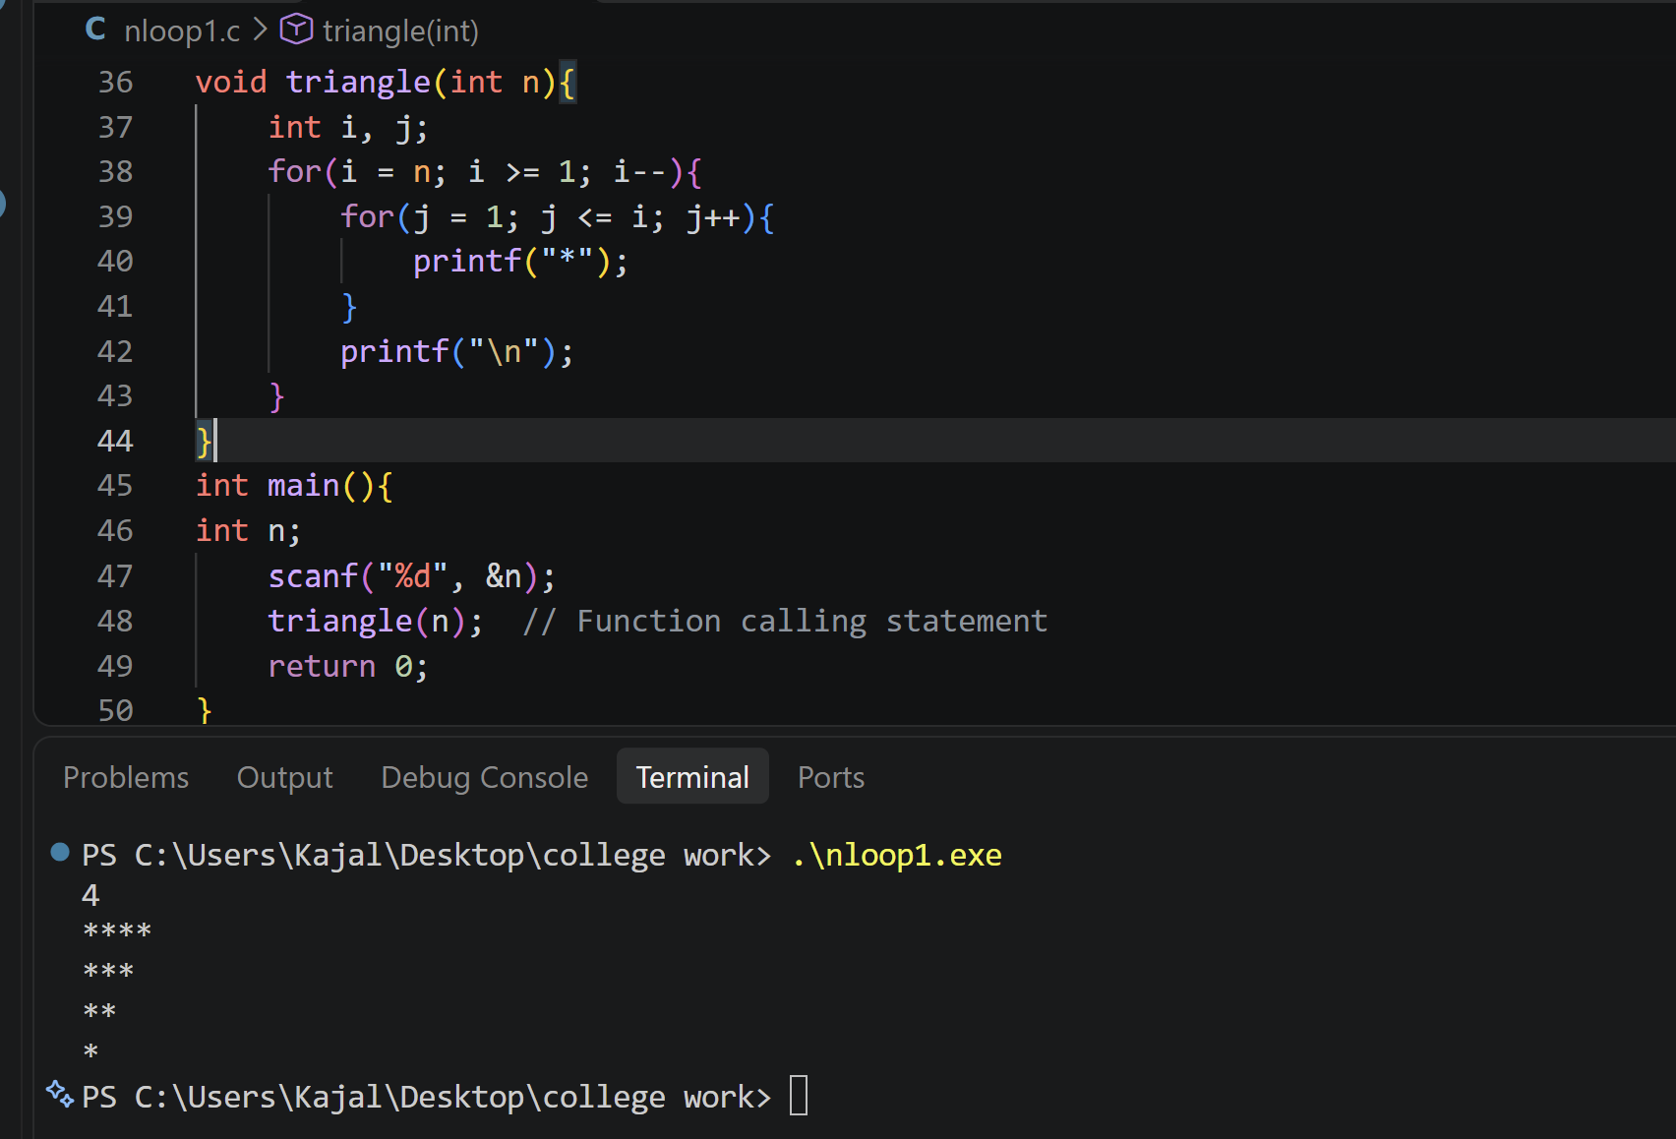
Problem name: 4.Print a number triangle
Platform: VS code
Problem statement: Given n, print n rows. On row I, print integers from 1 through I, separated by one space.
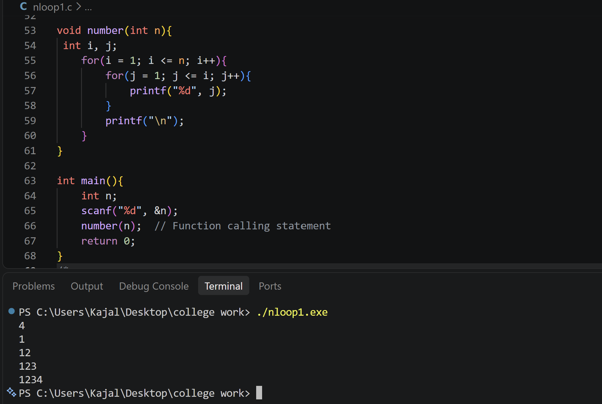

Problem name : 5.Print a repeated number triangle
6. Print a consecutive number triangle
7.Print a right aligned star triangle
Platform: VS code
Problem statement: Given n, print n rows. On row I, print the number i exactly i times, separated by one space.
Print consecutive positive integers across triangular rows. Row 1 has one number, row 2 has two, and so on. Counting starts at 1 and continues across rows.
Given n, print a right-aligned triangle. Row 1 has one asterisk and row n has n asterisks. Use leading spaces to align the right edges.
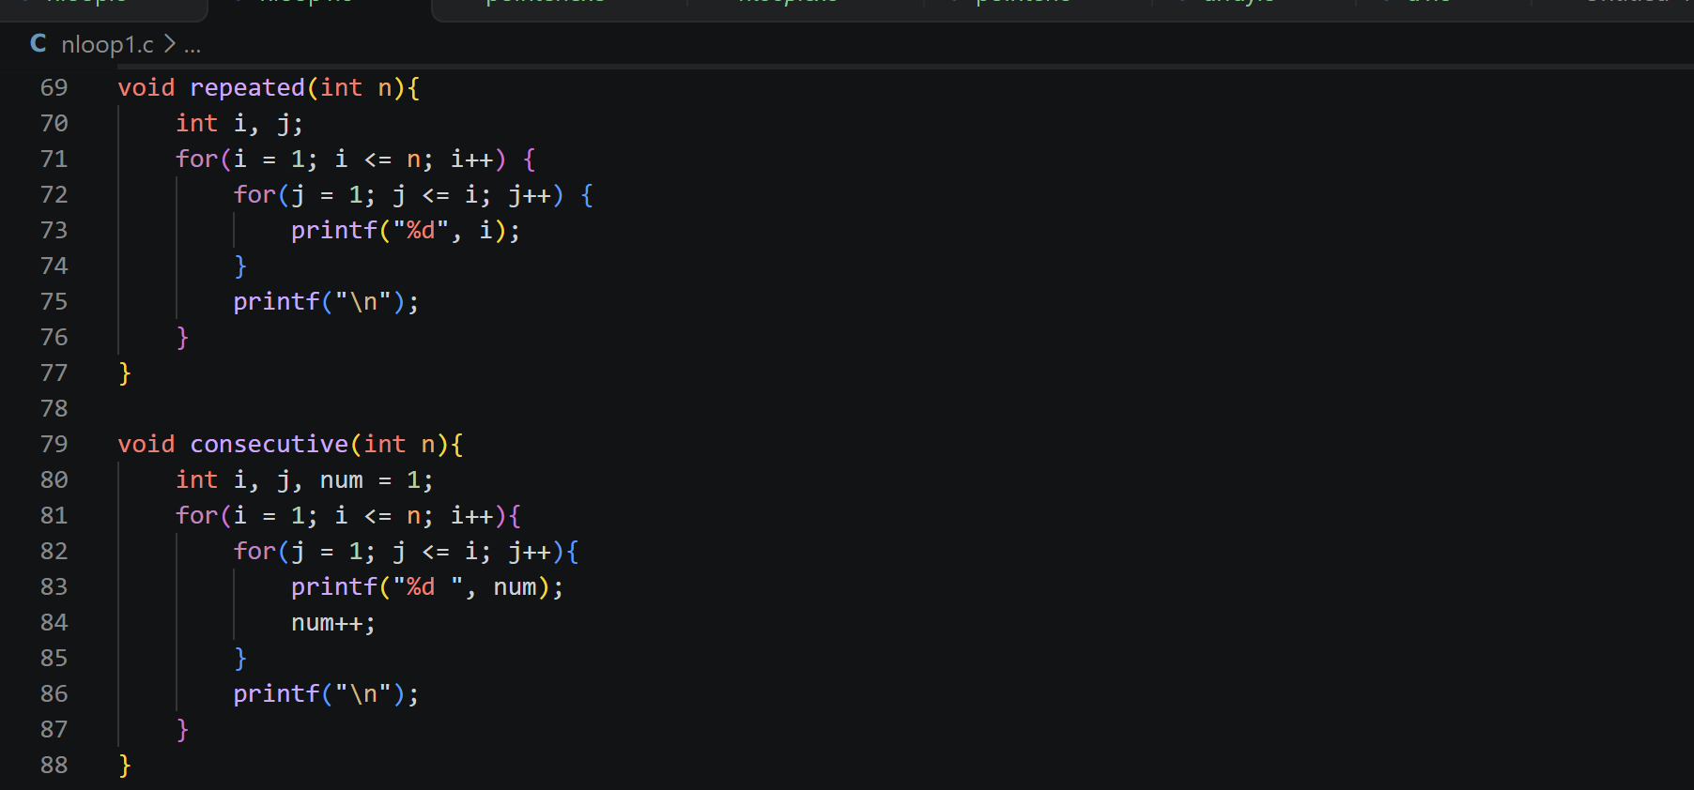
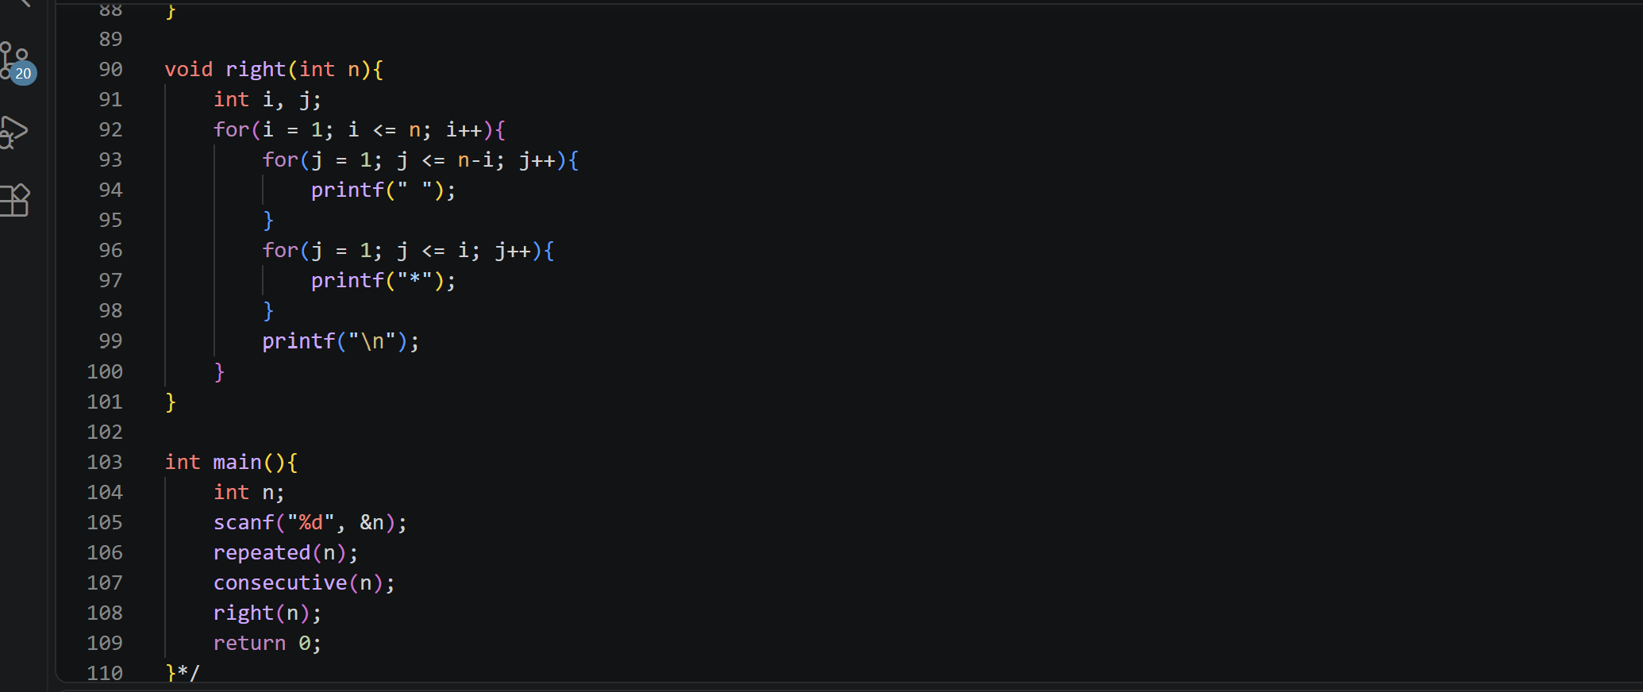
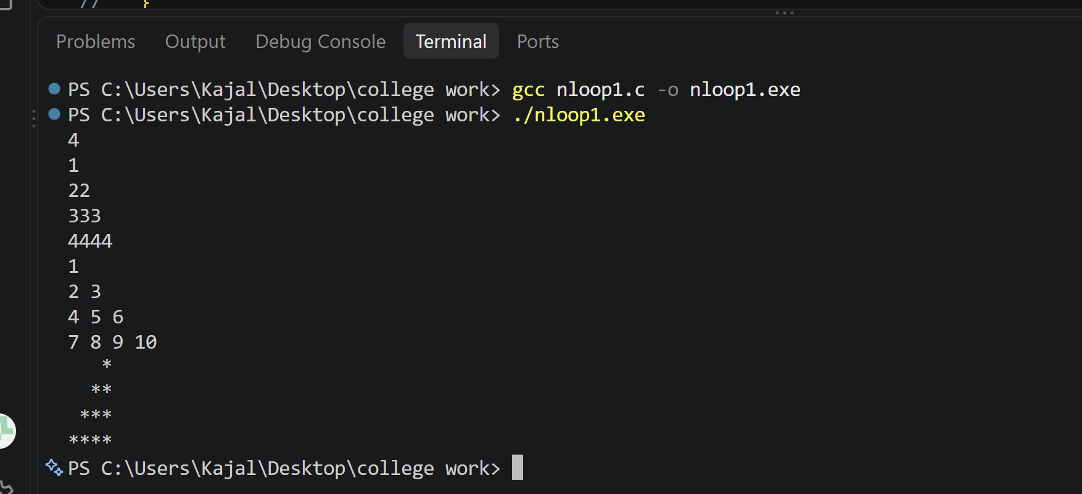
Problem name: 8.Print a Centered Pyramid
9.Print an Inverted Centered Pyramid
10.Print a Hollow Square
Platform: VSCode
Problem statement: Given n, print a centered pyramid with n rows. Row i contains 2i-1 asterisks, preceded by enough spaces to the centre it.
Given n, print an inverted centered pyramid. The first row contains 2n-1 asterisks; each next row has two fewer and one more leading space.
Given n, print an n-by-n hollow square. Print an asterisk on the first row, last row, first column, or last column. Print a space inside.
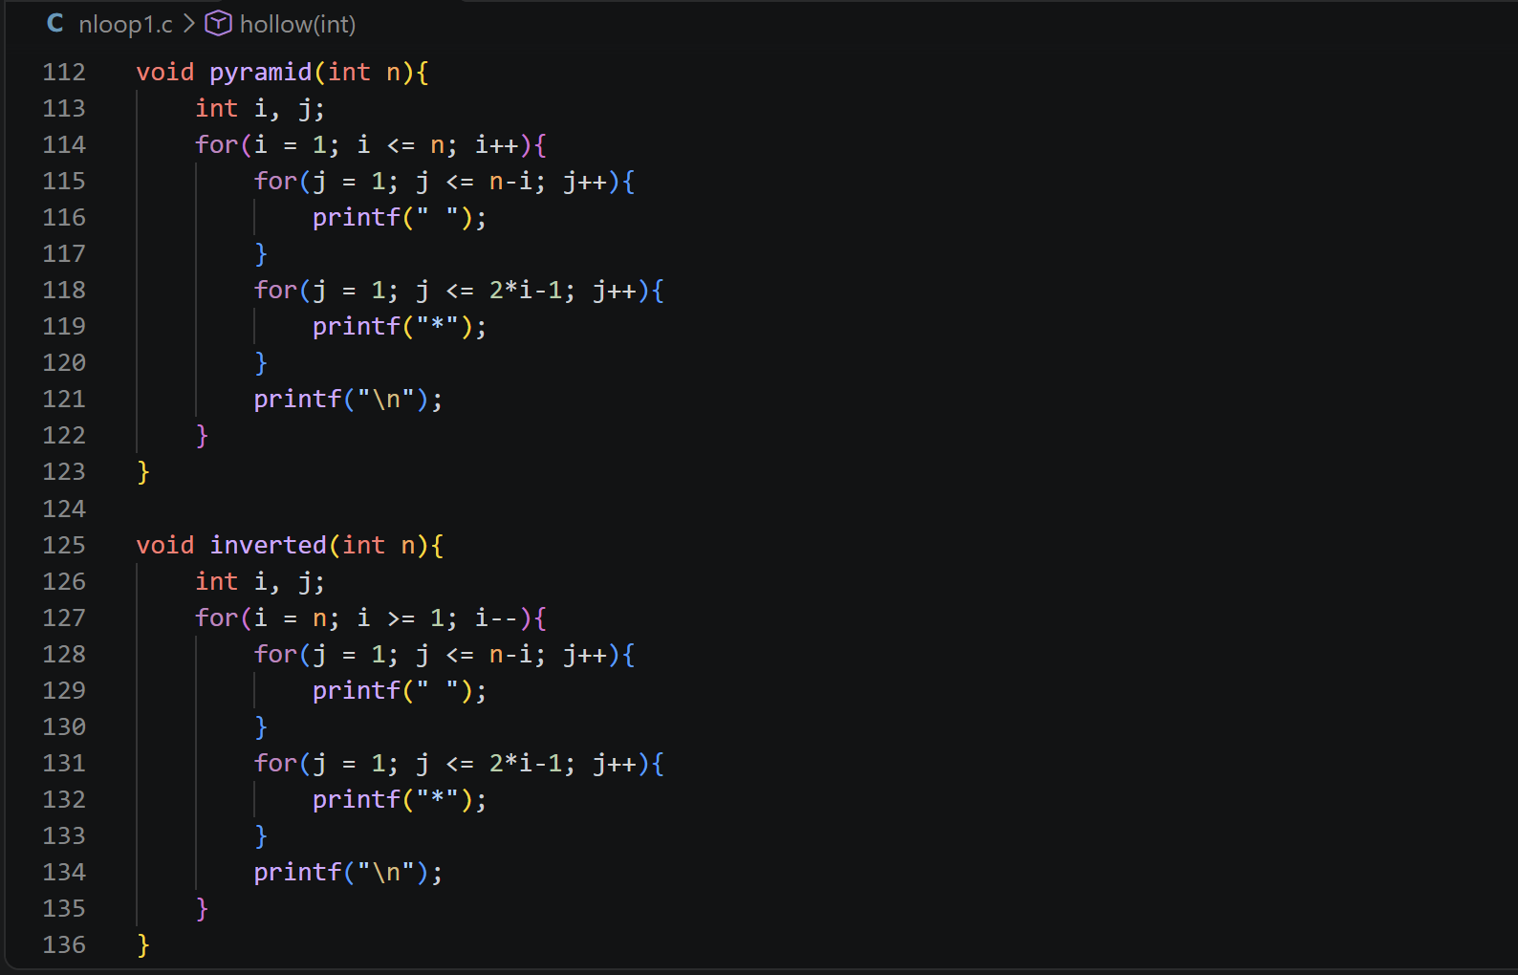
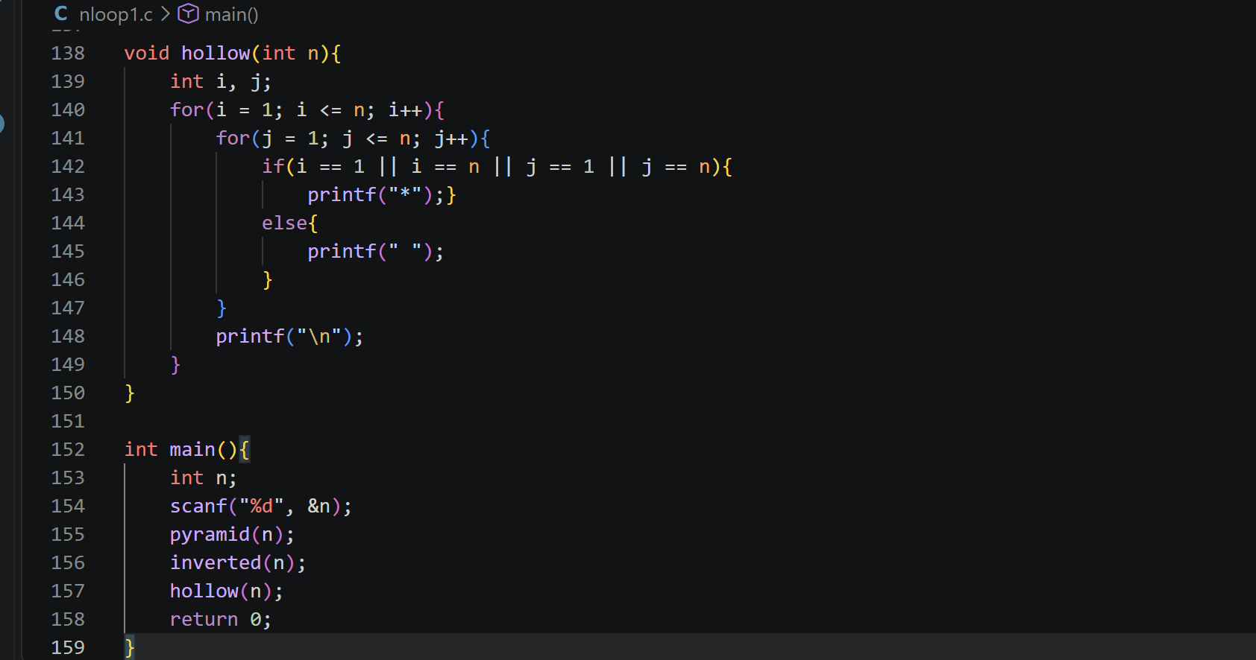
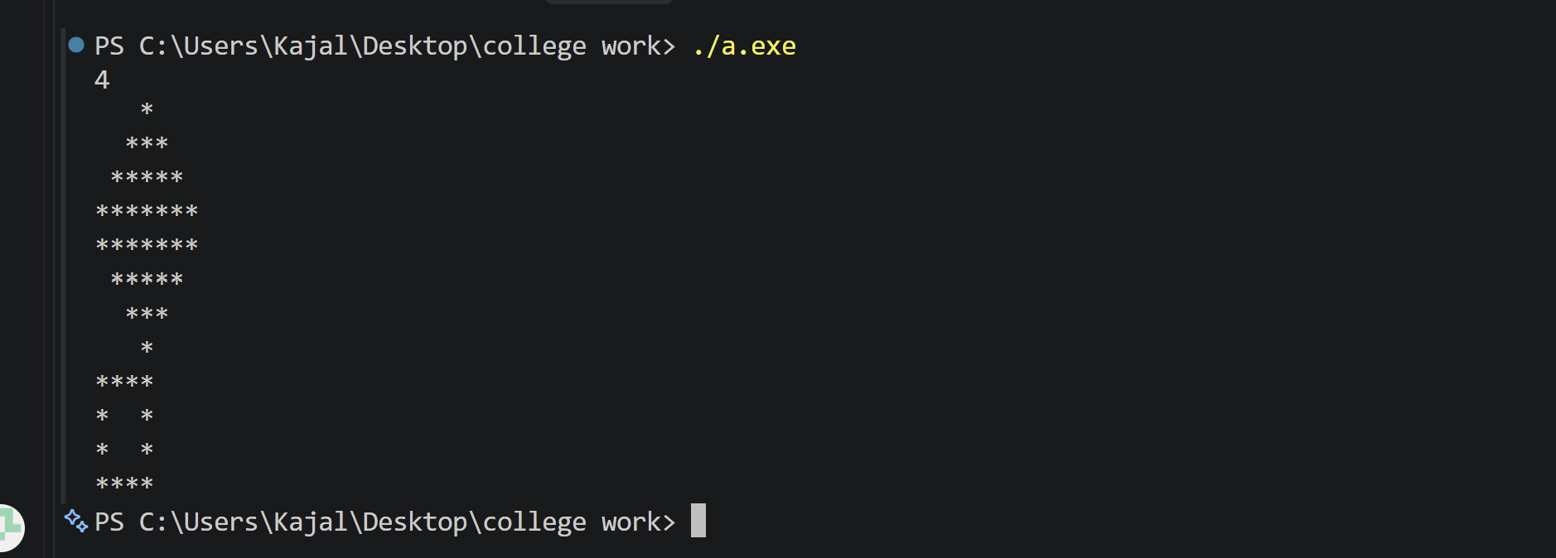
Problem name :11.Print a hollow right angled triangle
Platform:VS code
Problem statement: Given n, print the outline of a left-aligned right-angled triangle. Print asterisks in the first column, on the diagonal boundary, and across the final row. Print spaces inside.

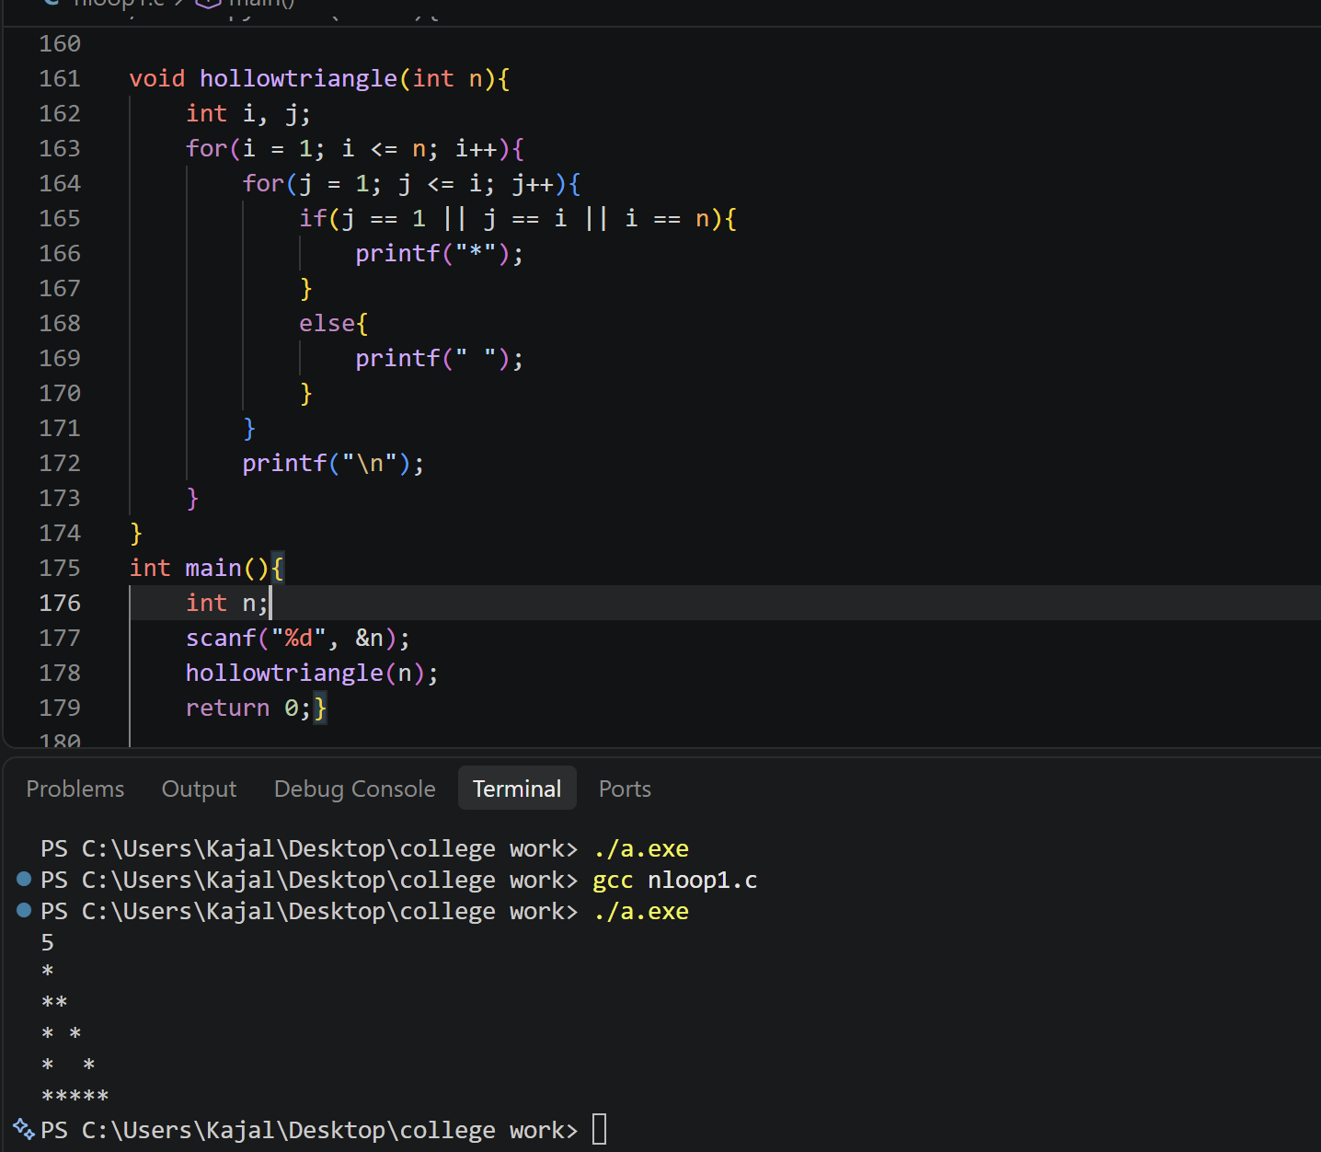
Problem name:12. Print a multiplication table grid
Platform : VS code
Problem statement: Given n, print an n-by-n multiplication grid. At row i and column j. print i multiplied by j. Separate values with one space.
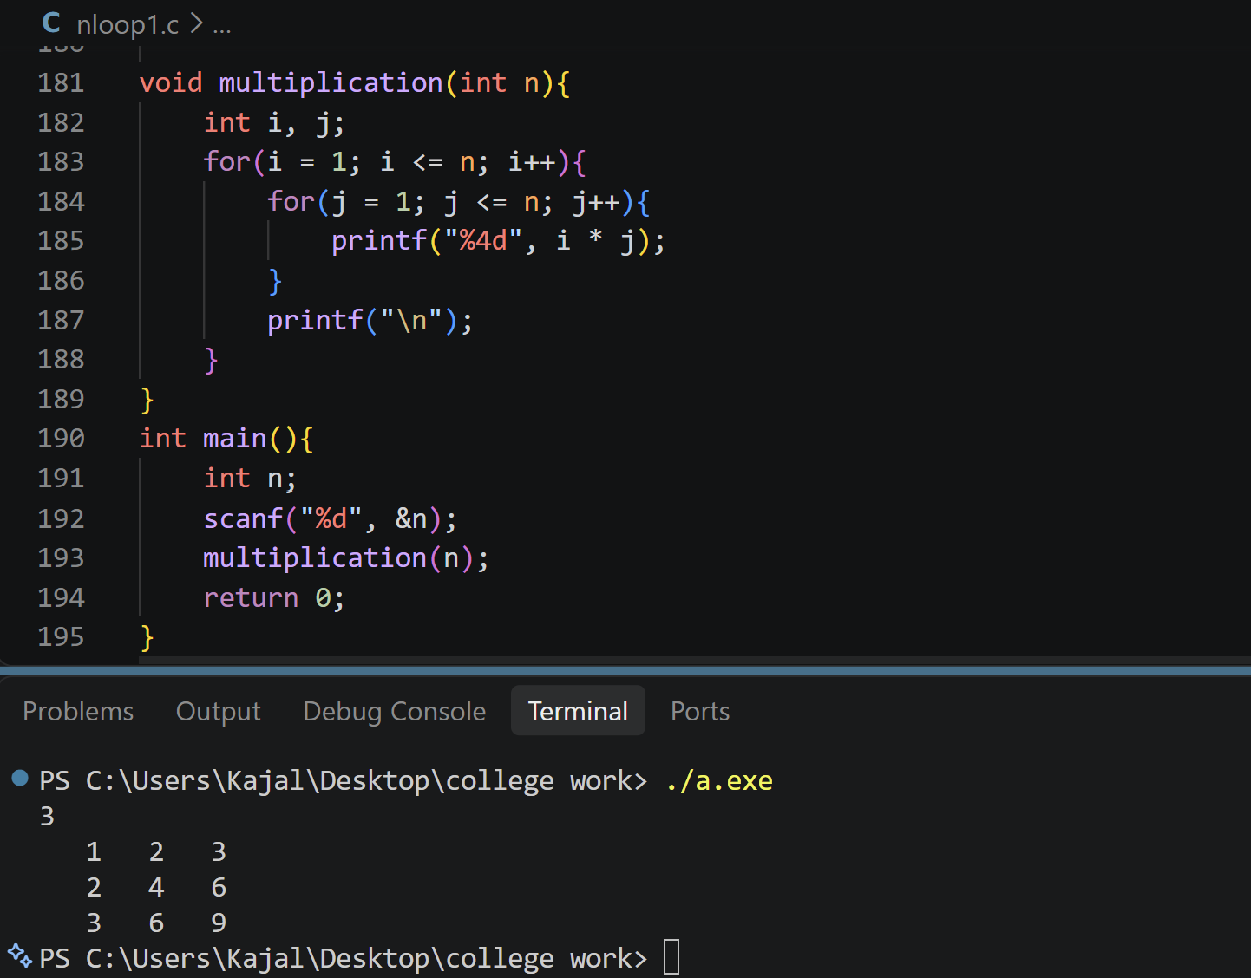
Problem name:13.Print a checkerboard
Platform: VS Code
Problem Statement: Given n, print an n-by-n checkerboard using X and O. The top-left character must be X; adjacent horizontal and vertical cells alternate.
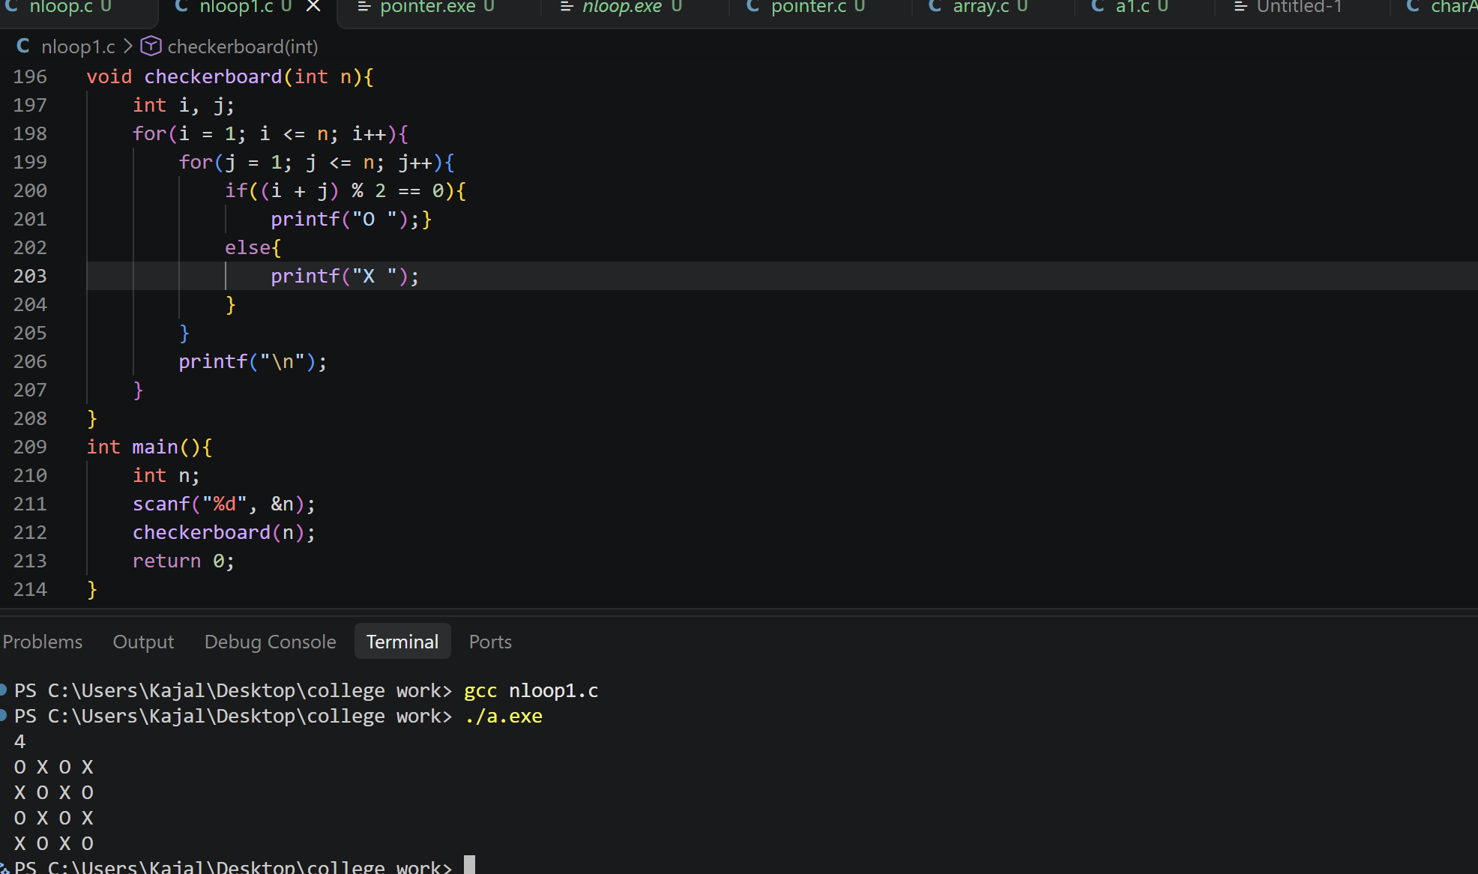
Problem name:14.Print Floyd’s triangle
Platform: VS Code
Problem Statement: Given n, print Floyd's triangle with n rows. Fill it with consecutive positive integers starting at 1, placing one number on row 1, two on row 2, and so on.
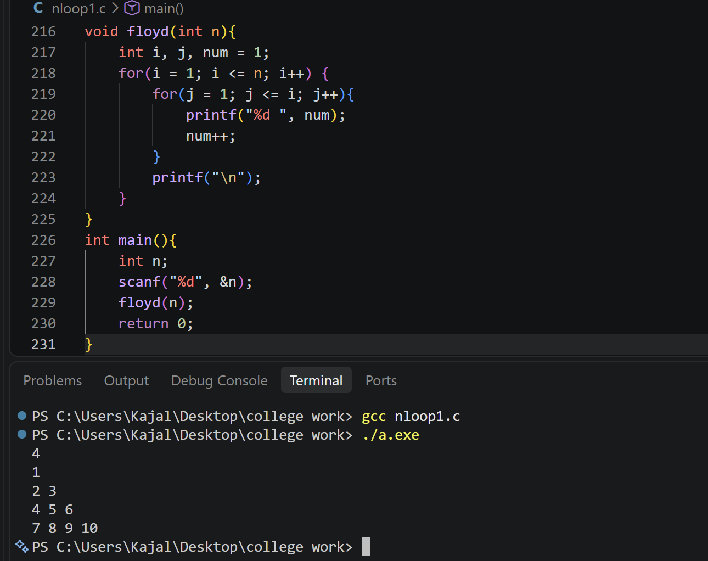
Problem name:15. Print a butterfly pattern
Platform :VS code
Problem Statement: Given an odd integer n. print a butterfly made of asterisks. The top half widens row by row and the lower half mirrors it. Use spaces between the left and right wings.
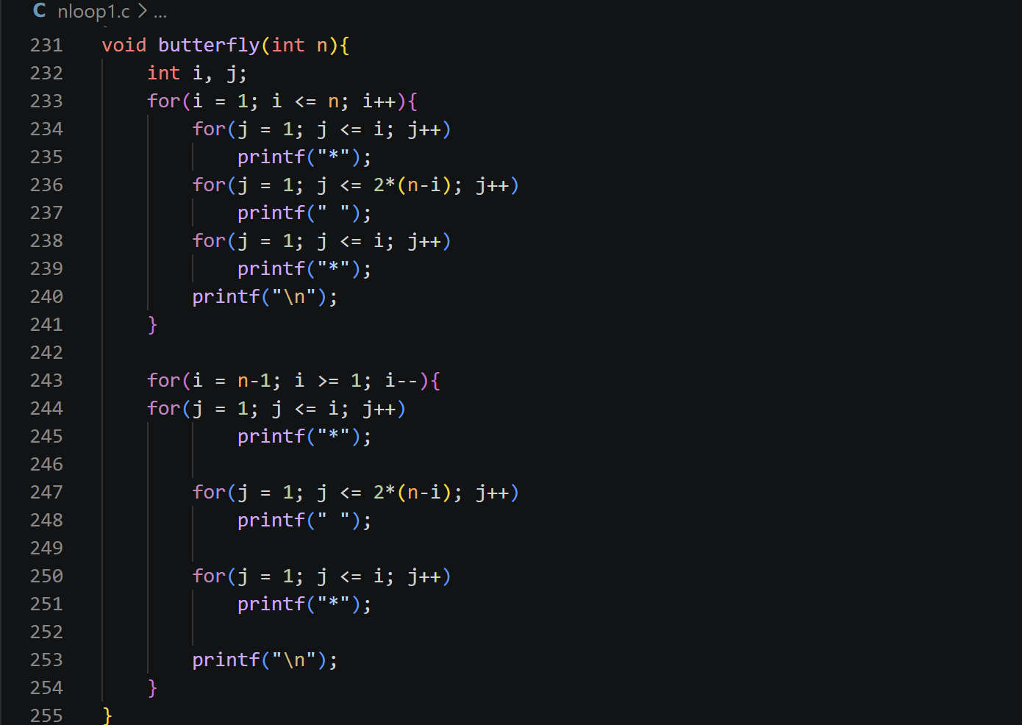
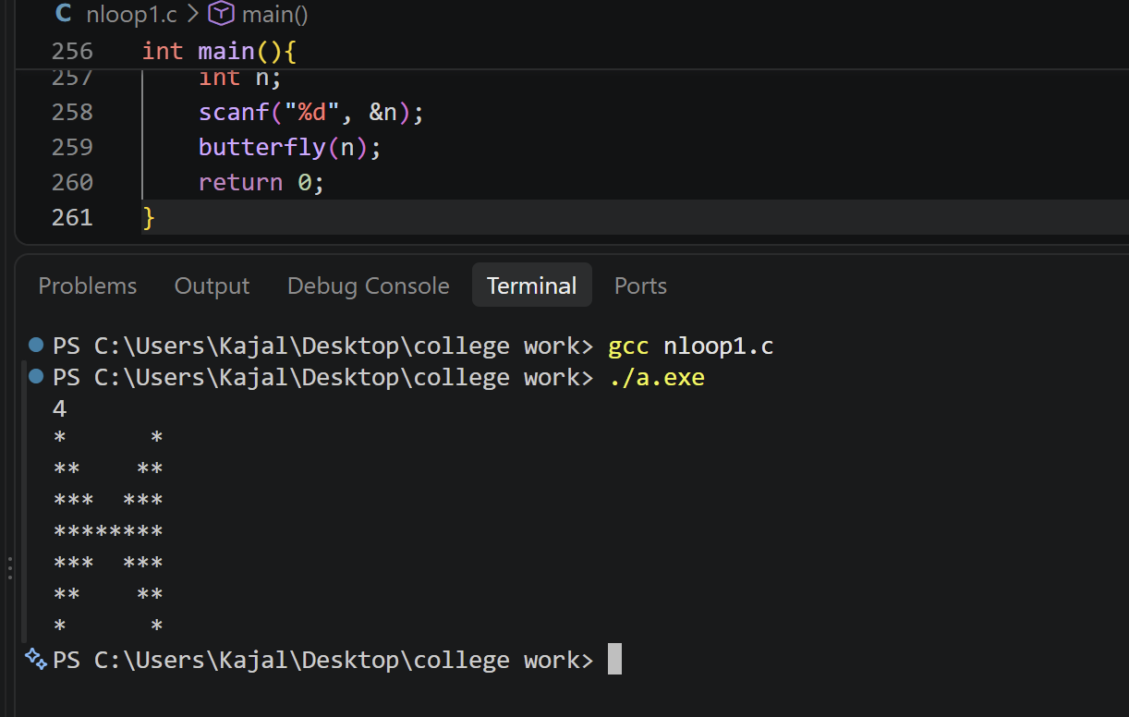
Problem name:16. Print a Diamond pattern
Platform :VS code
Problem Statement: Given n, print a centered diamond. The upper half has n rows including the widest row, then print n-1 rows in decreasing width.


