CurriculumVitae
Name: Kajal Karmakar
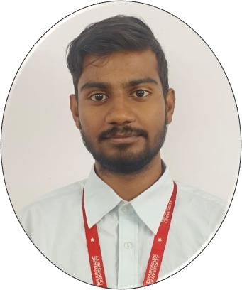
Address (Present &Permanent):----
Vill: Sandhipur,Gharbeta
Dist-west medinipur
West Bengal – 727127
Email id–karmakarkajal621@gmail.com
Mobile No–8391920450
Date of birth–08.06.2005
Place of Domicile–West Bengal
Language Known–Bengali, English and Hindi Gender–Male
About myself:
A multi-passionate person skilled in programming and technology and committed to innovation and continuous learning.
Level | Name of  Institution/  Department | Board/Council/ University | Year | esult | Class
Bachelor of  Technology in Computer  Science(AIML) | Department of  Computer Science | Brainware University | 2024- 2028 | 8.33/10 | 2^{and}(even) Semester
Bachelor of  Technology in Computer  Science(AIML) | Department of  Computer Science | Brainware University | 2024- 2028 | 7.33/10  (SGPA) | 1st (Odd) Semester
Higher Secondary Education | Netaji nagar sripati sikha  sadan | WBSE | 2023 | 64% | 12th
Secondary Education | Netaji nagar sripati sikha  sadan | WBSE | 2021 | 74% | 10th

Academic Qualification:
Interests:
⮚ Learning more about technology
⮚ Knowing more about artificial intelligence Skills:
- C-programming
- Javascript
- Html,CSS
- java
- python

