SUMMER TRAINING

PROJECT REPORT
(Term June-July 2025)

Car Price Prediction Model

Submitted by
Name | Registration Number
Prakhar Purwar | 12323770
Prashant Kumar | 12315454
Jubin Mazumdar | 12316322
Asmit Kushagra | 12317766
Kajal Kumari | 12312143

Course Code: PETV79

Under the Guidance of
Mahipal Singh Papola (UID: 32137)

School of Computer Science and Engineering
Certificate
This is to certify that the project report titled "Car Price Prediction using Machine Learning" is a record of original work carried out by Prakhar Purwar, Prashant Kumar, Jubin Mazumdar, Asmit Kushagra and Kajal Kumari during their summer internship as a part of their B.Tech (Computer Science and Engineering) curriculum at Lovely Professional University. The work has been completed under my guidance and supervision and is a part of their partial fulfillment of the degree.

Date: ___________
Place: __________

Supervisor
Mahipal Sir
Department of CSE, LPU

Acknowledgement
We would like to express our heartfelt gratitude to our project guide Mahipal Sir for his invaluable support, continuous guidance, and encouragement throughout the duration of this project. We would also like to thank the faculty and staff of the School of Computer Science and Engineering, LPU, for providing the necessary academic environment and technical resources.

TABLE OF CAPITALIZED
- Introduction
1.1 Company Profile
1.2 Overview of Training Domain
1.3 Objective of the Project
- Training Overview
2.1 Tools & Technologies Used
2.2 Areas Covered During Training
2.3 Daily/Weekly Work Summary
- Project Details
3.1 Title of the Project
3.2 Problem Definition
3.3 Scope and Objectives
3.4 System Requirements
3.5 Architecture Diagram
3.6 Data Flow Diagram
- Implementation
4.1 Tools Used
4.2 Methodology
4.3 Modules / Screenshots
4.4 Code Snippets
- Results and Discussion
5.1 Output / Report
5.2 Challenges Faced
5.3 Learnings
- Conclusion
6.1 Summary
- References

CHAPTER 1: INTRODUCTION
1.1 COMPANY PROFILE
This project was undertaken as part of the academic curriculum at the School of Computer Science and Engineering, Lovely Professional University (LPU), Phagwara, Punjab. LPU is a premier educational institution in India, recognized for its focus on industry-oriented education and research. The School of Computer Science and Engineering is equipped with modern facilities and fosters innovation in fields such as machine learning, data science, artificial intelligence, and software engineering. The department emphasizes practical training through projects, enabling students to apply theoretical knowledge to real-world problems.

1.2 OVERVIEW OF TRAINING DOMAIN
The training domain for this project is Machine Learning (ML) and Data Science, with a focus on regression modeling, data preprocessing, exploratory data analysis (EDA), and web application deployment. The project involved developing a predictive model to estimate used car prices, a regression task requiring skills in data cleaning, feature engineering, model training, and user interface development. The training provided hands-on experience with Python-based ML tools and deployment frameworks, preparing us for real-world applications in the automotive industry.

1.3 OBJECTIVE OF THE PROJECT
The objectives of the Car Price Prediction project are:
- To preprocess a dataset of used car listings to ensure high data quality.
- To engineer features that capture key factors influencing car prices, such as brand, year, and mileage.
- To develop and train a Random Forest regression model to accurately predict car prices.
- To deploy the model as an interactive Streamlit web application for user accessibility.
- To evaluate the model’s performance using regression metrics (e.g., R², MSE) and analyze its limitations to propose future improvements.

CHAPTER 2: TRAINING OVERVIEW
2.1 TOOLS & TECHNOLOGIES USED
The project utilized the following tools and technologies:
- PYTHON: Core programming language for data processing, modeling, and deployment.
- SCIKIT-LEARN: For implementing the Random Forest regression model and computing evaluation metrics.
- PANDAS: For data manipulation, cleaning, and preprocessing.
- NUMPY: For numerical computations and array operations.
- MATPLOTLIB AND SEABORN: For creating visualizations such as scatter plots, box plots, and regression plots.
- STREAMLIT: For developing and deploying the interactive web application.
- JUPYTER NOTEBOOK: For exploratory data analysis, prototyping, and code development.

2.2 AREAS COVERED DURING TRAINING
The training covered the following key areas:
- DATA PREPROCESSING: Handling missing values, removing duplicates, and encoding categorical variables.
- EXPLORATORY DATA ANALYSIS: Performing univariate and bivariate analyses to identify patterns and correlations.
- FEATURE ENGINEERING: Extracting relevant features (e.g., car brand) and cleaning numerical data (e.g., mileage, engine).
- MODEL DEVELOPMENT: Training a Random Forest regression model and evaluating its performance.
- DEPLOYMENT: Building a user-friendly web application using Streamlit for real-time predictions.
- VISUALIZATION: Creating plots to visualize feature distributions and relationships.

2.3 DAILY WORK SUMMARY
The project was executed over five days, with the following milestones:
- DAY 1: Collected the dataset from the CarDekho platform and performed initial exploration to identify issues (e.g., missing values, duplicates).
- DAY 2: Preprocessed the dataset by dropping unnecessary columns (e.g., torque), handling missing values (221 rows), removing duplicates (1,189 rows), and engineering features (e.g., brand extraction).
- DAY 3: Conducted EDA, including univariate analysis (e.g., price distribution), bivariate analysis (e.g., year vs. price), and correlation matrix computation.
- DAY 4: Trained the Random Forest model, evaluated it using R² (0.9128) and MSE (63,232,848,857.42 INR²), and developed the initial Streamlit app.
- DAY 5: Refined the model, added input validation to the Streamlit app, and finalized the project report.

CHAPTER 3: PROJECT DETAILS
3.1 TITLE OF THE PROJECT
Car Price Prediction Using Machine Learning

3.2 PROBLEM DEFINITION
Pricing used cars is a challenging task due to the influence of multiple factors, including car brand, year of manufacture, kilometers driven, fuel type, seller type, transmission, ownership status, mileage, engine capacity, and maximum power. Manual price estimation is time-consuming, subjective, and prone to errors. This project addresses the need for an automated, data-driven solution to predict used car prices accurately, benefiting buyers, sellers, and dealerships in the automotive market.

3.3 SCOPE AND OBJECTIVES
SCOPE:
- Develop a machine learning model to predict used car prices based on a dataset of 8,148 car listings.
- Ensure data quality through preprocessing and feature engineering.
- Deploy the model as a user-friendly web application for real-time predictions.
- Achieve high predictive accuracy (target R² > 0.85) and provide insights into key price drivers.
OBJECTIVES:
- Clean and preprocess the dataset to remove inconsistencies and ensure model compatibility.
- Engineer features to capture relevant information (e.g., car brand, numerical values from mileage).
- Train a Random Forest model to predict prices with high accuracy.
- Deploy the model via Streamlit for accessibility to non-technical users.
- Evaluate model performance and identify areas for improvement.

3.4 SYSTEM REQUIREMENTS
- HARDWARE: Standard laptop/desktop with at least 8 GB RAM and a 2 GHz processor.
- SOFTWARE:
  - Python 3.8 or higher
  - Libraries: scikit-learn, pandas, NumPy, Matplotlib, Seaborn, Streamlit
  - Jupyter Notebook for development and testing
- DATASET: "Car dekho - Car dekho.csv" with 8,148 observations and 12 features (reduced to 5,328 after preprocessing).
- OPERATING SYSTEM: Windows, macOS, or Linux.

3.5 ARCHITECTURE DIAGRAM

Figure 1: Architecture Diagram

3.6 DATA FLOW DIAGRAM
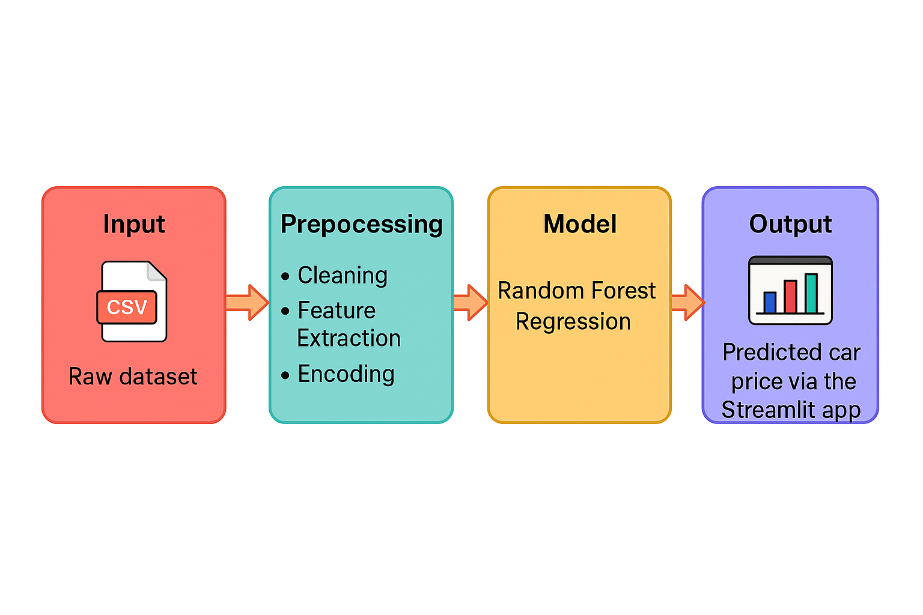
Figure: Data Flow Diagram

CHAPTER 4: IMPLEMENTATION
4.1 TOOLS USED
The implementation utilized:
- PYTHON LIBRARIES: pandas for data manipulation, NumPy for numerical operations, scikit-learn for model training and evaluation.
- VISUALIZATION TOOLS: Matplotlib and Seaborn for generating scatter plots, box plots, and regression plots.
- STREAMLIT: For building and deploying the interactive web application.
- JUPYTER NOTEBOOK: For prototyping and exploratory analysis.

4.2 METHODOLOGY
The project followed a structured machine learning pipeline:
- DATA COLLECTION: Sourced the dataset ("Car dekho - Car dekho.csv") with 8,148 observations and 12 features.
- PREPROCESSING:
  - Dropped the torque column due to inconsistent data formats.
  - Removed 221 rows with missing values in mileage, engine, max_power, and seats.
  - Eliminated 1,189 duplicate rows, reducing the dataset to 6,738 observations (further cleaned to 5,328 for training/testing).
  - Extracted car brand from the Name column (e.g., "Maruti Alto" → "Maruti"), reducing dimensionality to 31 unique brands.
  - Encoded categorical features: fuel (Petrol=1, Diesel=2, etc.), seller_type (Individual=1, Dealer=2), transmission (Manual=1, Automatic=2), owner (First Owner=1, Second Owner=2, etc.).
  - Cleaned numerical features: mileage (e.g., "19.03 kmpl" → 19.03), engine (e.g., "999 CC" → 999.0).

- EXPLORATORY DATA ANALYSIS:
  - Univariate analysis: Examined distributions of selling_price (positively skewed), year (peaking 2015–2020), and km_driven (10,000–100,000 km).
  - Bivariate analysis: Identified correlations, e.g., year vs. selling_price (0.65), km_driven vs. selling_price (-0.45).
  - Visualizations: Scatter plots (year vs. price), box plots (fuel type vs. price), and correlation matrix.
- MODEL TRAINING:
  - Split data into 80% training (4,262 cars) and 20% testing (1,066 cars) using scikit-learn’s train_test_split.
  - Trained a Random Forest regression model with 100 trees (default hyperparameters).
- EVALUATION: Computed R² (0.9128) and MSE (63,232,848,857.42 INR²) on the test set.
- DEPLOYMENT: Developed a Streamlit app to accept user inputs (e.g., brand, year, fuel) and display predicted prices, with the model saved as model.pkl.

4.3 MODULES / SCREENSHOTS
The project consists of the following modules:
- PREPROCESSING MODULE: Handles data cleaning, encoding, and feature engineering.
- EDA MODULE: Generates visualizations (e.g., scatter plots, box plots, correlation matrix).
- MODEL MODULE: Trains and saves the Random Forest model.
- WEB APP MODULE: Streamlit interface for user interaction, including input fields for car details and output displaying predicted prices.

sssssssssssssssss

- STREAMLIT INTERFACE: A web page with dropdowns for selecting brand, fuel type, transmission, and owner status, sliders for year and kilometers driven, and text inputs for mileage, engine, and max power. A "Predict" button displays the predicted price in INR.
- EDA PLOTS: Includes a scatter plot of year vs. selling price with a regression line, box plots of fuel type vs. price, and a correlation matrix heatmap.

4.4 CODE SNIPPETS

CHAPTER 5: RESULTS AND DISCUSSION
5.1 OUTPUT / REPORT
The Random Forest model achieved the following performance on the test set (1,066 cars):
- R² SCORE: 0.9128, indicating that the model explains 91.28% of the variance in car prices.
- MEAN SQUARED ERROR (MSE): 63,232,848,857.42 INR².
- FEATURE IMPORTANCE:
  - YEAR: 30% (newer cars increase prices).
  - ENGINE: 20% (larger engines correlate with higher prices).
  - MAX POWER: 15% (higher power outputs indicate premium vehicles).
  - KM DRIVEN: 10% (higher mileage reduces prices).
The model was deployed via a Streamlit web application, allowing users to input car details (e.g., brand, year, fuel type) and receive real-time price predictions.
Visualizations included:
- A scatter plot of year vs. selling price with a regression line, showing a strong positive correlation.
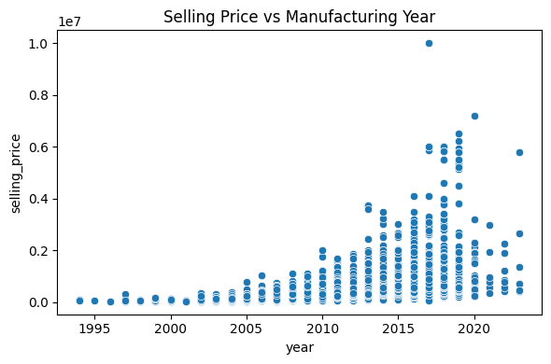
- Box plots of fuel type vs. price, highlighting higher median prices for Diesel cars.
- A correlation matrix heatmap to quantify feature relationships.
Feature Importance Chart (Note: Described as text since actual chart cannot be included):
- A bar chart displaying feature importance scores (e.g., year: 0.30, engine: 0.20), created using Matplotlib, with labels and colors for clarity.

5.2 CHALLENGES FACED
- DATA QUALITY: The dataset had 221 missing values and 1,189 duplicates, reducing the size from 8,148 to 5,328 observations (34.6% data loss). Dropping rows was effective but reduced dataset diversity.
- RARE CATEGORIES: Limited data for Electric cars (1%), CNG (3%), and LPG (1%) led to lower prediction accuracy for these cases.
- FEATURE ENCODING: Integer encoding for brands (e.g., Maruti=1, Hyundai=2) assumed an ordinal relationship, potentially introducing bias.
- OUTLIERS: Inconsistencies (e.g., BMW with 998 CC engine) were noted but not fully addressed, impacting model reliability.
- HYPERPARAMETER TUNING: Default Random Forest parameters were used, potentially missing opportunities for optimization.

5.3 LEARNINGS
- Mastered the end-to-end machine learning pipeline, from data preprocessing to deployment.
- Gained proficiency in Python libraries (pandas, scikit-learn, Streamlit) and their application in real-world problems.
- Understood the importance of EDA in identifying key price drivers (e.g., year, engine).
- Learned to balance model complexity and performance using Random Forest’s ensemble approach.
- Developed skills in building and deploying user-friendly web applications with Streamlit.
- Recognized the challenges of handling imbalanced datasets and the need for advanced techniques (e.g., oversampling, feature selection).

CHAPTER 6: CONCLUSION
6.1 SUMMARY
- Successfully developed a Random Forest regression model to predict used car prices, achieving an R² score of 0.9128, explaining 91.28% of price variance, and an RMSE of approximately 251,460 INR on a test set of 1,066 cars.
- Preprocessed a dataset of 8,148 car listings, reducing it to 5,328 observations by removing 221 rows with missing values and 1,189 duplicates, and engineered features like car brand and numerical values for mileage and engine.
- Identified key price drivers through feature importance analysis: year (30%), engine (20%), max power (15%), and kilometers driven (10%), aligning with domain knowledge about car valuation.
- Deployed the model via a Streamlit web application, enabling real-time price predictions for users by inputting car details (e.g., brand, year, fuel type), enhancing accessibility for buyers, sellers, and dealerships.
- Faced challenges with rare categories (e.g., Electric cars, 1% of data) and outliers (e.g., BMW with 998 CC engine), which reduced prediction accuracy for specific cases.
- Proposed future improvements, including hyperparameter tuning (e.g., GridSearchCV), advanced feature selection (e.g., Recursive Feature Elimination), and collecting more data for rare categories to enhance model robustness.
- Gained practical skills in the end-to-end machine learning pipeline, including data preprocessing, exploratory data analysis, model training, evaluation, and web deployment using Python and Streamlit.
- Demonstrated the application of machine learning to solve real-world problems in the automotive industry, providing a valuable tool for pricing decisions and market analysis.
- Highlighted the need for further research, such as experimenting with models like XGBoost or incorporating additional features (e.g., car model details), to improve prediction accuracy and generalizability.

REFERENCES
- SCIKIT-LEARN: Machine Learning in Python, https://scikit-learn.org/stable/.
- STREAMLIT: A faster way to build and share data apps, https://streamlit.io/.
- PANDAS: Python Data Analysis Library, https://pandas.pydata.org/.
- NUMPY: The fundamental package for scientific computing with Python, https://numpy.org/.
- DATACAMP: Introduction to Regression with Python, https://www.datacamp.com/community/tutorials/introduction-regression-python.
- KAGGLE: Car Price Prediction Dataset, https://www.kaggle.com/datasets.
- STREAMLIT DOCUMENTATION: Building Web Apps with Python, https://docs.streamlit.io/.

