**COMMANDS:-**

1. **Check Python version – python --version**
2. **Check Django version – django-admin --version**
3. **CREATE A PROJECT – django-admin startproject test(name of the project or folder)**
4. **Create app in a project – python manage.py startapp poduct(name of the app)**
5. **Create a folder for put all static files :- python manage.py collectstatic**
6. **Reset Password:** **python manage.py changepassword puja**

**Remember :-(in models)**

**We have to write a app config in setting.py🡪 Install apps**

**To Admin settings-**

**We have to create super user:**

**🡪python manage.py createsuperuser.**

**To show database in admin:**

**We have to register the model(class or table) in admin file. Ex- admin.site.register(Destination)**

**To image settings-**

**Step1**

**We have field also for image in models: ImageField(upload_to=’pics’)**

**Step-2**

**Then go to the settings.py and specify the path:**

**MEDIA_URL=’/media/’**

**MEDIA_ROOT=os.path.join(BASE_DIR,’media’)**

**Step-3**

**We have to go main project urls.py file then import & write path after the urlpatterns like:-**

from django.conf import settings

from django.conf.urls.static import static

urlpatterns = [

    path('admin/', admin.site.urls),

    path('',include('Trip.urls'))

]+static(settings.MEDIA_URL,document_root=settings.MEDIA_ROOT)

**MVT- Model View Template: MVT Framework (Model use for data which is come from database, View is use to write logic and Template is use for layout)**

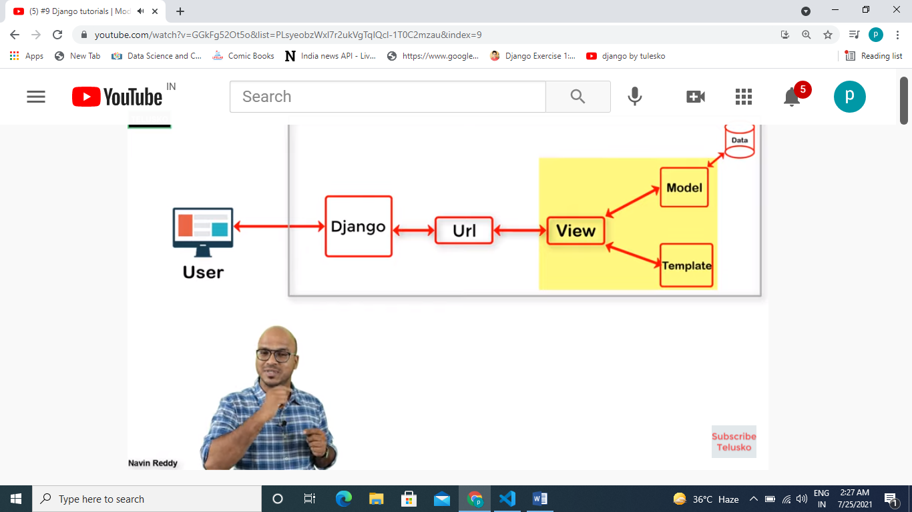

**MVC: - Model View Controller,**

**Django(MTV) Spring(MVC)**

**Model Model**

**Template View**

**View Controller**