(School of engineering and Technology)

Assignment 2

Topic

Linux Setup and Automation

Submitted By: Submitted To:
Kajal Mr. Rajesh Sir
2501360019
B. Tech CSE(UX/UI) -1st SEM

1. Introduction

Linux, a powerful and open-source operating system, stands as one of the most essential skills for anyone in the field of Computer Science and Information Technology.
It provides unmatched flexibility, stability, and control, allowing developers and administrators to perform tasks efficiently using the command line and shell scripting.
This assignment explores the process of installing Linux, executing fundamental commands, and writing automation scripts that simplify repetitive system tasks.
By completing this exercise, we understand not only the technical procedures but also the logical mindset required for system automation and efficient computing.

2. Linux Installation

Overview
Ubuntu Linux was installed using the Windows Subsystem for Linux (WSL) on Windows 11.
This method provides the full functionality of a Linux environment within Windows, eliminating the need for a virtual machine or dual-boot setup.
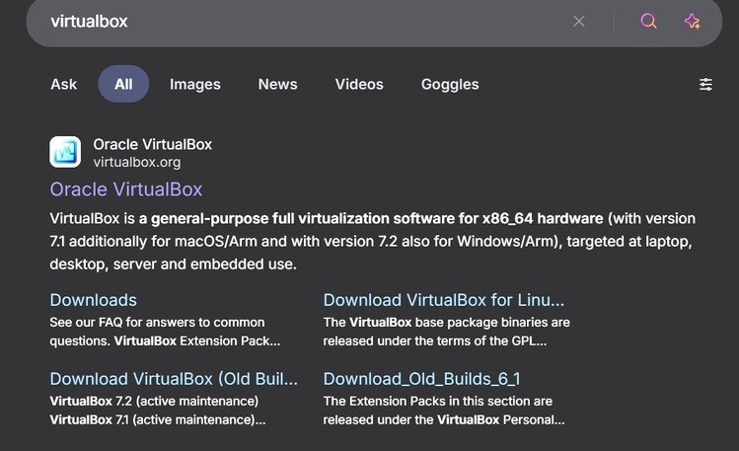

System Configuration:
. CPU: ryzen 7 (7000 series )
• RAM: 8 GBS
• Disk Allocation: 50 GB
• Operating System: Windows 11

Installation Steps:
- Open Microsoft Store and search for “Ubuntu”.
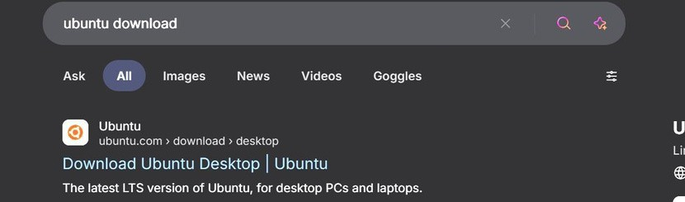

2. Click Get to install the Ubuntu distribution.
3. Launch Ubuntu from the Start Menu.
4. Create a username and password for the Linux user.
5. Run the following command to update all packages
6. Verify the installation by typing ls, pwd, and whoami to ensure everything works correctly

3. Shell Command Implementation and Documentation

The table below lists 20 essential Linux commands, including their syntax, purpose, and when to use them.
These commands help navigate the file system, manage files, control permissions, and monitor system activity.

Command Description Example Purpose / Output
ls List files and directories ls -l Displays files in detail
cd Change directory cd Documents Switches to Documents folder
pwd Print working directory pwd Shows current path
mkdir Create new directory mkdir projects Makes folder “projects”
touch Create filetouch demo.txt Creates empty text file
cp Copy files cp a.txt backup/ Copies file to backup
mv Move/Rename mv old.txt new.txt Moves or renames
rm Remove files rm test.txt Deletes the file
chmod Change permissions chmod 755 script.sh Grants execute rights
chown Change ownership chown user file.txt Transfers ownership
ps Process status ps aux Lists running processes
top System monitor top Displays live CPU/RAM stats
kill Terminate process kill 1234 Stops process with PID 1234
ping Test connectivity ping google.com Checks internet connection
ifconfig View network info ifconfig Shows IP configuration
netstat Network statistics netstat -tuln Lists open ports
echo Print text echo “Hello World ’’ Displays message
cat View file content cat notes.txt Prints file data
grep Search text grep “main” file.c Finds matching text
history Show past commands history Lists command history

4. Shell Script Development
Three Bash scripts were created to demonstrate automation tasks in Linux.
- Backup Script:
#!/bin/bash
# Author: Kajal
# Date: 15 Nov 2025
# Purpose: Backup a directory with a timestamp

src_dir=$1
backup_dir=$HOME/backup_$(date +%Y%m%d_%H%M%S)
mkdir -p $backup_dir
cp -r $src_dir $backup_dir
echo "Backup created successfully at $backup_dir"

. This script copies any given directory into a backup folder, automatically naming it with the current date and time.

- CPU/Memory Monitoring Script:
#!/bin/bash
# Author: kajal
# Purpose: Log CPU and Memory usage period logfile=$HOME/system_usage.log
while true; do
echo "$(date): CPU/Memory Status" >> $logfile
top -bn1 | head -n 5 >> $logfile
sleep 60
done
. This script logs CPU and memory usage every minute into a log file for later analysis.

- Automated Download Script:
#!/bin/bash
# Author: kajal
# Purpose: Download a file from a URL using wget
url=$1
dest=$HOME/downloads
mkdir -p $dest
wget -P $dest $url
echo "Download complete. File saved in $dest"
. This script uses wget to automatically download a file from the internet and store it in a predefined directory.

6. Reflection and Learning Outcomes
The assignment finally gave me an opportunity to understand the core of Linux-not just an operating system, but a powerful environment for creativity and control.

Everything from the installation of Ubuntu to using commands on shells built another layer of confidence. I remember how much file permissions-which is chmod-and process management bothered me, but it really taught me how powerful command line tools can be if understood correctly. Writing shell scripts brought with it a sense of empowerment at realizing that much repetitive work was able to be automated in just a few lines of code. Most importantly, I learned how Linux scripting fits into modern professional roles in DevOps, cybersecurity, and cloud computing, where automation and precision are key. Conclusion: The experience not only cemented my technical know-how but also nurtured an appreciation for free and open-source tools and collaborative platforms like GitHub.

