1  Creating and Renaming Files/Directories

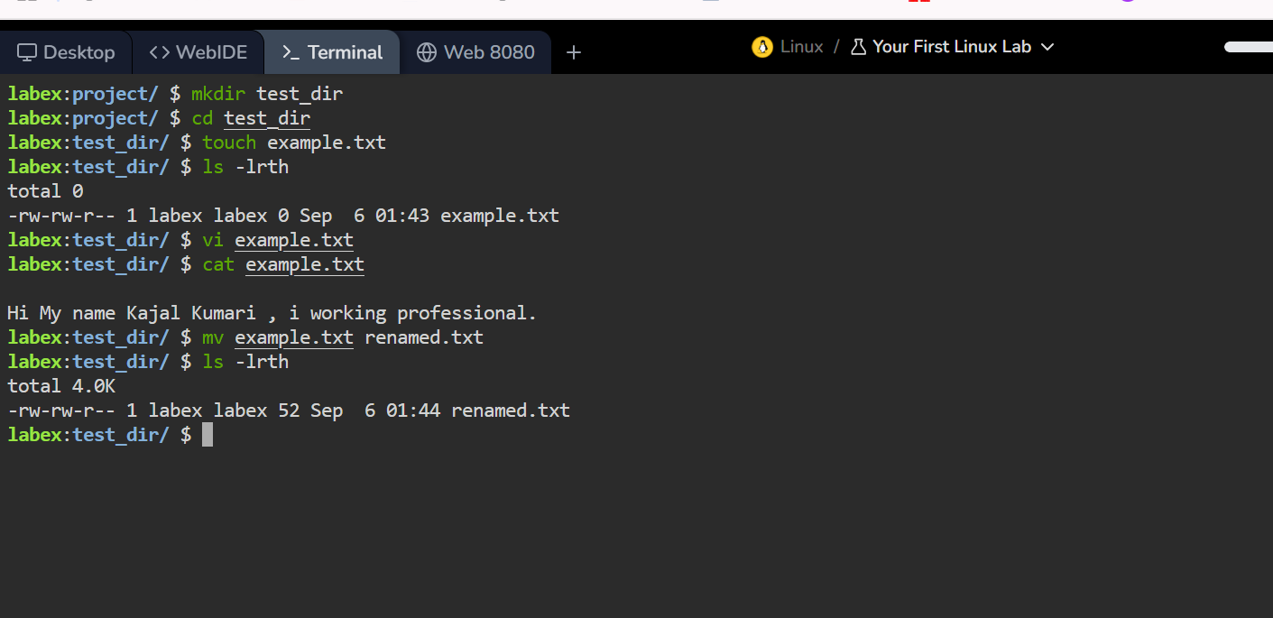

2. Viewing File Contents

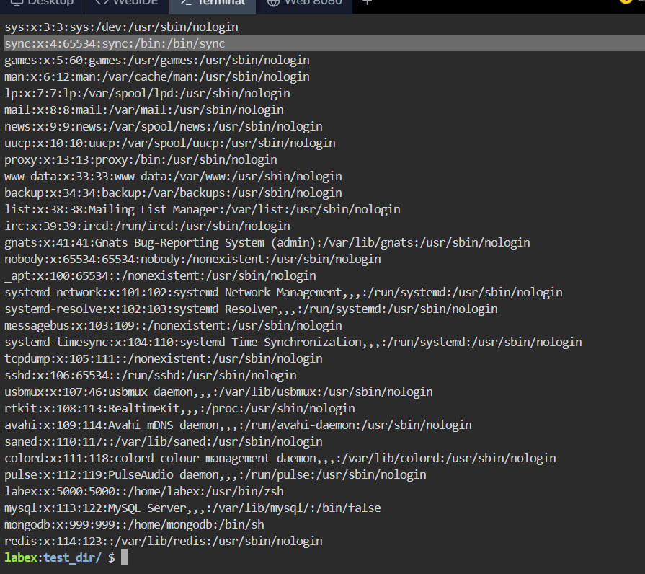

Display only the first 5 lines of /etc/passwd using head.

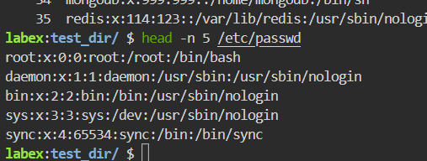

Display only the last 5 lines of /etc/passwd using tail.

With the help of tail command we will get the last lines of /etc/passwd

3.Searching for Patterns

Use grep to find all lines containing the word "root" in /etc/passwd.

4. Zipping and Unzipping

Compress the test_dir directory into a file named test_dir.zip using zip.

Unzip test_dir.zip into a new directory named unzipped_dir.

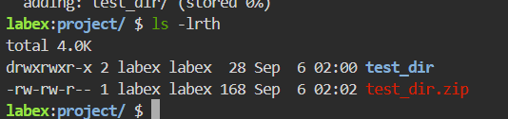

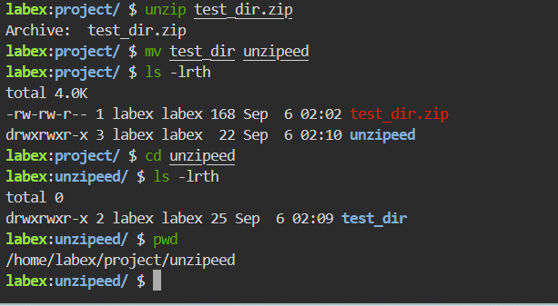

5. Downloading Files

Use wget to download a file from a URL (e.g., <https://example.com/sample.txt>).

6. Changing Permissions

Create a file named secure.txt and change its permissions to read-only for everyone using chmod.

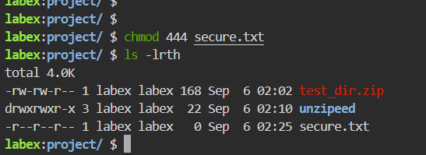

7. Working with Environment Variables

Use export to set a new environment variable called MY_VAR with the value "Hello, Linux!".

