**MODULE: 1 (SDLC)**

* What is software? What is software engineering?

Answer:-

Software: Software is a set of instructions, data or programs used to operate computers and execute specific tasks. It is the opposite of hardware, which describes the physical aspects of a computer

Software engineering: Software engineering is the process of developing, testing and deploying computer applications to solve real-word problems by adhering to a set of engineering principles and best practices.

* Explain types of software.

Answer :- There are a 5 types of software which are listed a below:

i) Application software

ii) System software

iii) Driver software

iv) Middleware

v) Programming software

i) Application Software:- The most common type of software, application software is a computer software package that performs a specific function for a user, or in some cases, for another application.

Example: Microsoft Office, Paint, Power point etc..

ii) System Software:- These software programs are designed to run a computer’s application programs and hardware.

The OS is the best example of system software; it manages all the other computer programs.

Example: Notepad, Calculator etc..

iii) Driver Software:- Also known as device drivers, this software is often considered a type of system software.

Device drivers control the devices and peripherals connected to a computer, enabling them to perform their specific tasks.

Example: Audio Driver, Video Driver etc..

iv) Middleware:- The term middleware describes software that mediates between application and system software or between two different kinds of application software. For example, middleware enables Microsoft Windows to talk to Excel and Word.

Example: database middleware, application server middleware

v) Programming Software:- Computer programmers use programming software to write code. Programming software and programming tools enable developers to develop, write, test and debug other software programs.

Example: Turbo c, Eclipse, Sublime etc..

* What is SDLC? Explain each phase of SDLC.

Answer:- SDLC stands for Software Development Life Cycle. The Software Development Life Cycle (SDLC)  
refers to a methodology with clearly defined processes for creating high-quality software. In detail, the SDLC methodology focuses on the following phases of software development:

1. Requirement Gathering
2. Analysis
3. Designing
4. Implementation
5. Testing
6. Maintenance

* What is DFD? Create a DFD diagram on Flipkart.

Answer:- DFD is the abbreviation for Data Flow Diagram. The flow of data of a system or a process is represented by DFD.

DFD diagram on Flipkart listed a below:-

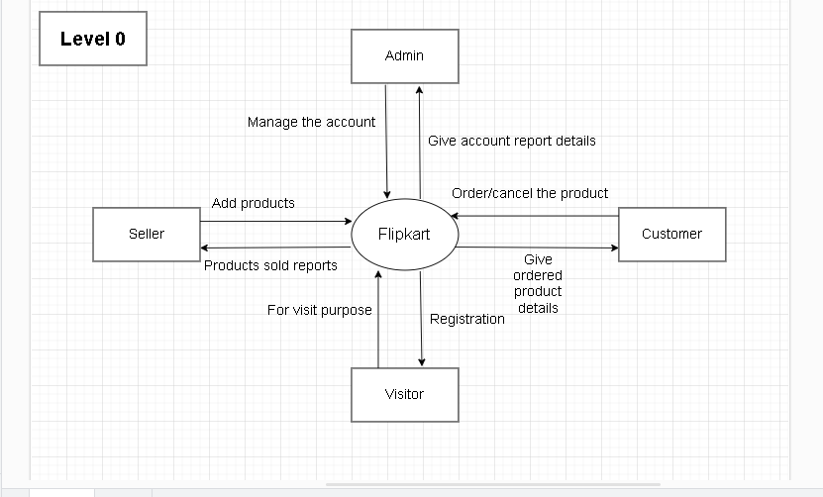

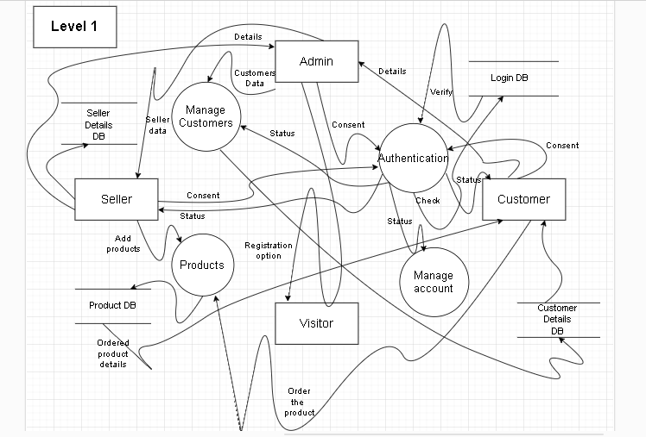

* What is Flow chart? Create a flowchart to make addition of two numbers

Answer:- A flowchart is a type of diagram that represents a workflow or process. A flowchart can also be defined as a diagrammatic representation of an alogorithm, a step-by-step approach to solving a task.

Flowchart of addition of two numbers listed a below:-

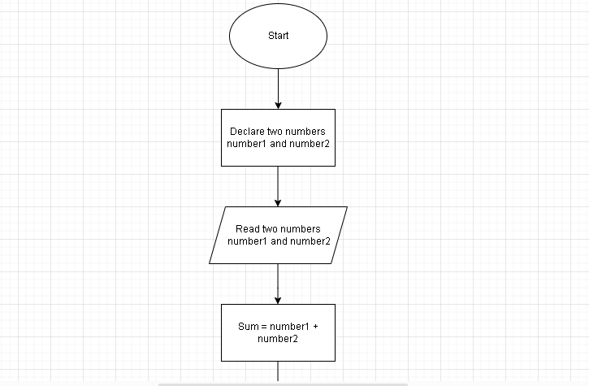

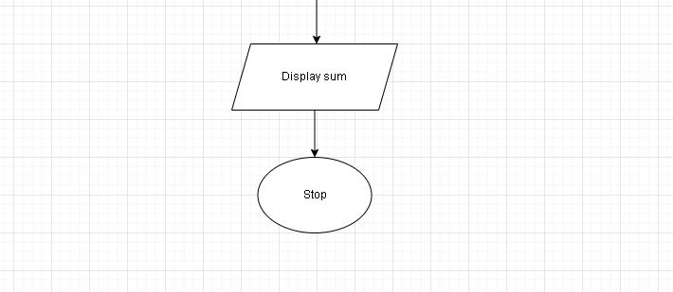

* What is Use case diagram? Create a use-case on bill payment on paytm

Answer:- A use case diagram is used to represent the dynamic behavior of a system. It encapsulates the system’s functionality by incorporating use cases, actors, and their relationships.

Use case diagram on bill payment on paytm listed a below:-

