BluePrint
Evidence-first founder decision system
━━━━━━━━━━━━━━━━━━━━━━━━

Turn the unfinished idea into your next provable move.

Built with | n8n · Nebius · Supabase · You.com · Pinecone · Mem0
Current Evidence | 85/85 agentic regression cases passing
Repository | https://github.com/kajalchourasia-cmd/blueprint-v2
Prepared | 30 August 2026

1. Problem, Vision and Release Scope

1.1 The founder problem
Early-stage founders do not lack information; they lack a trustworthy decision path. Customer signals, competitor notes, market facts, constraints and next actions are usually split across search tabs, spreadsheets and isolated AI chats. The result can sound polished while hiding weak evidence, duplicated assumptions and unclear ownership.

The decision problem is:
How might we help a founder turn an unfinished idea into a sourced, progressive Blueprint that shows what is known, what is assumed, what is risky and what should be tested next—without pretending that desk research proves demand?

1.2 Target user and job to be done
Primary user: an early-stage founder or product lead with an idea but incomplete proof.
Core job: decide whether to proceed, revise or pause, then understand the smallest defensible next move.
Success is not “the model wrote a report.” Success is that the founder completes the evidence-to-decision workflow, can inspect the sources and assumptions, and reaches the next stage only through an explicit checkpoint.

1.3 Product vision
Blueprint is an evidence-first multi-agent decision system. It captures the founder’s goal and constraints, creates Foundation immediately, runs Customer/User, Competitor and Market research through specialist agents, independently audits the evidence, calculates a transparent viability verdict and builds a versioned Blueprint that changes as accepted evidence changes.

1.4 V1 release boundary

In scope:
• Founder idea, user, geography, goal, capital, time and prior-evidence onboarding.
• Customer/User, Competitor and secondary Market research.
• Evidence audit, deterministic scoring, progressive Blueprint and financial readiness boundary.
• Contextual Ask Blueprint RAG, founder checkpoints, targeted rerun preview, memory, observability and bounded recovery.

Deliberately out of scope:
• Sending messages, contacting leads, booking meetings, publishing, paying or deleting.
• Claiming public desk research is a completed customer interview or proven willingness to pay.
• Uploaded-document ingestion and LlamaIndex pipelines; planned for V2.
• Voice interaction, model fine-tuning and autonomous business execution.

2. Agent Framework and Autonomy Boundary
The one-liner and framework below define Blueprint before the architecture: its job, autonomous boundary, human approvals, memory, failure handling and measurable completion rule.

Blueprint’s one-liner

Blueprint helps an early-stage founder turn an unfinished product idea into an evidence-backed decision and next-step Blueprint in a web app, replacing fragmented manual research across search tabs, notes and spreadsheets; it autonomously plans and runs scoped customer, competitor and market research through n8n, You.com and Nebius, hands stage progression, reruns and every write action to the founder, and succeeds when the founder reaches a grounded proceed, revise or pause decision with traceable evidence.

Three rules that govern Blueprint
- Task completion, not single-shot accuracy. Blueprint succeeds when the founder completes the evidence-to-decision workflow, not when one model call sounds persuasive.
- State is the hard part. Supabase owns durable truth; Streamlit holds only session UI state; Pinecone and Mem0 are bounded, rebuildable projections.
- Write actions deserve a human. Read-only research may run autonomously, while reruns, profile-truth changes, stage progression and every external write require explicit approval.

Completed agent framework
The framework fixes the control flow, authority and failure behavior before implementation details.

Field | Blueprint decision
Agent goal | Turn an unfinished founder idea into an evidence-backed proceed, revise or pause decision and a versioned next-step Blueprint.
Where do people use it? | A public-facing Streamlit web app with no visible sign-up; founders move from onboarding to research, verdict, Blueprint and section-scoped chat.
What steps does it take, in order? | 1. Capture the idea, goal and constraints. 2. Create Foundation immediately. 3. Plan and run selected customer, competitor and market research in parallel. 4. Audit evidence. 5. Compute the viability verdict. 6. Ask the founder to proceed, revise, override or pause. 7. Version the Blueprint and resume the approved route.
What can it actually do? | Read autonomously: query web sources, retrieve owner-scoped project state and inspect accepted evidence. Analyze: plan tasks, synthesize findings, detect conflicts, calculate deterministic scores and critique quality. Write only with approval: create a new Blueprint version, rerun research or advance a stage. It never sends messages, pays, purchases, publishes or deletes.
What does it need to remember? | Session memory: selected page and transient UI state. Durable episodic state: idea, profile versions, runs, tasks, evidence, decisions and Blueprint versions in Supabase. Semantic evidence: accepted project evidence in Pinecone. Founder journey: confirmed goals, preferences, constraints and corrections in Mem0.
What should it never do? | Never invent demand, market size, willingness to pay or citations; never expose another owner’s data; never treat Pinecone or Mem0 as canonical truth; never store raw chain of thought; never silently rerun, advance a gate, contact someone, publish, pay or delete.
Human-in-the-loop | The founder reviews the research verdict before Stage 2, reviews Gate 2 before the Action Blueprint, approves every rerun or profile-truth change, and explicitly approves any write. Reads remain autonomous.
What happens when something breaks? | Classify the failure, persist a redacted observation and preserve successful sibling work. Retry transient failures within budget; perform one bounded schema/citation repair; otherwise return needs input, partial completion, human review or safe fail. Resume from durable Supabase state.
How do you know it worked? | A founder completes Stage 1, understands the evidence and limitations, and reaches a justified gate decision without operator assistance. Demo target: a usable verdict and next move in under 15 minutes, with end-to-end completion in at least 8 of 10 evaluation runs.

3. Solution Overview

Blueprint converts one founder idea into a controlled evidence loop:
• Capture founder context once and persist it as owner-scoped state.
• Produce deterministic Foundation immediately.
• Plan and dispatch eligible research modules instead of executing one fixed A→B→C chain.
• Run Customer/User, Competitor and Market specialists independently and in parallel.
• Audit claims before they affect the verdict.
• Pause at a founder gate before any consequential rerun or stage transition.
• Preserve completed work, failures, contradictions and versions so the next route is explainable.

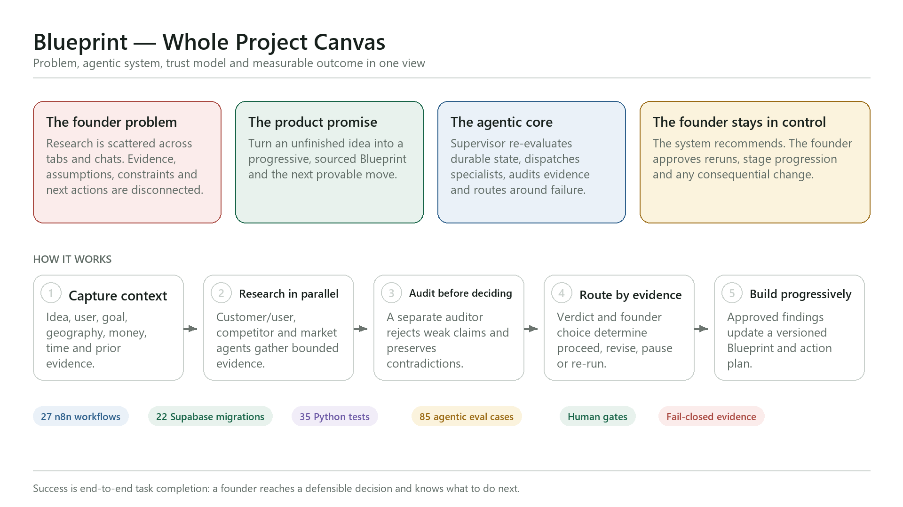

4. Founder Experience and End-to-End User Flow

The founder starts on the Streamlit landing page, describes the idea and completes a bounded onboarding flow. The dashboard opens on Foundation immediately while research tasks move through waiting, running, completed, needs-input, human-review or failed states. Completed sections remain readable while siblings continue. The founder can inspect sources, ask section-specific questions, open the full progressive Blueprint and review a financial boundary without losing the active run.

Gate 1 appears only after the selected Stage 1 research streams and Evidence Audit reach a terminal state. The founder can proceed, revise/pivot, rerun a scoped module, override with a recorded reason or pause. Stage 2 Prove & Design remains locked until that decision. Stage 3 is advisory: it proposes MVP, first-customer, launch and distribution milestones but does not execute the founder’s business.

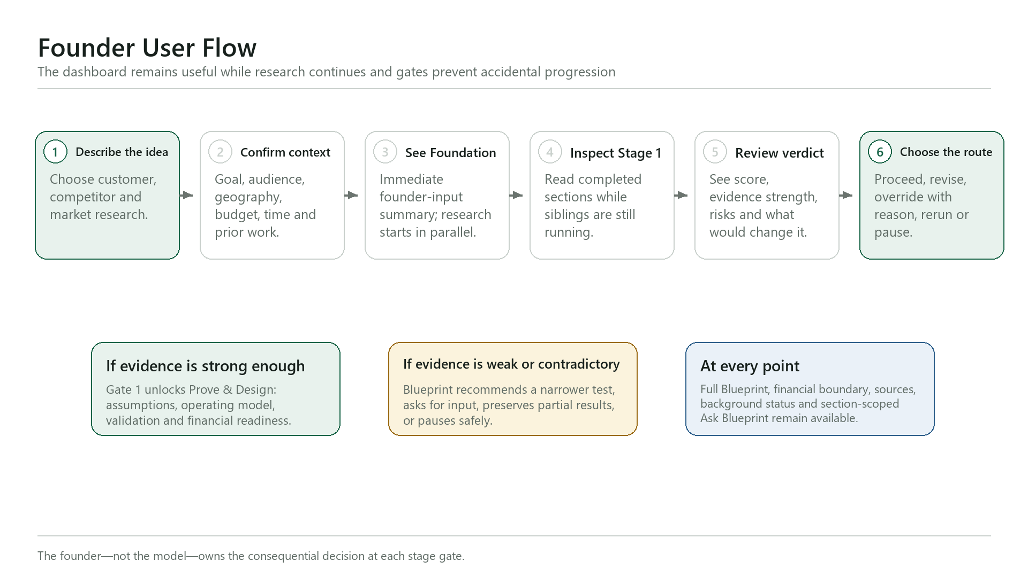

5. End-to-End Architecture

The system separates three concerns:
• Experience layer — Streamlit presents onboarding, progress, research, chat and approvals.
• Control plane — n8n verifies the request, loads durable state, plans work, schedules eligible tasks, calls specialists, audits results and waits at human gates.
• Data and evidence plane — Supabase is canonical; You.com supplies bounded web discovery; Nebius performs structured extraction and review; Pinecone and Mem0 are rebuildable, lower-authority projections.

This separation prevents a model response, vector result or chat history from silently becoming project truth.

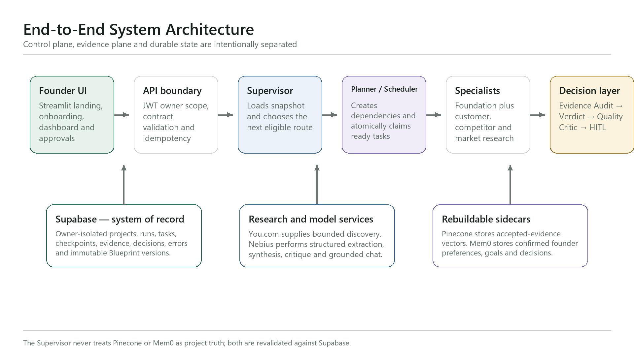

6. Why This Is Agentic, Not a Fixed Workflow

A fixed workflow would always run the same next node. Blueprint instead re-evaluates durable state after every observation. The Supervisor can dispatch ready work, request missing founder input, route a repair, reload stale state, preserve a partial result, escalate a contradiction, stop safely or wait at a gate. The planner creates only allowlisted tasks and dependencies; the scheduler atomically claims only currently eligible work.

“Learning” in V1 means closed-loop adaptation from recorded outcomes: accepted or rejected evidence, corrections, task observations, gate decisions and prior failures change the next plan. It does not mean hidden self-training or weight updates.

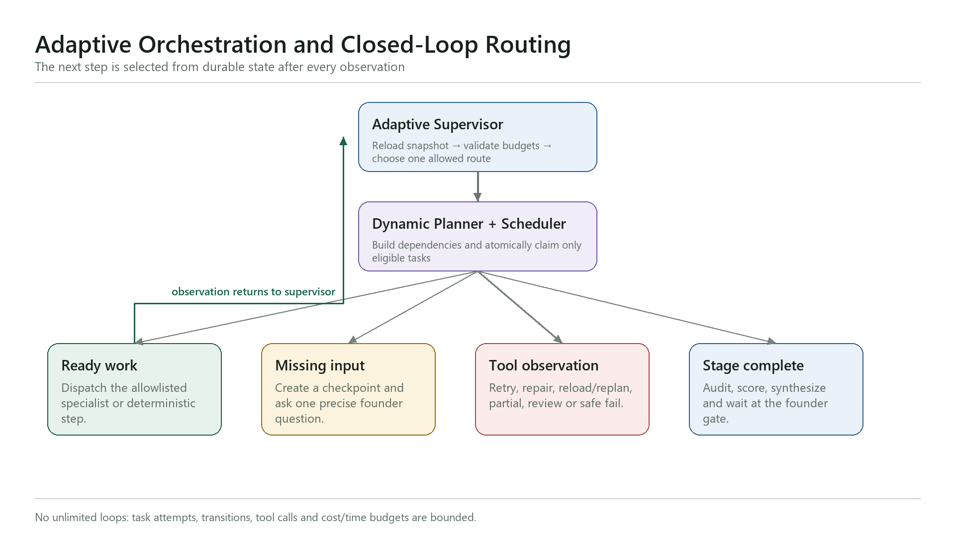

7. Stage 1 Research Agents and Decision Convergence

Foundation builder
Deterministic Python/n8n logic converts confirmed onboarding answers into the problem hypothesis, user boundary, success definition, constraints, riskiest assumptions, unknowns and action prompts. It intentionally performs no web search and no model call, so the founder sees useful output immediately.

Customer/User Research specialist
Defines the user problem, goals and jobs; produces evidence-bounded personas; distinguishes public signals from actual interviews; identifies current behaviours, triggers, barriers and willingness-to-pay unknowns; and creates a primary-research plan with recruitment channels and non-leading questions.

Competitor Research specialist
Separates direct competitors from indirect alternatives, services, manual workarounds, non-consumption and status quo. It profiles core offer, MVP, strengths, complaints, pricing boundary, geography relevance and evidence-backed gaps. Directories and search tools are sources—not competitors.

Market Research specialist
Performs secondary research only. It maps category direction, reachable beachhead, demand/adoption forces, constraints, market fit and misalignment. Unsupported TAM, CAGR, revenue, conversion or willingness-to-pay figures are withheld rather than estimated.

Evidence Auditor and Viability Engine
A separate auditor checks citation allowlists, relevance, freshness, conflicts, coverage and missing streams. Only accepted evidence can affect the 40/30/30 demand, differentiation and market-access score. Evidence sufficiency is reported separately from commercial viability.

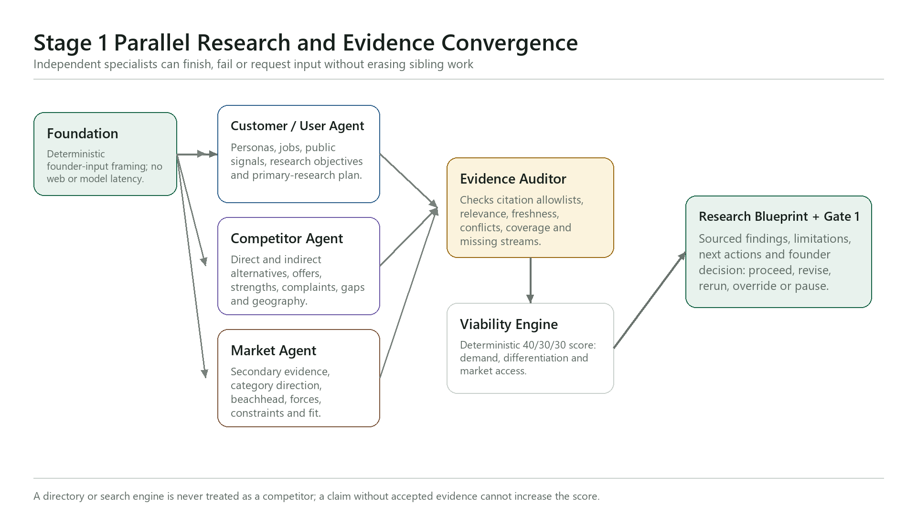

8. Agent Handoffs and Shared-State Contract

Agents do not exchange hidden reasoning. Every handoff carries typed, inspectable fields: owner, project, run, state version, module, dependencies, attempt, status, evidence IDs, observation verdict, route reason, checkpoint and output version. Supabase optimistic versioning prevents stale workers from overwriting newer decisions.

The main roles are the API boundary, Adaptive Supervisor, Dynamic Planner, Eligible Scheduler, three research specialists, Evidence Auditor, Viability Engine, Blueprint Synthesizer, independent Quality Critic, Research Copilot and Failure Router. Narrow roles improve testability and stop one agent from quietly crossing another role’s authority.

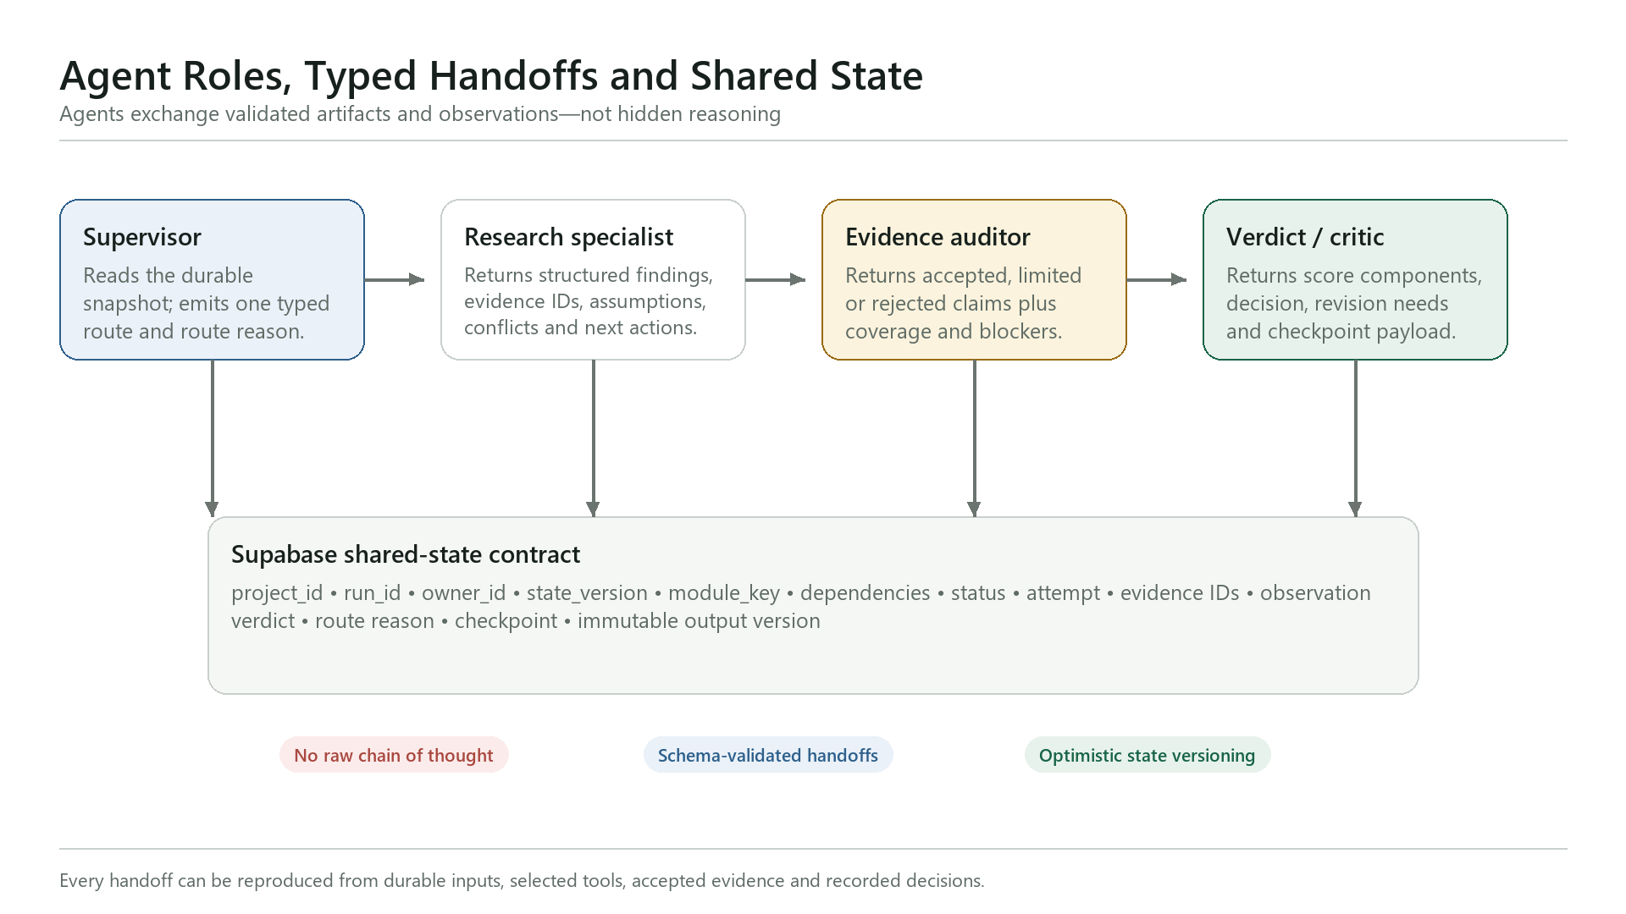

9. State and Memory Design

Blueprint uses four memory layers because no single store can safely serve every purpose:
• Streamlit session memory — temporary navigation and UI context.
• Supabase episodic memory — canonical projects, runs, tasks, evidence, decisions, errors, checkpoints and immutable Blueprint versions.
• Pinecone semantic memory — rebuildable vectors for accepted evidence only; every hit is revalidated against Supabase.
• Mem0 founder-journey memory — confirmed goals, preferences, corrections and decisions for cross-session personalization; never project truth.

Raw chain of thought, provider secrets, unconfirmed personalization and rejected evidence are not persisted.

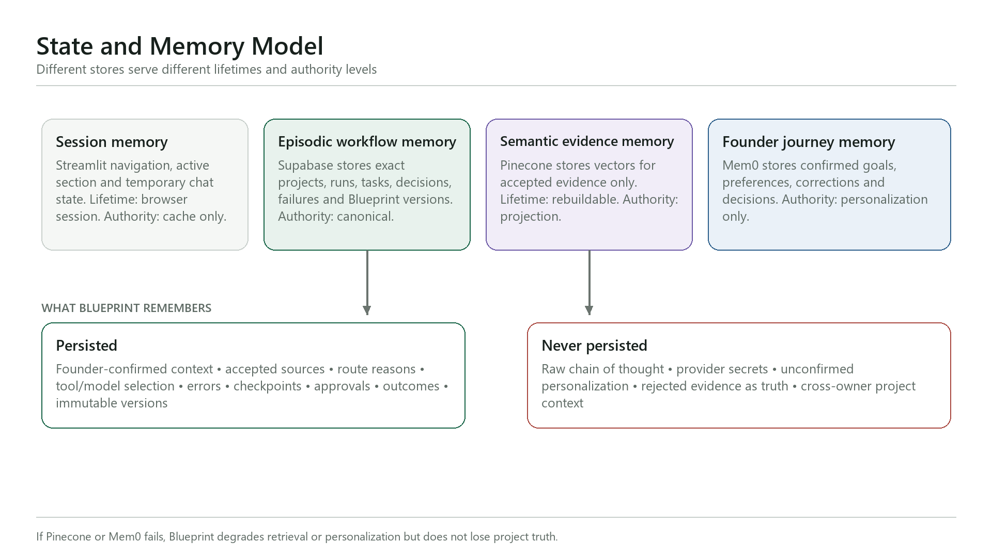

10. Ask Blueprint: Grounded RAG and Action Coaching

Ask Blueprint is section-scoped and owner-scoped. It classifies the request, loads the selected section and accepted project evidence from Supabase, optionally retrieves semantically related accepted evidence from Pinecone, revalidates every hit and generates a bounded answer with citations, limitations and a suggested next move.

The assistant has three lanes:
• Project facts require accepted evidence.
• Stable general explanations are labelled as general guidance.
• Action coaching can expand an existing Blueprint actionable into founder-run steps.

A rerun is only a proposal until the founder approves its dependency impact. Requests to contact, send, publish, buy, book, pay or delete are denied with a safe alternative.

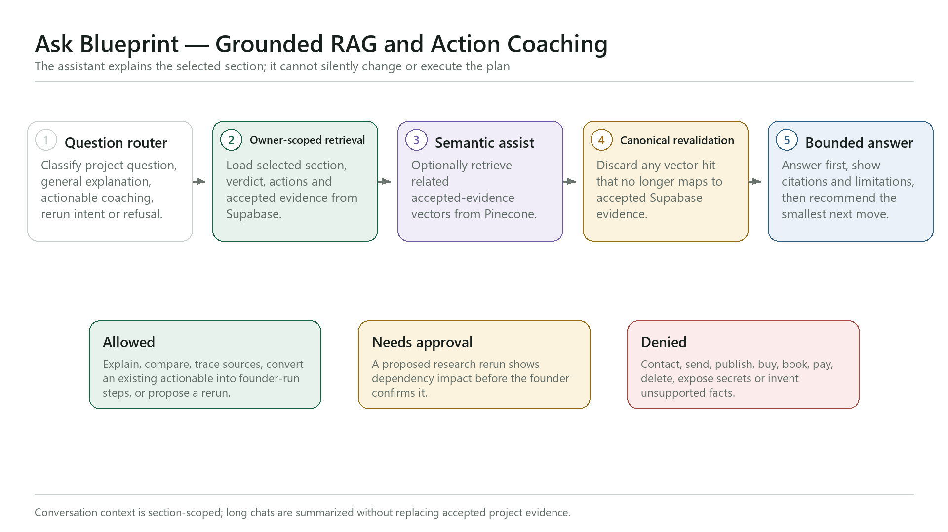

11. Human-in-the-Loop, Failure Handling and Recovery

Reads may be autonomous. Any action that changes confirmed founder truth, invalidates downstream work, creates a finalized Blueprint version, reruns research, advances a stage or affects an external system requires human approval.

Expected failures enter a shared resilience controller. It classifies authentication, policy, rate-limit, timeout, empty-result, schema, grounding, quality, conflict, budget, provider and internal failures, then selects exactly one bounded route: retry, repair, reload/replan, memory-degraded, partial-complete, human-review, safe-fail or policy-denied. BP-90 remains the global uncaught-error boundary.

Successful sibling research is preserved. Unsupported citations are rejected. Contradictions lower confidence. Attempt, transition, tool-call, cost and time budgets prevent infinite loops.

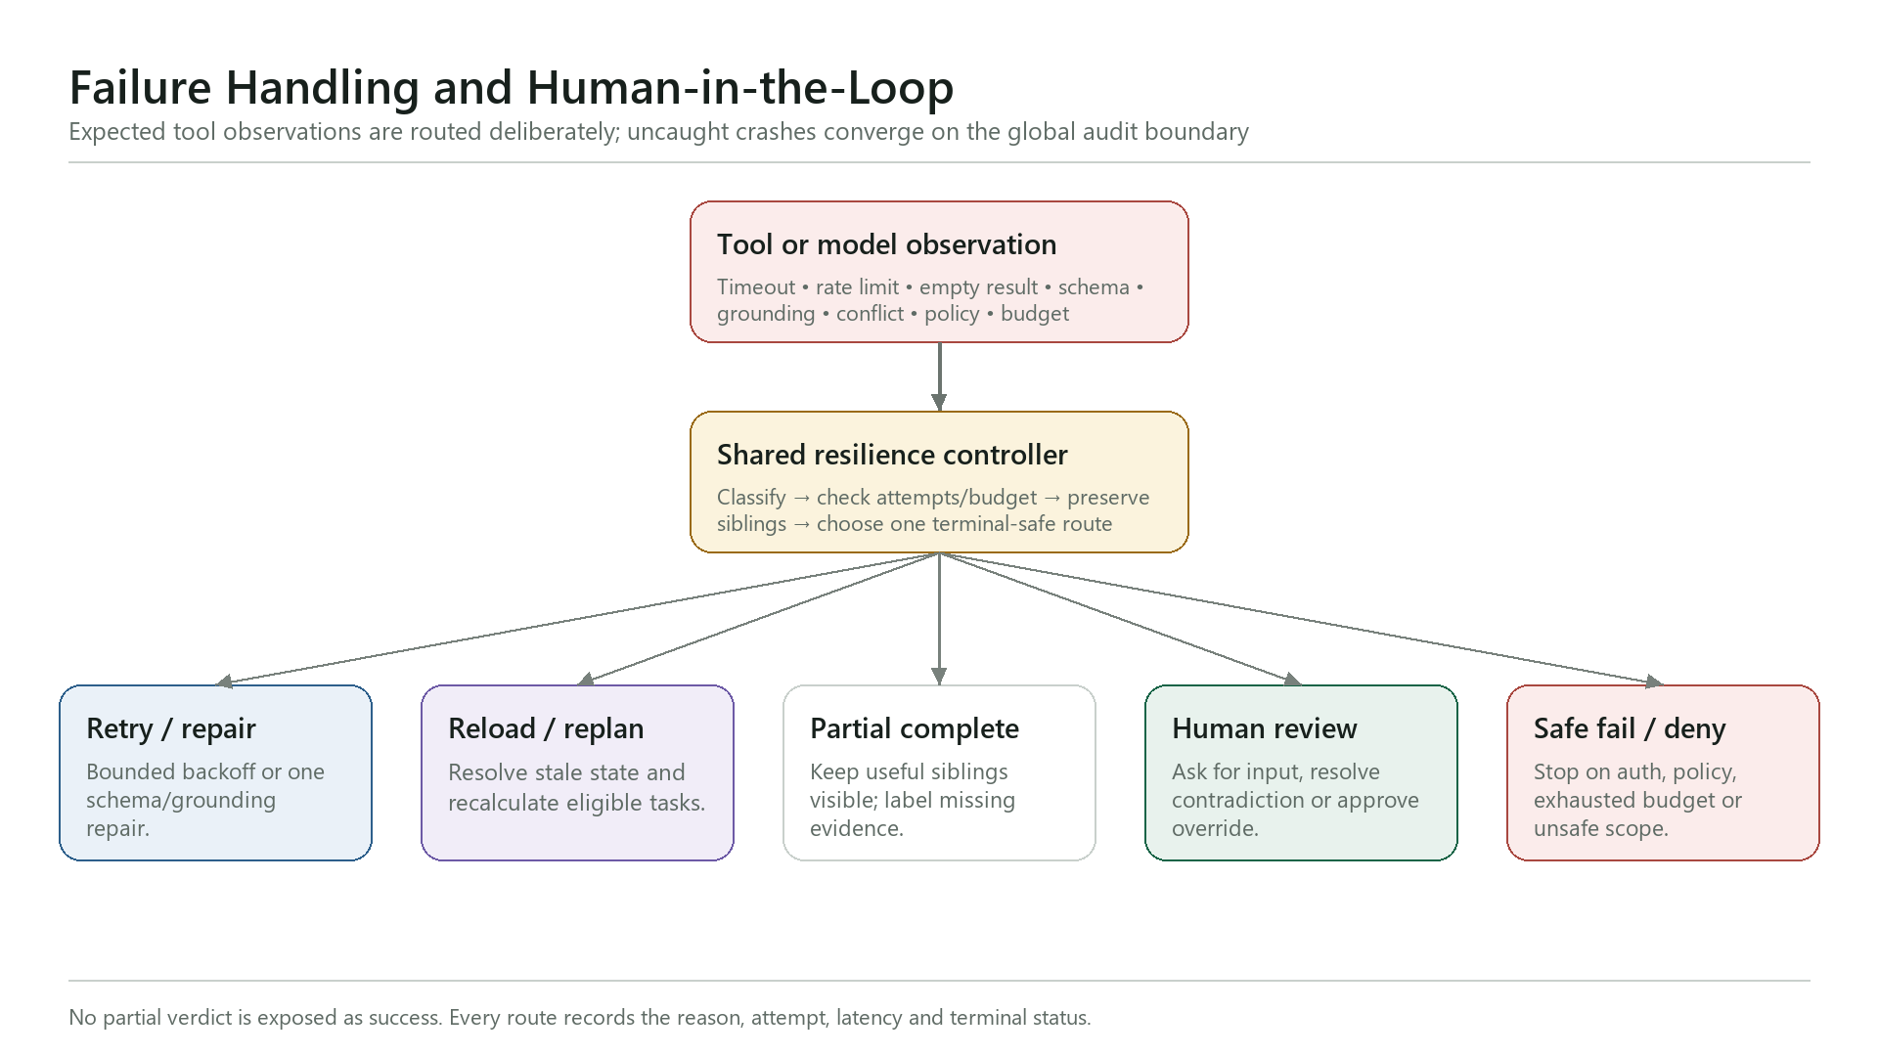

12. Evaluation, Observability and Performance

The acceptance target is task completion with inspectable evidence and safe recovery. The current repository verifies:
• 35/35 Python tests covering owner-isolated anonymous sessions, API contracts, deterministic Foundation, progress restoration, titles and grounded-chat fallbacks.
• 11/11 Stage 6B workflow-structure checks.
• 85/85 agentic regression cases across scope, security, routing, state, HITL, grounding, budgets, completion, memory, reruns and failures.

Every important route records owner/project/run identity, task and attempt, selected tool/model, timestamps and latency, evidence outcome, retry/repair reason, checkpoint and final status. Secrets are never written to traces.

Latency is handled by design: Foundation is deterministic; the three Stage 1 specialists can run in parallel; completed sections stream into the dashboard; queries and result sizes are bounded; model roles use explicit token budgets; and failures stop or degrade instead of spinning indefinitely.

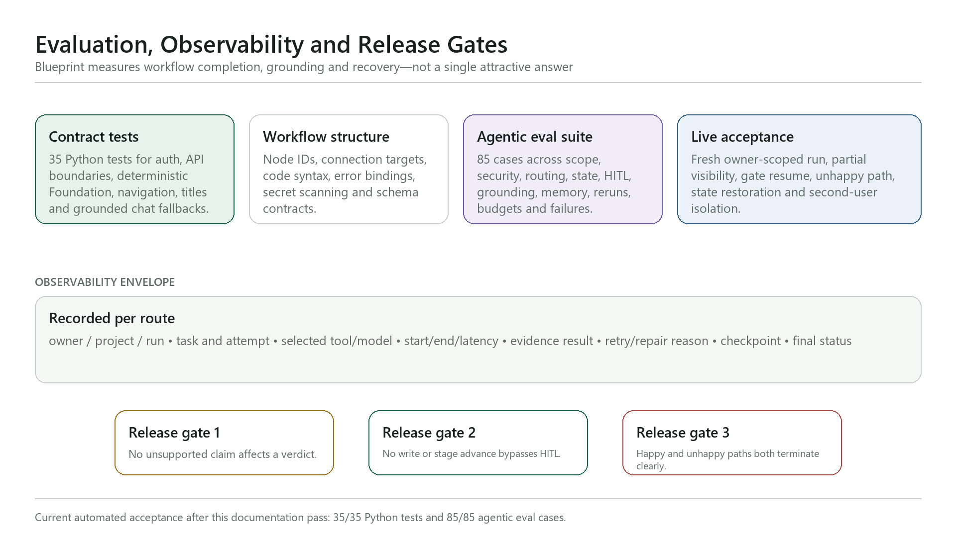

13. Security, Privacy and Trust Boundaries

Supabase Row Level Security and JWT owner scope isolate each anonymous founder session. Public inputs are schema-validated and idempotent. Retrieved webpages are treated as untrusted evidence, never executable instructions. Secret/service-role credentials remain server-side in n8n credentials or environment variables. No agent has arbitrary HTTP, messaging, payment, booking, CRM-write or delete authority.

14. Technology and Architecture Decisions

Selected stack:
• Streamlit for the fastest public-facing founder workspace.
• n8n for visible, importable orchestration and provider integrations.
• Supabase/PostgreSQL for canonical state, RLS, RPCs and immutable versions.
• You.com for bounded web discovery.
• Nebius for fast specialist extraction, strong synthesis and independent audit roles.
• Pinecone for semantic accepted-evidence retrieval.
• Mem0 for confirmed founder-journey personalization.

Deferred choices:
• Fireworks was removed from V1 to reduce provider and failure surfaces.
• LlamaIndex is deferred until uploaded-document RAG is implemented in V2.
• ElevenLabs/voice is deferred because it does not improve the core evidence-to-decision task.
• Fine-tuning is unnecessary before sufficient labelled failure/evaluation data exists.
• Hierarchical or peer-to-peer agent networks add coordination complexity without improving this bounded control problem.

15. Implementation Evolution and Learnings

The architecture was built in gates rather than as one large flow:
• Establish owner-isolated state and rollback-only RLS tests before public webhooks.
• Add global error/audit handling and controlled failure injection.
• Validate live provider roles and token budgets.
• Build the authenticated Start API and core research workflow.
• Split the core into supervisor, planner, scheduler, specialists, audit, verdict, quality, HITL, memory, rerun and resilience workflows.
• Connect Streamlit to the real n8n path and verify state restoration.
• Strengthen presentation, deterministic Foundation and grounded chat after live UX testing.

Material lessons:
• A happy path did not expose overwritten routing precedence; branch-specific evals did.
• n8n fan-out requires item-count checks at every boundary.
• Search snippets are directional evidence, not proof of demand or willingness to pay.
• Independent audit must use a different role and cannot accept a placeholder verdict.
• Pinecone and Mem0 must remain rebuildable projections, never authorities.
• Public Streamlit cannot call localhost n8n; production needs a stable HTTPS endpoint.

16. Datasets, Build Prompts and Reproducibility

Datasets and evidence:
• Founder-provided onboarding context.
• Public web results retrieved through You.com with canonical URLs and source metadata.
• Accepted evidence, contradictions and audit results stored owner-scoped in Supabase.
• Frozen synthetic regression fixtures for routing, scope, HITL, memory, grounding and failure cases.
No private customer dataset, fabricated interview transcript or scraped personal profile is used.

Representative vibe-coding prompts were sanitized and recorded in the repository. They asked the coding assistant to translate the audited architecture into safe phases, create credential-safe preflight and persistent n8n storage, implement owner-scoped state before webhooks, build typed agent contracts, test unhappy paths, harden chat scope, and convert live failures into regression fixtures. Human review changed prompts, routing precedence, token budgets, provider roles and release boundaries before acceptance.

Reproduction:
1. Run Supabase migrations in order.
2. Import the JSON workflows from backend/n8n and bind server-side credentials.
3. Start self-hosted n8n with persistent storage.
4. Configure Streamlit public Supabase values and local n8n webhook URLs.
5. Run Python, workflow-structure and agentic regression suites.
6. Execute the exact founder happy path and guarded denial path in the demo runbook.

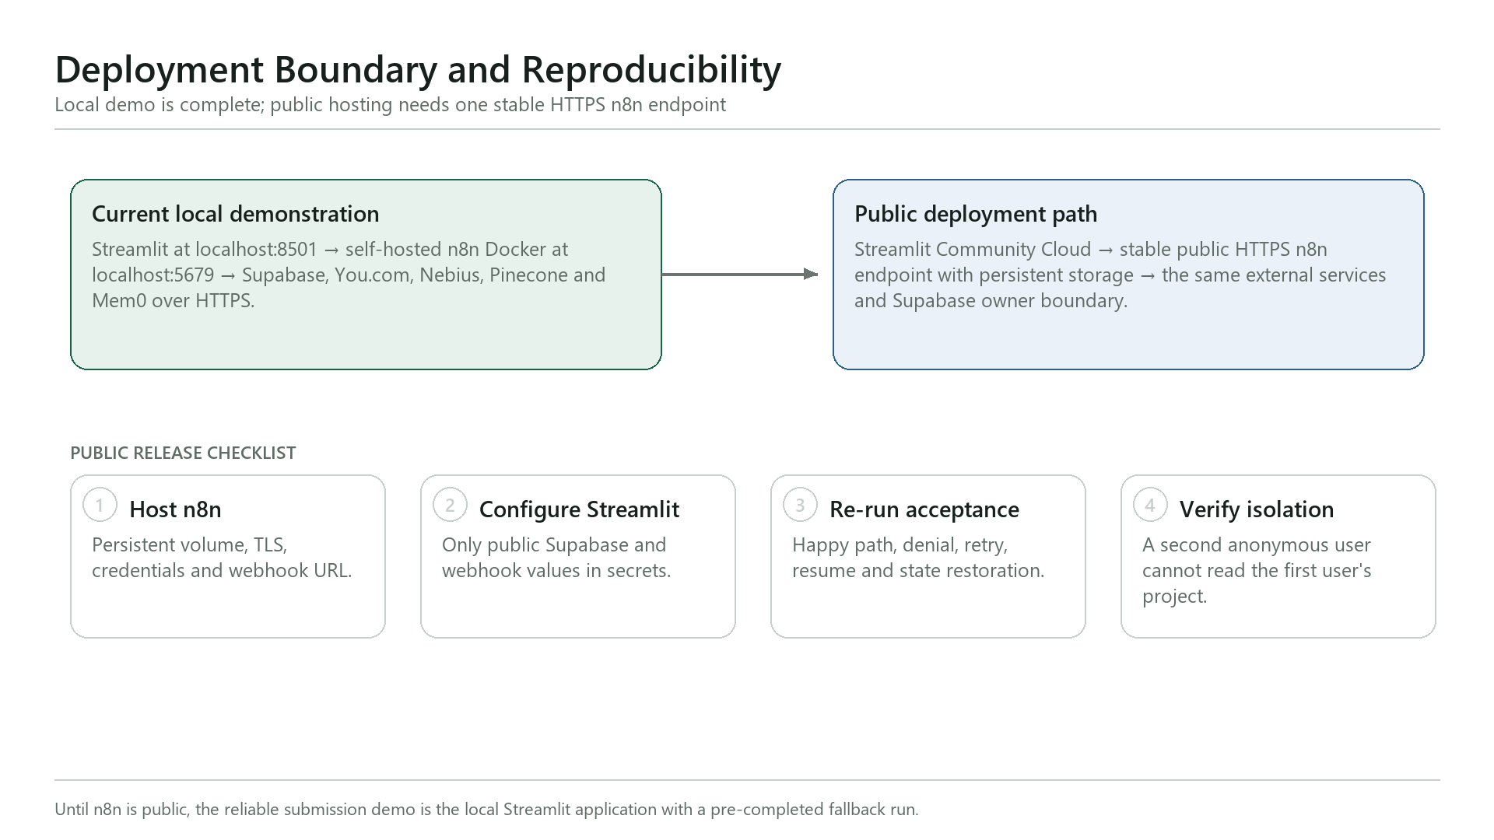

17. Limitations and Roadmap

Current limitations:
• The reliable submission path is local Streamlit plus local persistent n8n; public hosting awaits a stable HTTPS n8n endpoint.
• Stage 1 has the strongest end-to-end evidence; Stage 2/3 need final live acceptance with founder approval.
• Public desk research cannot prove purchase intent.
• Semantic and personalization sidecars may degrade without changing canonical truth.
• Uploaded-document ingestion, LlamaIndex, voice and external action tools remain out of V1.

Safe V2 expansion:
• Founder document upload with governed parsing, chunking, provenance and approved indexing.
• Temporal conflict handling and inspect/correct/delete controls for Mem0.
• Public deployment, second-user isolation acceptance and latency dashboards.
• Persona-specific pricing experiments only after real behavioural evidence.

18. Conclusion

Blueprint is not a report generator. It is a founder-controlled, multi-agent decision system that plans from durable state, runs narrow specialists, audits evidence independently, exposes uncertainty, adapts after every observation and stops at human gates. The result is a living Blueprint that tells the founder not only what the research found, but what is safe to believe and what to prove next.

Appendix A. Detailed Architecture and Implementation Reference

The native tables below provide the evaluator with the complete layer map, workflow catalog, handoff contracts, routing matrix, memory model, tool boundaries, failure paths, alternatives, evaluation evidence and deployment gates.

A.1 Architecture Reference Tables
The tables below document the implemented Blueprint Evidence Dev control plane, its agent contracts, evidence boundaries, recovery behavior, evaluation proof, and the remaining public-deployment gate.

Table 1. System Layers and Authority

Layer | Primary System | Responsibility | Authority / Boundary
Experience | Streamlit | Landing, onboarding, dashboard, reports, gates, Blueprint, finance and Ask Blueprint. | Never stores provider secrets; session state is only a UI cache.
API boundary | BP-API workflows | Owner verification, idempotent start, rerun, checkpoint and stalled-run resume. | Rejects malformed or cross-owner requests before orchestration.
Control plane | n8n supervisor, planner and scheduler | Builds the task graph, enforces dependencies and budgets, dispatches workers, then re-evaluates. | Agents recommend work; deterministic policy constrains what can run.
Intelligence | You.com + Nebius | Web discovery, structured extraction, synthesis and independent critique. | Model output is untrusted until schema, citation and policy validation pass.
Canonical state | Supabase / PostgreSQL | Projects, versions, runs, tasks, evidence, observations, checkpoints, actions and traces. | System of record with owner-scoped RLS; every resumable handoff is durable.
Memory sidecars | Pinecone + Mem0 | Semantic evidence projection and confirmed founder-journey projection. | Rebuildable and bounded; neither may overwrite Supabase truth.

Table 2. n8n Workflow and Agent Catalog

Workflow / Agent | Type | LLM or Service | Primary Job
BP-API-01 Start Run | API boundary | Supabase + n8n | Authenticate the invisible guest, create an idempotent run, and invoke the supervisor.
BP-00 Adaptive Supervisor | Orchestrator | n8n + Supabase | Load state, validate scope, call planner/scheduler, and re-evaluate until a terminal checkpoint.
BP-PLAN-01 Dynamic Planner | Planning agent | Deterministic policy | Build the stage- and goal-specific DAG with explicit dependencies and budgets.
BP-SCHED-01 Eligible Scheduler | Scheduler | n8n + Supabase | Atomically claim eligible tasks, dispatch workers, persist observations, and unlock dependants.
BP-STAGE1-01 Research Specialist | Specialist agent | You.com + Nebius | Produce customer, competitor, or market findings with structured evidence cards.
BP-STAGE1-ASYNC-01 Runner | Async worker | n8n | Run selected Stage 1 specialists in parallel without blocking completed sections.
BP-AUDIT-01 Evidence Auditor | Independent auditor | Nebius + Supabase | Check relevance, freshness, citations, conflicts and allowlisted evidence before acceptance.
BP-VERDICT-01 Viability Engine | Decision agent | Deterministic 40/30/30 policy | Score demand, differentiation and market access; emit the Gate 1 contract.
BP-SYNTH-01 Blueprint Synthesizer | Synthesis agent | Nebius + Supabase | Create an immutable Research Blueprint version from audited sections and verdict.
BP-HITL-01 Checkpoint Resume | Human gate | Supabase + n8n | Record proceed, override, revise or pause; safely resume the selected route.
BP-STAGE23-01 Advisory Blueprint | Specialist agent | Nebius + policy | Create goal-specific Prove & Design and advisory Action Blueprint modules.
BP-QA-01 Blueprint Quality | Critic agent | Nebius | Critique, allow one bounded revision, re-critique, then pass or require human review.
BP-CHAT-01 Research Copilot | Grounded copilot | Supabase + Nebius | Answer within the selected section, show evidence, or propose a human-approved rerun.
BP-RERUN-01 Profile Impact Rerun | Change-impact agent | Supabase + n8n | Detect which modules a profile edit invalidates and create a new versioned route.
BP-RESILIENCE-01 Failure Router | Recovery controller | n8n + Supabase | Classify failures into retry, repair, reload, partial, human review or safe failure.
BP-PINE-01 Evidence Memory | Semantic sidecar | Pinecone + Supabase | Index only auditor-accepted evidence and revalidate every hit against canonical records.
BP-MEM0-01 Journey Memory | Preference sidecar | Mem0 + Supabase | Store only confirmed goals, preferences, constraints, decisions, corrections and episode summaries.

Table 3. Agent Handoff Contracts

Agent | Receives | Returns | Next Handoff
Supervisor | Project snapshot, goal, locks and budgets. | Allowed task graph plus route reason. | Planner or terminal checkpoint.
Planner | Eligible stage, requested modules and evidence gaps. | Bounded DAG, dependencies and tools. | Scheduler.
Specialists | Task context and discovery evidence. | Structured findings, evidence IDs and limitations. | Evidence Auditor.
Evidence Auditor | Selected outputs and raw evidence allowlist. | Accepted/rejected evidence, conflicts and coverage. | Verdict Engine.
Verdict Engine | Audited dimensions and coverage. | Score, decision label and checkpoint contract. | Blueprint Synthesizer and Gate 1.
Blueprint Synthesizer | Immutable sections, verdict and actions. | Versioned Research or Action Blueprint. | Founder checkpoint / dashboard.
Quality Critic | Candidate Blueprint plus quality rubric. | Pass, one revision request, or human-review requirement. | Publish version or HITL.
Research Copilot | Owner-scoped section and accepted evidence. | Grounded answer, bounded refusal, or rerun proposal. | User; writes only after approval.

Table 4. Routing and Branching Decision Matrix

Observed State | Route | Automated Action | Human Decision
Idea missing or request out of scope | Needs input / deny | Return a clear bounded response; do not start research. | Founder supplies a valid idea if desired.
Discover requested | Parallel Stage 1 | Create Foundation immediately; queue customer, competitor and market specialists together. | None for read-only research.
Evidence coverage below threshold | Repair or partial | Run one bounded repair; preserve successful siblings and expose limitations. | Review partial result if repair still fails.
Transient provider failure | Retry | Retry with backoff within attempt and cycle budgets. | Only if retries are exhausted.
Schema or citation failure | Repair | Reject malformed output and perform one structured repair. | Escalate if the repaired output still fails.
Verdict at or above threshold | Gate 1 proceed | Prepare the dynamic Stage 2 plan. | Approve before any new Blueprint write is finalized.
Verdict below threshold | Gate 1 revise / override / pause | Show score, why it is weak, and evidence-backed improvements. | Choose revise, explicit override, rerun or pause.
Profile or goal edited | Impact rerun | Invalidate only affected modules and create a new version. | Approve the targeted rerun.
Cycle or budget exhausted | Safe fail | Persist a resumable terminal state and redact technical details. | Resume after correction or inspect the audit log.

Table 5. State and Memory Model

Memory Type | Store | What It Remembers | Lifetime | Authority
Working / UI | Streamlit session | Current page, selected section, transient input and UI cache. | Browser session | Ephemeral; reload from Supabase.
Episodic + exact | Supabase / PostgreSQL | Profiles, versions, runs, tasks, observations, checkpoints, actions, chat and Blueprint history. | Durable | Canonical system of record.
Semantic evidence | Pinecone | Meaning-based retrieval over auditor-accepted evidence in owner/project namespaces. | Rebuildable | Projection; every hit is revalidated.
Founder journey | Mem0 | Confirmed goals, preferences, constraints, decisions, corrections, lessons and episode summaries. | Cross-session projection | Personalization only; inspectable and deletable.

Table 6. Tool Selection and Explicit Boundaries

Tool | Used For | Why It Fits | Explicit Boundary
You.com Search API | Bounded web discovery for customer, competitor and market research. | Returns web results and excerpts suitable for evidence cards. | Directories are discovery sources, not automatically competitors or proof.
Nebius Token Factory | Structured analysis, synthesis, chat and independent critique. | Fast model access with separate roles for generation and review. | No model output bypasses schema, citation or policy checks.
Supabase | Authentication, RLS, canonical state and resumability. | Relational ownership, durable transactions and queryable evidence lineage. | Publishable key in Streamlit; sensitive keys stay server-side.
Pinecone | Semantic retrieval over accepted evidence. | Fast meaning-based retrieval for section-scoped questions. | Optional sidecar; not the current exact-state critical path.
Mem0 | Founder-journey continuity. | Purpose-built confirmed-memory projection across sessions. | No raw chain of thought, unconfirmed guesses or project truth.
Streamlit | No-sign-up evaluator experience and progressive results. | Fast product UI with background-state polling. | Public deployment requires a non-local HTTPS n8n endpoint.

Table 7. Failure Modes and Recovery Paths

Failure | Detection | Recovery | Terminal / User State
Provider timeout or 5xx | HTTP status, timeout and attempt trace. | Retry with backoff inside the task budget. | Running, then partial or needs review.
Malformed model JSON | Schema validation fails. | One repair prompt against the original evidence and contract. | Human review after the bounded repair fails.
Unsupported citation | Evidence ID, URL or allowlist mismatch. | Reject the claim; audit or rerun the affected specialist. | Completed with limitation or withheld verdict.
Conflicting evidence | Auditor detects incompatible accepted claims. | Persist contradiction and lower decision confidence. | Founder sees the conflict before Gate 1.
Stalled run | Lease/heartbeat exceeds threshold. | Reload canonical state and resume only eligible tasks. | Resumable; no duplicate completed work.
Memory service unavailable | Projection write/read fails. | Continue from Supabase and record degraded memory mode. | Product continues; personalization is reduced.
Cross-owner request | JWT/RLS ownership check fails. | Reject before any data access or agent call. | Safe denial with no data leakage.
Cycle or spend budget exhausted | Supervisor counters reach configured limit. | Stop routing, preserve progress and emit a safe checkpoint. | Founder may correct input or resume later.

Table 8. Architecture Alternatives Considered

Alternative | Advantage | Disadvantage | Decision
One large agent | Fastest initial prototype. | Opaque routing, weak recovery, difficult evaluation and prompt overload. | Rejected in favor of typed agents plus deterministic control.
Fixed A → B → C workflow | Simple to visualize and test. | Cannot skip, parallelize, repair or replan from evidence and user goals. | Rejected; Blueprint uses a dynamic DAG and re-evaluation loop.
Peer-to-peer agent network | Flexible collaboration. | Hard to bound authority, latency, cost and ownership of shared state. | Rejected for V1; supervisor-mediated handoffs are inspectable.
Mem0 as the only database | Convenient conversational memory. | Not suitable as canonical relational workflow state or evidence lineage. | Rejected; Supabase is authoritative and Mem0 is a projection.
Pinecone as the only retrieval path | Strong semantic recall. | Poor fit for exact status, ownership, versions and checkpoints. | Rejected; exact queries use Supabase, semantic evidence may use Pinecone.
Self-training or fine-tuning during runs | Potential long-term specialization. | No safe online-training dataset, adds risk and cannot explain a live correction. | Rejected; learning means versioned corrections, evals and bounded memory.

Table 9. Evaluation and Observability Evidence

Evaluation Layer | What It Tests | Current Evidence | Release Gate
Schema and contract tests | API, worker, verdict, checkpoint, rerun and memory payloads. | 11/11 Python contracts. | Malformed handoffs are rejected before runtime.
Deterministic agentic fixtures | Scope, routing, state, HITL, grounding, memory and completion. | 85/85 agentic regression cases pass. | Every checklist rule has an executable assertion.
Planner branch tests | Goal-dependent Discover, Prove & Design and Action Blueprint DAGs. | 7/7 planner branches. | No fixed checklist is substituted for the founder's goal.
Live failure injection | Provider, schema, policy, conflict and memory-degraded paths. | 15/15 resilience routes. | Each failure reaches retry, repair, partial, human or safe fail.
Browser closed loop | Landing, run, partial sections, verdict, checkpoint and resume. | Stage 1 path exercised; Stage 2/3 final acceptance remains. | Evaluator must complete the workflow, not only see one good answer.

Table 10. Deployment Readiness and Release Gates

Component | Current State | Remaining Work | Release Gate
Streamlit product | Runs locally with invisible guest identity and owner-scoped state. | Final UI/research acceptance and cloud secrets. | Fresh evaluator can complete Stage 1 without sign-up.
n8n control plane | Runs locally in Docker with persisted workflows and credentials. | Host behind stable public HTTPS with persistent storage. | Webhook must be reachable from Streamlit Community Cloud.
Cloud services | Supabase, You.com, Nebius, Pinecone and Mem0 configured. | Confirm production quotas and least-privilege credentials. | No sensitive key is exposed in Streamlit.
Stage 2/3 continuation | Implemented in workflows and UI contracts. | Run founder-approved live continuation through Gate 2. | New Blueprint version is created without losing V1.
Tenant isolation | RLS and owner-scoped contracts implemented. | Run a second anonymous-user isolation test. | No project, evidence or chat crosses owners.
Public release | Repository and Streamlit-shaped app are ready. | Update n8n webhook secret, deploy main, run smoke and failure tests. | Public HTTPS path passes happy, unhappy and resume scenarios.

