ASSIGNMENT-MYSQL

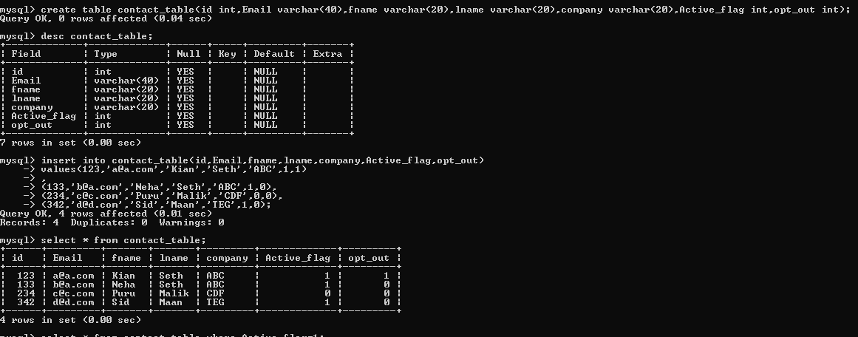

1. Select all columns from the contact table where active flag is 1.

Output: 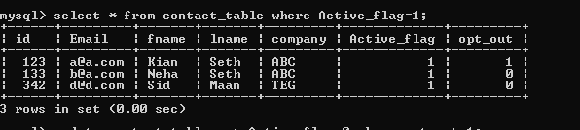

1. Deactivate contacts who are opted out.

Output:

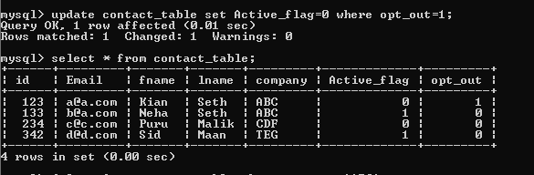

1. Delete all the contacts who have company name as ‘ABC’.

Output:

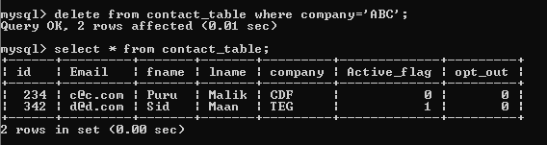

1. Insert a new row with id as 658, name as ‘mili’ , email as ‘mili@gmail.com’, company as ‘DGH’, active flag as 1, opt out flag as 1.

Output:

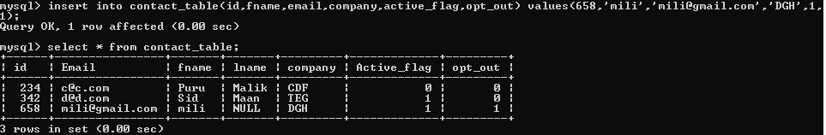

1. Pull out unique values of company column.

Output:

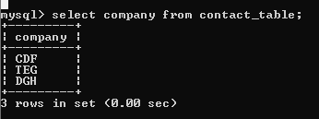

1. Update name mili to niti.

Output:

