**Assignment-MongoDB**

Exercise 1(20 marks):

|  |  |  |  |  |  |
| --- | --- | --- | --- | --- | --- |
| Id | Email | Name | Department | submission | Grade |
| 101 | a@a.com | Alex | CSE | 1 | N.A. |
| 203 | b@a.com | John | CIVIL | 0 | N.A. |
| 305 | c@c.com | Sam | CSE | 0 | N.A. |
| 719 | d@d.com | Rob | ELECTRONICS | 1 | N.A. |

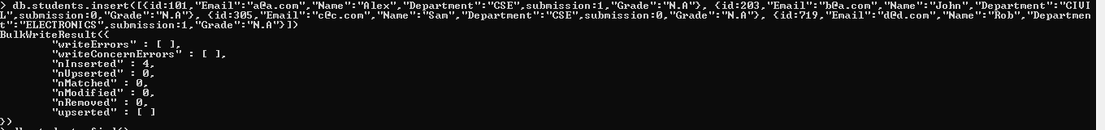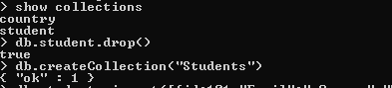

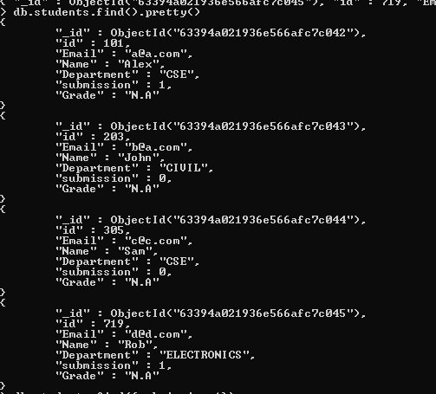

1. Find the records of all the students who have submitted their assignment.

Output:

D:\full stack development\mongoDB\mongoDB\assignment\4.PNG

1. Assign grade C to those students who have not submitted their assignments.

Output:



1. Assign grade A to those students who have submitted their assignment.

Output:

1. Insert a document with id as 812, name as “Rick”, email as e@e.com, submission as 1 and grade as N.A.

Output:

1. Update department of Sam as “MECHANICAL”.

Output: