Problem Statement:

|  |  |  |  |
| --- | --- | --- | --- |
| Id | country | continent | currency |
| 1 | India | Asia | rupee |
| 2 | USA | North america | dollar |
| 3 | Japan | Asia | yen |
| 4 | China | Asia | yuan |

1. Write a Sql statement to create a table containing the column name as follows:

Id,country,continent,currency.

Output:

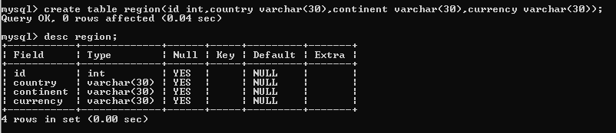

1. Write a Sql statement to insert into the table the given above data in the same order as shown in above table.

Output:

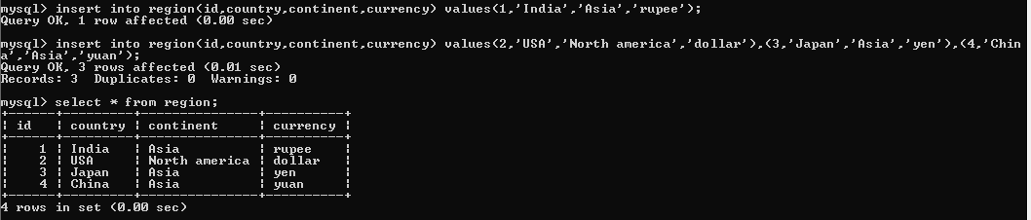

1. Write a Sql statement to insert into the table the given data : id=5,country=Bangladesh,currency=taka.

Output:

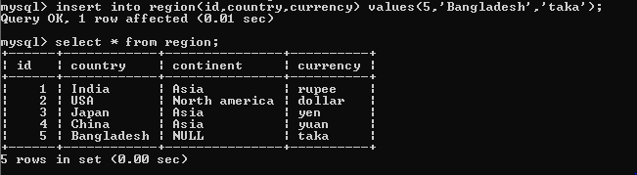

1. Write a Sql statement to change the continent of all the countries to “not given”.

Output:

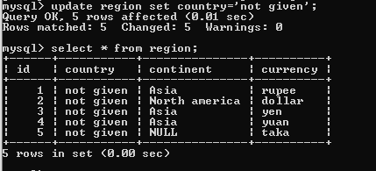

1. Write a Sql statement to change the country from China to “People republic of china”.

Output:

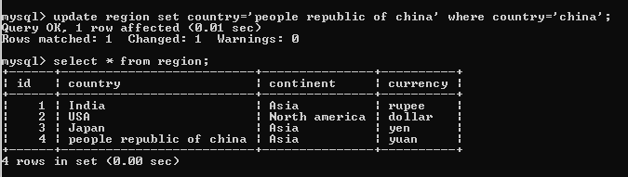

1. Write a Sql statement to add a column “country_population” with default value as “no data”.

Output:

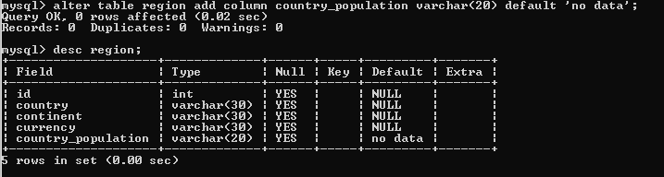

1. Write a Sql statement to drop the column “country_population”.

Output:

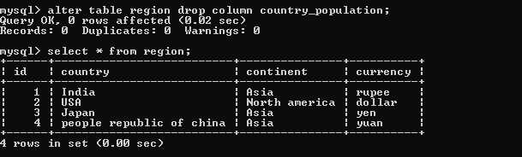

1. Write a Sql statement to add the primary key to the id column of the given table.

Output:

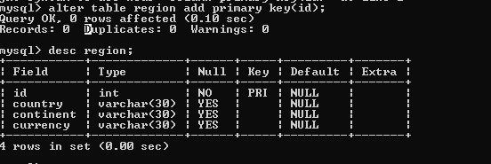

1. Write a Sql statement to change the table name to “Country_Census”.

Output:

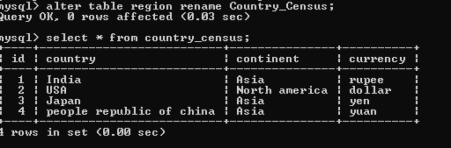

1. Write a Sql statement to display the country from the table.

Output:

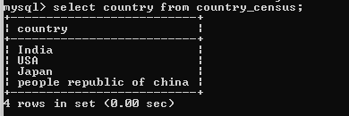

1. write a Sql statement to display the id and continent from the table.

Output:

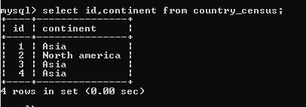

1. Write a Sql statement to delete the table data where id=3.

Output:

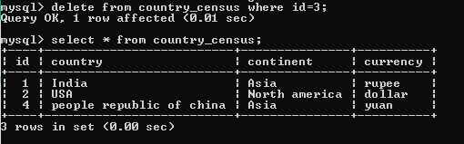

1. Write a Sql statement to drop the table.

Output:

D:\full stack development\mongoDB\mysql\assignment\question13.PNG

1. Create a table with table_name as “Country_data” ,same as the above table.

Output:

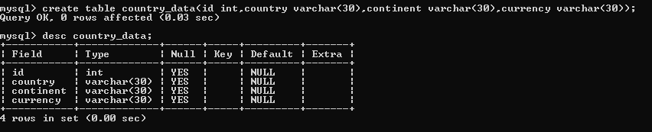

1. Insert into table data of your choice upto 3 data.

Output:  
