**Team Members:**

Kajal Pawar – 2019BTECS00010

Navjyot Sakhalkar – 2019BTECS00011

Mohd Nifasat Beg – 2019BTECS00013

**Centralized and Automated Healthcare Systems : A Essential Smart Application Post Covid-19**

**INTRODUCTION :**

In many of the Healthcare Management Systems that are observed today, there is a huge requirement for automation. Automation is the use of control systems and information technologies to reduce the need for human work in the development of services. As more and more users keep depositing data on the cloud, the security problems related to cloud increases. There are a large number of characteristics of Cloud Computing, such as, scalability, multi-user, virtualization etc. Due to these characteristics, the normally used security measures are not effective and it does not make the cloud computing system totally safe from third party unauthorized access.

To ensure that a patient is taken care of and given the required treatment at the right time is must. Taking necessary actions in case of emergencies by automatically calling the caretaker is one of the main objectives of this work Apt data of the patient will be collected and sent from or to the testing centers. Timely reminders of tests to be conducted for the patient at the testing center needs to be given. Maintenance of the patient’s reports and also sending them to the caretaker of the patient is very important. This will help in maintaining the health conditions. Maintaining the confidentiality of the patient data by using audio steganography methods during the transmission of data and also during the storage of data builds a more secure network. Having a decision making system which suggests the best kind of treatment to be given to a patient among the various decisions put-forth by the certified doctors in the Doctors’ Forum will ensure that a patient would not be given unnecessary treatment and will prevent the doctors from taking advantage of some uneducated and poor patients, ensuring that the confidentiality of the case will not be misused.

**Literature Review :**

Allan Hasley [2] has mentioned the National Project planned in the year 2005. In this article, he mentioned the motive to have a reliable IT Infrastructure for EHR of all authorized users and the project has to adopt to the new technologies in the future. The project failed due to mismanagement, technical issues etc. The project was started with the estimation of 6 billion Pounds. But eventually was stopped from further completion in 2011 with almost spending not less than 13 billion Pounds [3].

Margret Hansen in his work stressed the benefits of using medical history in any emergency cases [5]. Authors introduced a ‘Health Smart Card’ concept, which would retrieve the case history of any particular individual person from wherever required. A practical implementation framework has not been discussed in this work. But nevertheless one can provide any framework for this approach.

In the work highlighted by Rui et al, a reference model through a Use-Case scenario for security models of EHR applications in the cloud was being proposed with the integration issues in the model. The work lacked any implementation of the application mentioned in the real world scenario [7].

Shekha et al, reviewed the security and privacy concepts in e-health systems managing EHR in the Cloud. Authors reviewed works conducted for the period 2000-2018[14]. Most of the work were categorized into: Security and privacy in EHR; Security and Privacy in e-Health data in Cloud; EHR Cloud Architecture; EHR Cryptography and Non-Cryptographic methods. The study conducted highlighted the need of Comprehensive Security mechanism and techniques to ensure integrity in EHR systems

**Summary :**

Allan Hasley  mentioned the motive to have a reliable IT Infrastructure for EHR of all authorized users and the project has to adopt to the new technologies in the future. The project failed due to mismanagement, technical issues etc. Margret Hansen introduced a ‘Health Smart Card’ concept, which would retrieve the case history of any particular individual person from wherever required. The work highlighted by Rui et al lacked any implementation of the application mentioned in the real world scenario. The study conducted by Shekha et al highlighted the need of Comprehensive Security mechanism

**Problem Statement :**

Develop an application that will automate the process in Healthcare Management System.

**Objectives :**

This Application will help in maintaining the health conditions. Maintaining the confidentiality of the patient data by using audio steganography methods during the transmission of data and also during the storage of data builds a more secure network

**Proposed Work :**

We have implemented the concept of Audio Steganography for ensuring the secrecy of the confidential medical data. Another concept that has been proposed through this work is the process of Automation in the Healthcare Management System Near Field Communication (NFS) could be used for authentication of a patient and also utilized for faster transfer of data from central repository in health care sectors.

**System Architecture :**

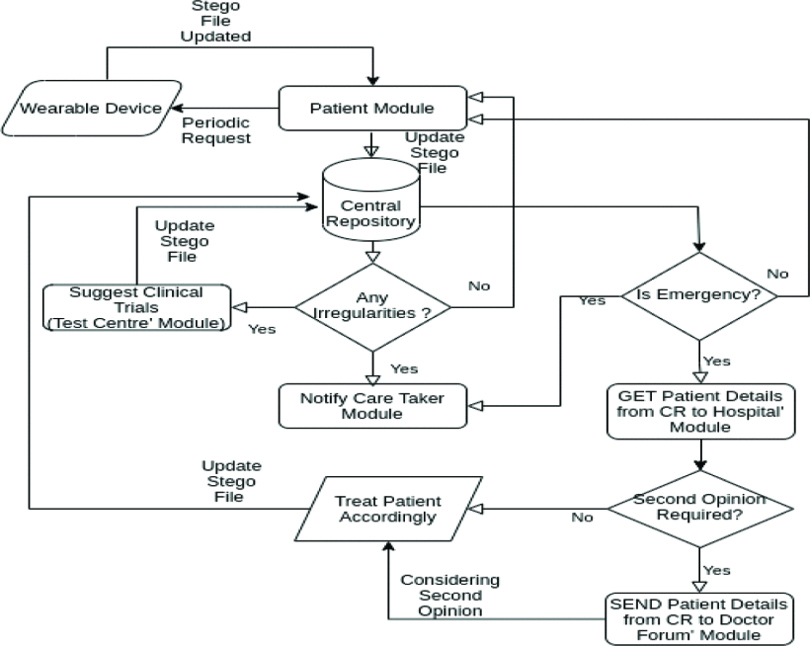

**Modules:**

1. Patients Module
2. Caretakers Module
3. Testing Center Module
4. Doctors forum Module
5. Hospitals Module

**Module Description:**

**1. Patients Module:** This application mainly used by the Patients. It provide proper authentication while logging in and ensures that no other person can gain access to the Patient's details. After logging in, the patient’s health parameters like blood pressure, heart rate, sugar level, ECG, height and weight will be collected periodically from wearable devices.

**2. Caretakers Module:** This application will be used by the Caretakers of the patient. This module provide the functionality that the caretaker can view the patient’s details and health parameters which were being displayed in the patient’s application. This application authenticates the identity of the caretaker before they get access to patient details. The test reports are updated in the application after the patient’s test in the testing center. This application reminds the caretaker about the next date when they have to take the patient for a check-up in the test center. When the medicine count reaches a minimum then it reminds caretaker about this.

**3. Testing Center Module:** This application is mainly designed for Testing Center. A Testing Center is where tests will be conducted to the patient. The results of the tests will be updated in this application. The report consists of Patient ID, Patient’s Name, Blood pressure, Weight, Sugar Level, ECG and Heart Rate. These health parameters will also be updated to the application in the Patient Module and in the Caretaker Module.

**4. Doctors Forum Module:** This Forum will be used by the doctors who do not work in that hospital where the patient visits. Using this feature the patients admitted in the hospital can get a second opinion from the doctors situated remotely. Whenever there is a complicated case, the case details will be put up by the hospital, into the Doctors Forum but the patient’s personal details will not be leaked. Once the case details are put into the Forum , the doctors present in the Forum can give their suggestions on what can be done to solve the case. This can help the doctors in the hospital to handle the case in an efficient manner

.

**5. Hospitals Module:** This application is mainly designed for the hospital authorities. This allows to add a new patient into the hospital records. The details such as name, age, place, blood group and the reason for which they have come to the hospital can be added in the application by authorities. This application contains the details of the patients and also their case details. Using this application the case details can be securely sent to the doctors in the doctor forum. In case of complicated cases this can help the doctors in the hospital to get the second opinion from the other doctors and solve the case efficiently.

**Conclusion :**

Another concept that has been proposed through this work is the process of Automation in the Healthcare Management System Near Field Communication (NFS) could be used for authentication of a patient and also utilized for faster transfer of data from central repository in health care sectors.

**References :**

**1.**Shubham Lavania, Palash Sushil Matey and Thanikaiselvan, "Real-Time Implementation of Steganography in Medical Images using Integer Wavelet Transform" in , Vellore, Tamilnadu, India:School of Electronic Engineering, VIT University.

<https://ieeexplore.ieee.org/document/7238344>

**2.**Hajar Ziglari and Arefeh Negini, "Evaluating Cloud Deployment Models Based on Security in EHR System", ICET2017*.*

<https://ieeexplore.ieee.org/document/8308142>

**3.**Rita Siburian Lindawati, "Steganography implementation on android smartphone using the LSB (least significant bit) to MP3 and WAV audio", 3rd International Conference onWireless and Telematics (ICWT*)*, 2017.

<https://ieeexplore.ieee.org/document/8284161>

.