|  |  |
| --- | --- |
| **COVER LETTER** |  |
|  |  |

**2017**

**Dear sir  
  
I am writing to you today, hoping to briefly introduce myself and demonstrate my capabilities and achievements within the ever growing and demanding sector of Computer Science.   
  
I am finishing my final year of education at Rajasthan technical university where I have been working towards my B.Tech in Computer Science. I am in 3rd year 6th semester with computer science branch.  
I expect to graduate in (19-5-2018) and therefore am eager to secure an exiting position with a company such as *Astrodunia*  for my future.   
  
My course has focussed on a variety of specialist tools such as Algorithm Analysis, Software engineering, creating Database Systems, web development , c , c++.These have assisted me in broadening my knowledge while showing me the diverse side of Computer Science that I find fascinating.  
  
I have gained further experience aside from my studies, through the website I made foodmunch.in ,which offered lunch and dinner by online booking after one hour in sikar , the time spent there opened my eyes further to the creative challenges required in the buisness startup and how it is forever evolving.This website was a success for me but due to some personal reasons it was needed to be closed. I rapidly adapted to the new work culture and team members who became trusted associates throughout my time spent there.   
This website solidified my beliefs in choosing this career path for me.  
  
I am fanatical about precision and order, enjoy problem solving and the challenges it brings with it and believe in team efforts.   
  
I am confident that I would be an appreciated and welcome asset to *Astrodunia* and I hope that you will give me the chance to interview for the available position as soon as possible.  
  
I thank you for your time taken today.  
Looking forward to hearing from you.  
  
Kind regards,   
kajal pareek**

**Sobhasaria Engineering College,**

**Sikar(Rajasthan)**

**INDIA.**

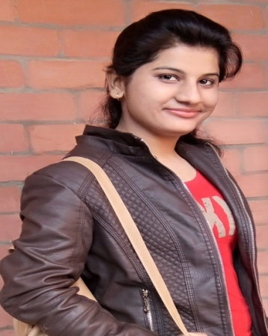

**Kajal Pareek**

PROJECTS:

* Made a website FOODMUNCH.IN which offers delivering lunch and dinner online in sikar,Rajasthan on small scale .
* Made a project of PHP on Rajasthan Technical University in Netcom,sikar .

**I am passionate about what I do and always give 100% . When I undertake a project or task I don’t just complete it , I go the extra mile and make it better than requested.**

***PROGRAMMING / WEB* : HTML , DHTML , CSS , JAVASCRIPT , PHP , PYTHON , C , C++,JAVA.**

**SOFTWARE : DREAMWEAVER , VISUAL STUDIO CODE , NOTEPAD++ , WORDPRESS .**

**DATABASES / DBMS : SQL , MICROSOFT SQL , ORACLE SQL .**

**OPERATING SYSTEM : WINDOWS 2000 / XP / 7 / 8 / 10 , UNIX .**

|  |  |  |  |
| --- | --- | --- | --- |
|  | QUALIFICATION | UNIVERSITY | PERCENT |
| 1. | B.TECH 2nd year | RTU | 69.5% |
| 2. | B.TECH 1st year | RTU | 67.5% |
| 2. | SENIOR SECONDARY | RBSE | 68% |
| 3. | SECONDARY | RBSE | 66.67% |

* Participated in two days workshop on SEO/WEBSITE DEVELOPMENT at SGI ,SIKAR in association with DEZIRE INFOSOFT.

* Participated in two days workshop on PHP and web development conducted by GEEKSLAB Technologies Pvt. Ltd. In association with VORTEX’16 EES-IIT DELHI held at SGI,SIKAR.

* Participated in two days workshop on ANDROID APPS DEVELOPMENT held at IIT DELHI organized by ROBOSAPIENS TECHNOLOGIES Pvt.Ltd.

PERSONAL ACHIEVENTS

**+91946100863**3,

**+918079067563**

**SALASAR BUS STAND ,SIKAR ,(RAJASTHAN),INDIA**

**pareekkajal7@gmail.com**

**pareekkajal7@gmail.com**

EDUCATION

**TECHNICAL SKILLS**

ABOUT ME

**OBJECTIVE:**

TO GROW PROFESSIONALLY AS A WEB DEVELOPER AT INTERNATIONAL LEVEL BY JOINING A REPUTED ORGANIZATION WHICH PROMOTES WORK CULTURE THAT FOSTERS MY GROWTH, CREATIVITY & MY INNER ABILITIES TO SHOW MY TALENTS AND HELPS TO FULFIL THE EXPECTATIONS OF THE COMPANY & ATTAINS STANDARDS OF CORPORATE PERFORMANCE OF THE COMPANY.

**CONTACT:**



**RESUME**