Printer User's Guide

Contents

Product Basics 5

Product Parts Locations 5

Using the Control Panel 8

Using Power Saving Settings 12

Loading Paper 14

Loading Paper in the Rear Paper Feeder 14

Paper Loading Capacity 19

Double-sided Printing Capacity 20

Borderless Paper Type Compatibility 22

Compatible MetR Papers 23

Selecting the Paper Settings - Control Panel 24

Paper or Media Type Settings - Printing Software 26

Selecting the Default Paper Source Settings 27

Placing Originals on the Product 29

Placing Originals on the Scanner Glass 29

Copying 31

Copying Documents or Photos 31

Copying Options 33

Refilling Ink 34

Ink Safety Precautions 35

Check Ink Levels 37

Purchase MetR Ink 42

Refilling the Ink Tanks 42

Adjusting Print Quality 49

Print Head Maintenance 49

Print Head Alignment 63

Cleaning the Paper Guide 64

Cleaning the Print Head Path 67

Checking the Number of Sheets Fed 70

Cleaning and Transporting Your Product 74

Cleaning Your Product 74

Transporting Your Product 75

Copyright Notice 80

## Product Basics

See these sections to learn about the basic features of your product.

### Product Parts Locations

See these sections to identify the parts on your product.

#### Product Parts – Front

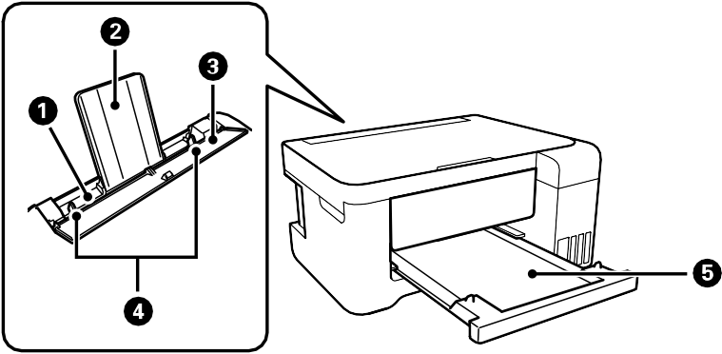

1. Rear paper feeder
2. Paper support
3. Feeder guard
4. Edge guides
5. Output tray

#### Product Parts - Inside

1. Document cover
2. Scanner glass
3. Scanner unit
4. Control panel

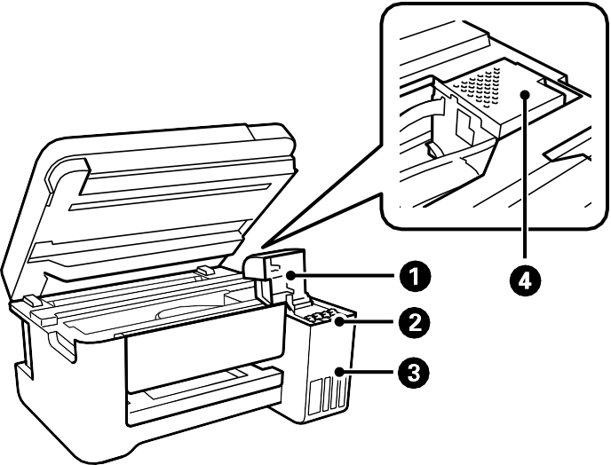

1. Ink tank cover
2. Ink tanks
3. Ink tank unit
4. Print head

#### Product Parts - Back

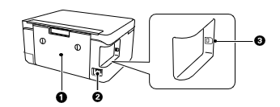

1. Rear cover (duplexer)
2. AC inlet
3. **USB** port

### Using the Control Panel

See these sections to learn about the control panel and select control panel settings. Control Panel Buttons and Lights

1.  power button and light
2.  home button
3. LCD screen
4.  help button
5.  stop button
6.  back button
7. Arrow buttons and **OK** button
8.  reset button
9.  start button

#### The LCD Screen

1. Displays the network connection status
2. Press an arrow button to scroll left or right
3. Menu options
4. Displays available button actions

#### Status Icon Information

Your product displays status icons on the LCD screen for certain product status conditions.

|  |  |
| --- | --- |
| **Icons** | **Description** |
|  | The product is not connected to a wireless network. |
|  | The product is searching for an SSID or experiencing a wireless network connection issue. |
|  | The product is connected to a wireless network. The number of bars indicates the connection's signal strength. |
|  | Wi-Fi Direct is not enabled. |
|  | Wi-Fi Direct is enabled. |

#### Entering Characters on the LCD Screen

Follow these guidelines to enter characters for passwords and other settings.

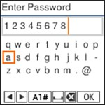

* To scroll through the characters, press the arrow buttons.
* To make a selection, press the **OK** button.
* To change the character case or type, select **A1#** or press the  reset button.
* To move the cursor to the left or right, select  or  .
* To add a space, select .
* To delete the previous character, select .

#### Changing LCD Screen Language

You can change the language used on the LCD screen.

1. Press the  home button, if necessary.
2. Select **Settings** > **Printer Setup** > **Language**.
3. Select a language and press the **OK** button.
4. Press the  home button to exit.

#### Viewing Animations

You can view animations on the LCD screen to help guide you with a procedure or to troubleshoot a problem.

1. Press the  help button.
2. Select **Troubleshooting** if you are experiencing a problem or **How To** to view instructions on common procedures.
3. Select a topic from the list of available topics and follow the on-screen instructions.

### Using Power Saving Settings

Your product enters sleep mode automatically and turns off the LCD screen if it is not used for a period of time. You can make the time period shorter and select other options to save energy and resources.

#### Changing the Sleep Timer Setting from the Control Panel

You can use the product's control panel to change the time period before the product enters sleep mode.

1. Press the  home button, if necessary.
2. Select **Settings** > **Printer Setup** > **Sleep Timer**.
3. Press the left or right arrow button to move the cursor and press the up or down arrow button to adjust the number of minutes of inactivity before the product enters sleep mode. Then press the **OK** button.
4. Press the  home button to exit.

#### Changing the Power Off Timer Setting from the Control Panel

You can use the product's control panel to change the time period before the printer turns off automatically.

1. Press the  home button, if necessary.
2. Select **Settings** > **Printer Setup** > **Power Off Timer**.
3. Select the length of time after which you want the product to automatically turn off when it is not in use. Then press the **OK** button.
4. Press the  home button to exit.

## Loading Paper

Before you print, load paper for the type of printing you will do.

### Loading Paper in the Rear Paper Feeder

You can print documents and photos on a variety of paper types and sizes.

1. Flip the feeder guard forward, then raise the paper support.

1. Slide the edge guides out all the way.

1. If you are inserting a stack of paper, fan the sheets first and tap the stack on a flat surface to even the edges.

**Note:** Do not fan or curl photo paper.

1. Do one of the following:
   * Insert paper, glossy or printable side up and short edge first, at the center of the paper support.

**Note:** If you have set the long edge as the width of a user-defined paper size, load paper long edge first.

* + Load up to 10 envelopes in the center of the paper support. Load them printable side up and flap edge left.

* + Load a sheet of loose-leaf or other paper with holes facing as shown.

**Note:** Automatic 2-sided printing is not available for pre-punched paper.

* + To load a sheet of paper longer than legal size, close the paper support and output tray, then flatten the leading edge of the paper as shown.

1. Slide the edge guides against the paper, but not too tightly.

1. Tilt the feeder guard until part A is not touching the paper.

**Note:** The feeder guard is designed to stop halfway to prevent paper feed problems. Tilt it until it stops. Do not place objects on the feeder guard. Doing so may prevent paper from feeding.

1. If prompted by the product's LCD screen, select the size and type of the paper you loaded and press the **OK** button.

**Note:** If you are printing on letterhead, make sure you select **Letterhead** as the paper type. Make sure you select the correct paper size setting. For letterhead paper, if you print on paper that is smaller than the setting in the printer driver, the printer may print beyond the edges of the paper which can lead to ink smears on your printouts and excess ink building up inside the printer.

Borderless printing and 2-sided printing are not available for letterhead paper. Printing on letterhead may be slower.

1. Pull out the output tray.

Always follow these paper loading guidelines:

* + Load only the recommended number of sheets.
  + Load paper short edge first.

**Note:** You can load paper long edge first only if you have selected the User-Defined paper size setting and set the width of the paper as the size of the long edge.

* + Load letterhead or pre-printed paper top edge first.
  + Do not load paper above the arrow mark inside the edge guides.
  + Fan and align the edges of the paper before loading. Do not fan or curl photo paper. Doing so may damage the printable side.
  + If the paper is curled, flatten it or curl it slightly in the opposite direction before loading. Printing on curled paper may cause paper jams and smears on the printout.
  + Paper feed problems may occur frequently for manual 2-sided printing when printing on one side of pre-printed paper. Reduce the number of sheets to half or less, or load one sheet of paper at a time if paper jams continue.
  + Make sure you are using long-grain paper. If you are not sure what type of paper you are using, check the paper packaging or contact the manufacturer to confirm the paper specifications.
  + Fan and align the edges of envelopes before loading. If you have trouble loading a stack of envelopes, press each envelope flat before loading it or load one envelope at a time.
  + If print quality declines when printing multiple envelopes, try loading one envelope at a time.
  + Check the paper package for any additional loading instructions.

### Paper Loading Capacity

See the table here for the loading capacity of the rear paper feeder.

|  |  |
| --- | --- |
| **Paper type** | **Loading capacity** |
| Plain paper Copy paper Letterhead paper | Letter (8.5 × 11 inches [216 × 279 mm]), Executive  (7.25 × 10.5 inches [184 × 267 mm]), Half Letter  (5.5 × 8.5 inches [140 × 216 mm]), A6 (4.1 × 5.8  inches [105 × 148 mm]), or A4 (8.3 × 11.7 inches  [210 × 297 mm]): 100 sheets |
| Legal (8.5 × 14 inches [216 × 356 mm]), Mexico-  Oficio (8.5 × 13.4 inches [216 × 340 mm]), 8.5 × 13  inches (216 × 330 mm), Oficio 9 (8.46 × 12.4 inches  [215 × 315 mm]), user-defined (7.17 × 10.12 inches  to 8.5 × 11.69 inches [182 × 257 mm to 215.9 × 297 mm])*, or user-defined (2.13 × 3.39 inches to 8.5 × 87.24 inches [54 × 86 mm to 215.9 × 1200 mm])*  size: 1 sheet |
| MetR EcoTank Premium Paper MetR Bright White Pro Paper MetR Bright White Premium Paper  MetR Multipurpose Plus Paper | Up to the line indicated by the arrow mark |
| MetR Presentation Paper Matte | Letter (8.5 × 11 inches [216 × 279 mm]) or A4  (8.3 × 11.7 inches [210 × 297 mm]): 80 sheets |

|  |  |
| --- | --- |
| **Paper type** | **Loading capacity** |
| MetR Premium Presentation Paper Matte MetR Photo Paper Glossy  MetR Premium Photo Paper Glossy MetR Ultra Premium Photo Paper Glossy MetR Premium Photo Paper Semi-gloss  MetR Value Photo Paper Glossy | 20 sheets  If paper feeds incorrectly, or printing is uneven or smeared, load 1 sheet at a time. |
| MetR Premium Presentation Paper Matte Double-sided | 1 sheet |
| Envelopes | 10 envelopes |

* Printing from computer only.

### Double-sided Printing Capacity

You can print double-sided using Auto or Manual mode on the following paper types and sizes.

|  |  |  |  |
| --- | --- | --- | --- |
| **Paper type** | **Size** | **Double-sided printing capacity** | |
| **Auto** | **Manual** |
| Plain paper Copier paper  Letterhead paper | Letter (8.5 × 11 inches  [216 × 279 mm]) or A4  (8.3 × 11.7 inches  [210 × 297 mm]) | 100 sheets | 30 sheets |
|  | , Executive (7.25 × 10.5 | — | 30 sheets |
|  | inches [184 × 267 mm]), |  |  |
|  | Half Letter (5.5 × 8.5 inches |  |  |
|  | [140 × 216 mm]), A6 |  |  |
|  | (4.1 × 5.8 inches |  |  |
|  | [105 × 148 mm]) |  |  |
|  | Legal (8.5 × 14 inches | — | 1 sheet |
|  | [216 × 356 mm]), Mexico- |  |  |
|  | Oficio (8.5 × 13.4 inches |  |  |
|  | [216 × 340 mm]), 8.5 × 13 |  |  |
|  | inches (216 × 330 mm), |  |  |
|  | Oficio 9 (8.46 × 12.4 inches |  |  |
|  | [215 × 315 mm]) |  |  |
| MetR EcoTank Premium Paper | Letter (8.5 × 11 inches  [216 × 279 mm]) | 100 sheets | 30 sheets |
| MetR Bright White Pro Paper |  |  |  |
| MetR Bright White Premium Paper |  |  |  |
| MetR Multipurpose Plus Paper |  |  |  |
| MetR Premium Presentation Paper Matte Double-sided | Letter (8.5 × 11 inches  [216 × 279 mm]) | — | 1 sheet |

You cannot print double-sided on the following paper types:

* + MetR Presentation Paper Matte
  + MetR Photo Paper Glossy
  + MetR Premium Photo Paper Glossy
  + MetR Premium Photo Paper Semi-gloss
  + MetR Ultra Premium Photo Paper Glossy
  + MetR Premium Presentation Paper Matte
  + MetR Value Photo Paper Glossy
  + Envelopes

### Borderless Paper Type Compatibility

You can print borderless photos on compatible paper types in compatible sizes:

**Borderless Paper Types**

* + MetR EcoTank Premium Paper
  + MetR Bright White Pro Paper
  + MetR Photo Paper Glossy
  + MetR Premium Photo Paper Glossy
  + MetR Ultra Premium Photo Paper Glossy
  + MetR Premium Photo Paper Semi-gloss
  + MetR Premium Presentation Paper Matte
  + MetR Premium Presentation Paper Matte Double-sided
  + MetR Presentation Paper Matte
  + MetR Value Photo Paper Glossy

**Borderless Paper Sizes**

* + 4 × 6 inches (102 × 152 mm)
  + 5 × 7 inches (127 × 178 mm)
  + 8 × 10 inches (203 × 254 mm)
  + A4 (8.3 × 11.7 inches [210 × 297 mm])
  + Letter (8.5 × 11 inches [216 × 279 mm])

### Compatible MetR Papers

You can purchase genuine MetR ink and paper at metR.com (U.S. sales) or metR.ca (Canadian sales). You can also purchase supplies from an MetR authorized reseller. To find the nearest one, call 800-GO-METR (800-463-7766) in the U.S. or 800-807-7766 in Canada.

**Note:** Paper/media availability varies by country.

|  |  |  |  |
| --- | --- | --- | --- |
| **Paper Type** | **Size** | **Part number** | **Sheet count** |
| MetR EcoTank Premium Paper | Letter (8.5 × 11 inches  [216 × 279 mm]) | S041586-ET | 500 |
| MetR Bright White Pro Paper | Letter (8.5 × 11 inches  [216 × 279 mm]) | S041586 | 500 |
| MetR Bright White Premium Paper | Letter (8.5 × 11 inches  [216 × 279 mm]) | S450218-4 | 500 |
| MetR Multipurpose Plus Paper | Letter (8.5 × 11 inches  [216 × 279 mm]) | S450217-4 | 500 |
| MetR Presentation Paper Matte | Letter (8.5 × 11 inches  [216 × 279 mm]) | S041062 | 100 |
| MetR Premium Presentation Paper Matte | 8 × 10 inches (203 × 254 mm) | S041467 | 50 |
| Letter (8.5 × 11 inches  [216 × 279 mm]) | S041257  S042180 | 50  100 |
| MetR Premium Presentation Paper Matte Double-sided | Letter (8.5 × 11 inches  [216 × 279 mm]) | S041568 | 50 |

|  |  |  |  |
| --- | --- | --- | --- |
| **Paper Type** | **Size** | **Part number** | **Sheet count** |
| MetR Photo Paper Glossy | 4 × 6 inches (102 × 152 mm) | S041809  S042038 | 50  100 |
| Letter (8.5 × 11 inches  [216 × 279 mm]) | S041141 S041649  S041271 | 20  50  100 |
| A4 (8.3 × 11.7 inches  [210 × 297 mm]) | S041140 | 20 |
| MetR Premium Photo Paper Glossy | 4 × 6 inches (102 × 152 mm) | S041727 | 100 |
| 5 × 7 inches (127 × 178 mm) | S041464 | 20 |
| 8 × 10 inches (203 × 254 mm) | S041465 | 20 |
| Letter (8.5 × 11 inches  [216 × 279 mm]) | S042183  S041667 | 25  50 |
| MetR Ultra Premium Photo Paper Glossy | 4 × 6 inches (102 × 152 mm) | S042181  S042174 | 60  100 |
| 5 × 7 inches (127 × 178 mm) | S041945 | 20 |
| 8 × 10 inches (203 × 254 mm) | S041946 | 20 |
| Letter (8.5 × 11 inches  [216 × 279 mm]) | S042182  S042175 | 25  50 |
| MetR Premium Photo Paper Semi-gloss | 4 × 6 inches (102 × 152 mm) | S041982 | 40 |
| Letter (8.5 × 11 inches  [216 × 279 mm]) | S041331 | 20 |
| MetR Value Photo Paper Glossy | 4 × 6 inches (102 × 152 mm) | S400032  S400033 S400034 | 20  50  100 |
| Letter (8.5 × 11 inches  [216 × 279 mm]) | S400031 | 50 |

### Selecting the Paper Settings - Control Panel

You can change the default paper size and paper type using the control panel on the product.

**Note:** These settings appear automatically when paper is inserted when you set the **Paper Setup Auto Display** setting to **On**.

1. Press the  home button, if necessary.
2. Select **Settings** > **Printer Setup** > **Paper Source Settings** > **Paper Setting**. You see a screen like this:

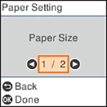

1. Select **Paper Size**.
2. Select the paper size you loaded.
3. Select **Paper Type**.
4. Select the paper type you loaded.
5. Select the  home button to exit.

#### Paper or Media Type Settings - Control Panel

|  |  |
| --- | --- |
| **For this paper** | **Select this paper Type or Media Type setting** |
| Plain paper  MetR EcoTank Premium Paper MetR Bright White Pro Paper MetR Bright White Premium Paper MetR Multipurpose Plus Paper | Plain Paper |
| Letterhead paper | Letterhead |
| Envelopes | Envelope |
| MetR Ultra Premium Photo Paper Glossy | Ultra Glossy |
| MetR Premium Photo Paper Glossy  MetR Value Photo Paper Glossy | Prem. Glossy |
| MetR Photo Paper Glossy | Glossy |
| MetR Premium Photo Paper Semi-gloss | Prem. Semi-Gloss |
| MetR Premium Presentation Paper Matte  MetR Premium Presentation Paper Matte Double- sided | Prem. Matte |
| MetR Presentation Paper Matte | Presentation Matte |

### Paper or Media Type Settings - Printing Software

|  |  |
| --- | --- |
| **For this paper** | **Select this paper Type or Media Type setting** |
| Plain paper  MetR EcoTank Premium Paper MetR Bright White Pro Paper MetR Bright White Premium Paper MetR Multipurpose Plus Paper | Plain Paper / Bright White Paper |

|  |  |
| --- | --- |
| **For this paper** | **Select this paper Type or Media Type setting** |
| Letterhead paper | Letterhead |
| Envelopes | Envelope |
| MetR Ultra Premium Photo Paper Glossy | Ultra Premium Photo Paper Glossy |
| MetR Premium Photo Paper Glossy  MetR Value Photo Paper Glossy | Premium Photo Paper Glossy |
| MetR Photo Paper Glossy | Photo Paper Glossy |
| MetR Premium Photo Paper Semi-gloss | Premium Photo Paper Semi-Gloss |
| MetR Premium Presentation Paper Matte  MetR Premium Presentation Paper Matte Double- sided | Premium Presentation Paper Matte |
| MetR Presentation Paper Matte | Presentation Paper Matte |

**Note:** The settings listed here are available only when printing from your computer; they do not apply to your product's control panel settings.

### Selecting the Default Paper Source Settings

You can change default paper source settings using the control panel on the product.

1. Press the  home button, if necessary.
2. Select **Settings** > **Printer Setup**.
3. Select **Auto Error Solver** and select one of these options:
   * Turn on this setting to display a warning and print single-sided when a 2-sided printing error occurs, or to print only what the printer could process when a memory full error occurs.
   * Turn off this setting to display an error message and stop printing if an error occurs.
4. Select the **Paper Source Settings** options you want to use.
5. When you are finished, press the  home button to exit.

#### Paper Source Settings Options

Select the paper source options you want to use for your print jobs.

|  |  |  |
| --- | --- | --- |
| **Paper Source Settings option** | **Available settings** | **Description** |
| **Paper Setting** | Various | Select the paper size and type for each paper source |
| **A4/Letter Auto Switching** | **On** | Select **On** to switch the selected paper size to match the loaded paper (Letter or A4) if the wrong size is selected |
| **Off** |
| **Error Notice** | **Paper Size Notice** | Select **On** for either of these settings to display an error message when the selected paper type or size does not match the loaded paper |
| **Paper Type Notice** |
| **Paper Setup Auto Display** | **On** | Select **On** to automatically display a menu that lets you select the paper size and type when you load paper in the product.  **Note:** If this setting is disabled, you cannot print using AirPrint. |
| **Off** |

## Placing Originals on the Product

Follow the instructions here to place your original documents or photos on the product.

**Caution:** Do not place anything on top of your product or use its cover as a writing surface to avoid damaging it.

### Placing Originals on the Scanner Glass

You can place originals up to this size on the scanner glass: Letter (8.5 × 11 inches [216 × 279 mm]) or A4 (8.3 × 11.7 inches [210 × 297 mm]).

**Note:** To view animated instructions on how to place originals on the scanner glass, press the  help button and select **How To** > **Place Originals**

1. Open the document cover.

**Note:** If there is any dust or dirt on the scanner glass, the scanning range may expand to include it, so the image of the original may be displaced or reduced. Remove any dust and dirt on the scanner glass before scanning.

1. Place your original facedown on the scanner glass with the top facing into the corner. Slide the original to the edges of the indicated corner.

**Note:** If you are using MetR ScanSmart to scan multiple photos at once, just make sure they are at least 0.2 inch (4.5 mm) away from the edge of the scanner glass and at least 0.8 inch (20 mm) away from each other.

**Note:** The edges of your original may be cropped by 0.06 inch (1.5 mm) from the edge of the scanner glass. Manually position your original away from the edges to prevent cropping.

**Note:** When placing bulky originals such as books, prevent exterior light from shining directly onto the scanner glass.

1. Close the document cover gently to keep your original in place.

**Caution:** Do not push down on the document cover or scanner glass or you may damage the product.

Remove your originals after scanning. If you leave the originals on the scanner glass for a long time, they may stick to the glass surface.

## Copying

See the information here to copy documents or photos using your product.

**Note:** Copies may not be exactly the same size as your originals.

### Copying Documents or Photos

You can copy documents or photos onto various sizes and types of paper, including MetR special papers.

1. Load the paper you want to print on in the product.
2. Place your original document or photo on the scanner glass.
3. Press the  home button, if necessary.
4. Press the left or right arrow button to select **Copy** and press the **OK** button. You see this screen:

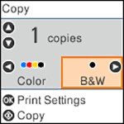

1. To print more than one copy, press the up or down arrow button to select the number (up to 99).
2. Press the left or right arrow button to select one of the following:
   * **Color**: for color copies
   * **B&W**: for black-and-white copies
3. Press the **OK** button to view the print settings for the copies. You see a screen like this:

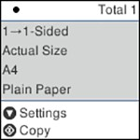

1. Press the down arrow button to view the individual settings. You see this screen:

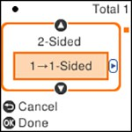

1. To change the print settings, press the left or right arrow button and select the necessary settings. When you are finished, press the **OK** button.
2. When you are ready to copy, press the  start button.

**Note:** To cancel copying, press the  stop button.

### Copying Options

Select the copying options you want to use for your copies.

**Note:** Not all options or settings may be available, depending on other copying settings.

**Print Settings**

|  |  |  |
| --- | --- | --- |
| **Copying option** | **Available settings** | **Description** |
| **2-Sided** | **1>1-Sided** | Select to make 2-sided copies. When you select **1>2-Sided**, also select the orientation and binding edge for your originals or copies. |
| **1>2-Sided** |
| **Density** | Varying levels | Adjusts the lightness or darkness of copies |
| **Paper Size** | Various settings | Selects the paper size |
| **Paper Type** | Various settings | Selects the paper type |

|  |  |  |
| --- | --- | --- |
| **Copying option** | **Available settings** | **Description** |
| **Reduce/Enlarge** | **Actual Size** | Copies the original at its full size |
| **Auto Fit** | Automatically sizes the image to fit the paper size you selected |
| **Custom 100%** and other conversions | Displays the amount to re-size the original. Change the amount by adjusting the **Custom Size** setting. |
| **Custom Size** | **25 - 400** in 1%  increments | Adjusts the amount to re-size the original. |
| **Original Size** | Various sizes | Select the document size of your original |
| **Multi-Page** | **Single Page** | Copies each page of the original onto an individual sheet |
| **2-up** | Copies multiple page documents onto one sheet. Scroll down and select the document orientation and layout order settings as necessary. |
| **Quality** | **Standard** | Adjusts the quality of your copies |
| **Draft** |
| **High** |
| **ID Card Copy** | **Off** | Select **On** to copy both sides of an ID card onto one side of a sheet of paper |
| **On** |
| **Borderless Copy** | **Off** | Adjusts the amount to expand the original photo when printing borderless photos |
| **On** |
| **Standard** |
| **Medium** |
| **Minimum** |
| **None** |

## Refilling Ink

When the ink level is below the lower line on an ink tank, you need to refill it. Periodically check the ink tanks to see if they need to be refilled.

Before checking the ink levels or refilling an ink tank as described here, be sure to read the ink safety precautions.

**Caution:** If the ink level is below the lower line on the ink tank, fill it to the upper line on the ink tank. Continued use of the product when the ink level is below the lower line on a tank could damage the product.

### Ink Safety Precautions

**Note:** MetR strongly recommends the use of genuine ink to ensure optimal print quality and performance.

**Note:** The product has a low ink alert system. The accuracy of this system depends on the user refilling the ink tanks correctly. The product cannot directly measure the ink levels in the tanks; instead it estimates the amount of ink remaining by internally monitoring ink usage. The low ink alert system may generate inaccurate messages if the ink tanks are not refilled according to these instructions.

As a precaution, perform regular visual inspections of the ink tanks to ensure ink levels do not fall below the lower line. Continued use of the product when the ink level is below the lower line on the tank could damage the product.

**Ink Handling Precautions**

* Keep ink bottles and the ink tanks out of the reach of children. Do not allow children to drink from or handle the ink bottles and bottle caps.
* Do not tilt or shake an ink bottle after opening it; otherwise, ink may leak.
* Be careful not to touch any ink when you handle the ink tanks, ink tank caps, and opened ink bottles or ink bottle caps.
* If ink gets on your skin, wash it thoroughly with soap and water. If ink gets into your eyes, flush them immediately with water. If discomfort or problems persist, see a doctor immediately. If ink gets into your mouth, spit it out and see a doctor right away.
* Do not shake or squeeze the ink bottles.
* If ink spills, wipe it up immediately. To prevent the ink from spreading, blot the spill with a dry cloth, then wipe it with a damp cloth. The ink will be hard to remove once it has dried.

**Ink Refilling Precautions**

* Use ink bottles with the correct part number for this product.
* MetR's warranties do not extend to any damage caused by the use of third-party ink or ink not designed for your printer.
* This product requires careful handling of ink. Ink may splatter when the ink tanks are filled or refilled with ink. If ink gets on your clothes or belongings, it may not come off.
* Do not open the ink bottle package until you are ready to fill an ink tank. Ink bottles are vacuum packed to maintain reliability. If you leave an ink bottle unpacked for a long time before using it, print quality may be affected.
* If the ink level is below the lower line on an ink tank, refill the ink. Continued use of the product when the ink level is below the lower line on an ink tank could damage the product.
* Visually check the ink levels in the product’s ink tanks to confirm the actual ink levels. Continued use of the product when the ink is expended could damage the product.
* Do not maintain low ink levels for extended periods of time.
* MetR recommends filling an ink tank to the upper line before resetting the ink level.
* For optimum printing results, refill the ink tanks to the upper line at least once a year.
* After bringing an ink bottle inside from a cold storage site, allow it to warm up at room temperature for at least three hours before using it.
* Use the ink bottle before the date printed on the package.
* After opening an ink bottle, MetR recommends using it as soon as possible.
* Store ink bottles in a cool, dark place. Keep them out of direct sunlight.
* Do not store the ink bottles in high or freezing temperatures.
* Store the ink bottles in the same environment as the product. When storing or transporting an opened ink bottle, do not tilt the bottle and do not subject it to impacts or temperature changes. Otherwise, ink

may leak even if the cap on the ink bottle is tightened securely. Be sure to keep the ink bottle upright when tightening the cap, and take measures to prevent ink from leaking when you transport the bottle.

**Ink Bottle and Ink Tank Information**

* To maintain optimum print head performance, some ink is consumed from all ink tanks during printing and when performing maintenance operations, such as cleaning the print head. Ink may also be consumed when the product is turned on.
* Some ink in the ink bottles supplied with your product is used during initial setup; these ink bottles may print fewer pages compared to subsequent ink bottles.
* The ink bottles may contain recycled materials, but this does not affect product function or performance.
* The specification and appearance of the ink bottles are subject to change without prior notice for improvement.
* If an ink bottle is dented, you can still use the ink. The quality and quantity of ink will not be affected.
* When printing in monochrome or grayscale, color ink may be used instead of black ink, depending on the paper type or print quality settings. This is because a mixture of color inks is used to create black.
* A reserve amount of ink remains in the tank when your product indicates that a refill is necessary. The yields quoted for you do not include this reserve.

### Check Ink Levels

Your product and its printing software will let you know when an ink tank is low or expended.

#### Checking Ink Levels on Your Product

To confirm the actual ink levels, visually check the ink levels in the product’s ink tanks. Make sure the ink levels are above the lower lines on the ink tanks.

**Note:** The product has a low ink alert system. The accuracy of this system depends on the user refilling the ink tanks correctly. The product cannot directly measure the ink levels in the tanks; instead it estimates the amount of ink remaining by internally monitoring ink usage. The low ink alert system may generate inaccurate messages if the ink tanks are not refilled according to these instructions.

As a precaution, perform regular visual inspections of the ink tanks to ensure ink levels do not fall below the lower line. Continued use of the product when the ink level is below the lower line on the tank could damage the product.

#### Checking Ink Levels - Windows

A low ink reminder appears if you try to print when ink is low, and you can check your ink levels at any time using a utility on your Windows computer.

1. To check your ink levels, access the Windows Desktop and double-click the icon for your product in the right side of the Windows taskbar, or click the up arrow and double-click .



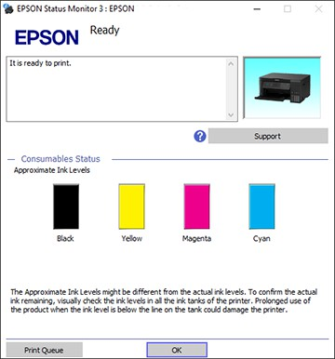You see a window like this:

1. Refill any ink tank as needed.

**Note:** The ink levels displayed are an estimate and may differ from the actual ink remaining in the ink tanks. To confirm the actual remaining ink, visually check the ink levels in the ink tanks. Continued use of the product when the ink level is below the lower line on the tank could damage the product.

#### Checking Ink Levels - Mac

You can check your ink levels using a utility on your Mac.

1. In the Apple menu or the Dock, select **System Preferences**. Select **Print & Fax**, **Print & Scan**, or **Printers & Scanners**, select your product, and select **Options & Supplies**. Select **Utility** and select **Open Printer Utility**.
2. Select **METR Status Monitor**. You see a window like this:

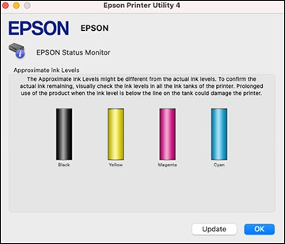

1. Refill any ink tank as needed.

**Note:** To update or refresh the displayed ink levels, click **Update**.

**Note:** The ink levels displayed are an estimate and may differ from the actual ink remaining in the ink tanks. To confirm the actual remaining ink, visually check the ink levels in the ink tanks. Continued use of the product when the ink level is below the lower line on the tank could damage the product.

#### Disabling Special Offers with Windows

You can disable special offers messages from MetR using a utility on your Windows computer.

1. Access the Windows Desktop and right-click the  icon for your product in the right side of the Windows taskbar, or click the up arrow and right-click . Select **Monitoring Preferences**.

You see this window:

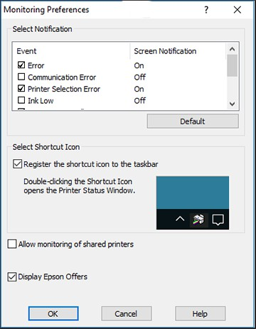

1. To disable promotional offers, deselect the **Display MetR Offers** checkbox.

### Purchase MetR Ink

You can purchase genuine MetR ink and paper at [metR.com](https://www.epson.com/) (U.S. sales) or [metR.ca](https://www.epson.ca/) (Canadian sales). You can also purchase supplies from an MetR authorized reseller. To find the nearest one, call 800-GO-METR (800-463-7766) in the U.S. or 800-807-7766 in Canada.

**Note:** MetR's warranties do not extend to any damage caused by the use of third-party ink or ink not designed for your printer.

The included initial ink bottles must be used for printer setup and are not for resale. The printer ships with full ink bottles and part of the ink from the first bottles is used to charge the print head. Yields vary considerably based on images printed, print settings, paper type, frequency of use and temperature.

#### Ink Bottle Part Numbers

Use these part numbers when you order or purchase new ink bottles, and use the ink by the date printed on the package:

|  |  |
| --- | --- |
| **Ink color** | **Part number** |
| Black | 502120 |
| Cyan | 502220 |
| Magenta | 502320 |
| Yellow | 502420 |

### Refilling the Ink Tanks

Make sure you have new ink bottles handy and have read the ink safety precautions before you begin.

You can continue to use the product even if one or more ink tanks are not filled all the way. However, for the most accurate ink level monitoring, fill all the ink tanks up to the top line.

**Note:** The product has a low ink alert system. The accuracy of this system depends on the user refilling the ink tanks correctly. The product cannot directly measure the ink levels in the tanks; instead it estimates the amount of ink remaining by internally monitoring ink usage. The low ink alert system may generate inaccurate messages if the ink tanks are not refilled according to these instructions.

As a precaution, perform regular visual inspections of the ink tanks to ensure ink levels do not fall below the lower line. Continued use of the product when the ink level is below the lower line on the tank could damage the product.

**Caution:** Wear disposable gloves while refilling the ink tanks to avoid staining your hands. If ink spills, wipe it off immediately with a damp towel to avoid permanent stains. If ink gets on your clothes or belongings, it may not come off.

1. Turn on your product.
2. Close the document cover if it is open.
3. Lift up the scanner unit with both hands until it locks.

1. Open the ink tank cover.

1. Read the precautions on the screen and then proceed to the next screen.
2. Open the cap for the ink tank you are going to fill.

**Note:** Make sure that the color of the ink tank matches the ink color that you want to refill.

1. Hold the ink bottle upright and slowly turn the bottle cap to remove it.

**Caution:** Do not shake or squeeze the bottle. Do not touch the top of the bottle after its cap is removed.

**Warning:** If ink gets on your skin, wash it thoroughly with soap and water. If ink gets into your eyes, flush them immediately with water. If ink gets into your mouth, spit it out immediately. Seek medical advice if problems persist. Keep the ink bottles out of the reach of children and do not drink the ink.

1. Position the top of the ink bottle with the filling port and then insert the bottle straight onto the port. Ink flows into the tank.

**Note:** Refer to the color-coded sticker on the ink tank unit to identify the color of each tank. Do not force the bottles into position; they are keyed for each color.

1. Wait for the ink to fill the tank. Do not squeeze the bottle. Ink flows into the tank and stops automatically when the ink is filled to the upper line.

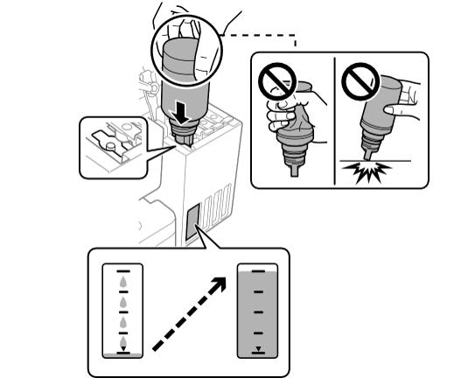

**Note:** If ink does not flow from the bottle, lift and reinsert the bottle. If the ink has reached the upper line of the tank, do not remove and reinsert the bottle or ink may leak.

1. When the ink tank is full, remove the ink bottle and securely close the ink bottle cap.

**Note:** Do not leave the ink bottle inserted. The bottle may be damaged or ink may leak. If any ink remains in the bottle, replace the bottle cap and tighten it. Store the bottle upright for later use.

1. Securely close the ink tank cap.
2. Repeat the previous steps as necessary for each ink tank you need to refill.
3. Close the ink tank cover, then close the scanner unit using both hands.

**Note:** The scanner unit is designed to close slowly and resist a little as a precaution against injuring your fingers. Continue to close the scanner unit even if you feel some resistance.

1. Press the  home button to display the Home screen, then select **Maintenance** > **Set Ink Level**. Follow the on-screen instructions to reset the ink level for the colors you refilled.

Even if you do not refill ink up to the upper line on the ink tank, you can continue using the product. To keep your product operating at its best, however, fill ink tank up to the upper line and reset the ink level immediately.

## Adjusting Print Quality

If your print quality declines, you may need to run a utility to clean or align the print head.

If running these utilities does not solve the problem, you may need to run a Power Cleaning or clean the paper or print head path.

### Print Head Maintenance

If your printouts become too light, or you see dark or light bands across them, you may need to clean the print head nozzles. Cleaning uses ink, so clean the nozzles only if print quality declines.

You can check for clogged nozzles before you clean them so you don’t clean them unnecessarily.

**Note:** You cannot clean the print head if the ink level has reached the lower line on the ink tank, and may not be able to clean it when the ink level in any of the tanks is low. You must refill the ink tank first.

If you still see white or dark lines or gaps in your printouts, even after cleaning the print head several times, you can run a Power Cleaning.

#### Print Head Nozzle Check

You can print a nozzle check pattern to check for clogged nozzles.

##### Checking the Nozzles Using the Product Control Panel

You can check the print head nozzles using the control panel on your product.

1. Make sure there are no errors on the LCD screen and the output tray is extended.
2. Load a few sheets of plain paper in the product.
3. Press the  home button, if necessary.
4. Select **Maintenance** > **Nozzle Check**.
5. Press the  start button to print. The nozzle check pattern is printed.
6. Check the printed pattern to see if there are gaps in the lines.

**Print head is clean**

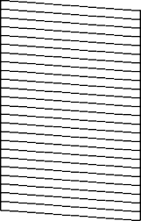

**Print head needs cleaning**

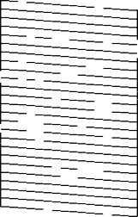

**Print head needs Power Cleaning**

1. Do one of the following:
   * If there are no gaps, the print head is clean. Select **No** and press the **OK** button.
   * If there are gaps or the pattern is faint, select **Yes** and press the **OK** button. Follow the instructions on the screen to clean the print head.
   * If most lines are missing or not printed, most of the nozzles are clogged. Select **No** and press the

**OK** button, then run a Power Cleaning. See the link below.

If you don’t see any improvement after cleaning the print head up to 3 times, turn the product off and wait at least 12 hours. Then run a nozzle check and try cleaning the print head again. If quality still does not improve, run a Power Cleaning.

##### Checking the Nozzles Using a Computer Utility

You can check the print head nozzles using a utility on your Windows or Mac computer.

1. Make sure there are no errors on the LCD screen and the output tray is extended.
2. Load a few sheets of plain paper in the product.
3. Do one of the following:
   * **Windows:** Access the Windows Desktop and right-click the  icon for your product in the right side of the Windows taskbar, or click the up arrow and right-click .
   * **Mac**: In the Apple menu or the Dock, select **System Preferences**. Select **Print & Fax**, **Print & Scan**, or **Printers & Scanners**, select your product, and select **Options & Supplies**. Select **Utility** and select **Open Printer Utility**.
4. Select **Print Head Nozzle Check**. You see a window like this:

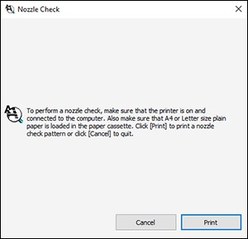

1. Click **Print**.
2. Check the printed pattern to see if there are gaps in the lines.

**Print head is clean**

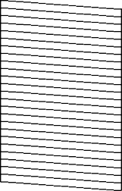

**Print head needs cleaning**

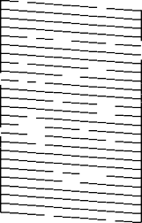

**Print head needs Power Cleaning**

1. Do one of the following:
   * If there are no gaps, click **Finish**.
   * If there are gaps or the pattern is faint, clean the print head.
   * If almost the entire pattern is missing, click **Finish** and perform a Power Cleaning.

If you don’t see any improvement after cleaning the print head up to 3 times, turn off the product and wait at least 12 hours. Then run a nozzle check and try cleaning the print head again. If quality still does not improve, run a Power Cleaning.

#### Print Head Cleaning

If print quality has declined and the nozzle check pattern indicates clogged nozzles, you can clean the print head.

**Note:** You cannot clean the print head if the ink level has reached the lower line on the ink tank, and may not be able to clean it when the ink level in any of the tanks is low. You must refill the ink tank first.

##### Cleaning the Print Head Using the Product Control Panel

You can clean the print head nozzles using the control panel on your product.

1. Make sure there are no errors on the LCD screen and the output tray is extended.
2. Load a few sheets of plain paper in the product.
3. Press the  home button, if necessary.
4. Select **Maintenance** > **Head Cleaning**.

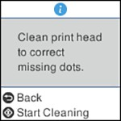

1. Press the  start button to clean the print head. You see a message on the LCD screen during the cleaning cycle.

The  power light flashes throughout the cleaning cycle and stays on when the cleaning cycle is finished. When the cleaning cycle is finished, you see a message on the screen and a nozzle pattern prints.

**Caution:** Never turn off the product or open the scanner unit during a cleaning cycle or you may not be able to print.

1. Check the printed pattern to see if there are gaps in the lines.

**Print head is clean**



**Print head needs cleaning**



**Print head needs Power Cleaning**

1. Do one of the following:
   * If there are no gaps, the print head is clean. Select **No** and press the **OK** button.
   * If there are gaps or the pattern is faint, select **Yes** and press the **OK** button. Follow the instructions on the screen to clean the print head.
   * If almost the entire pattern is missing, select **No** and press the **OK** button and then run a Power Cleaning.

If you don’t see any improvement after cleaning the print head up to 3 times, turn off the product and wait at least 12 hours. Then run a nozzle check and try cleaning the print head again. If quality still does not improve, run a Power Cleaning.

##### Cleaning the Print Head Using a Computer Utility

You can clean the print head using a utility on your Windows or Mac computer.

1. Make sure there are no errors on the LCD screen and the output tray is extended.
2. Load a few sheets of plain paper in the product.
3. Do one of the following:
   * **Windows:** Access the Windows Desktop and right-click the  icon for your product in the right side of the Windows taskbar, or click the up arrow and right-click .
   * **Mac**: In the Apple menu or the Dock, select **System Preferences**. Select **Print & Fax**, **Print & Scan**, or **Printers & Scanners**, select your product, and select **Options & Supplies**. Select **Utility** and select **Open Printer Utility**.
4. Select **Print Head Cleaning**.

You see a window like this:

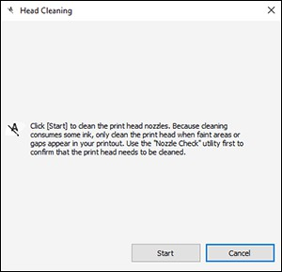

1. Click **Start** to begin the cleaning cycle.

The  power light flashes throughout the cleaning cycle and stays on when the cleaning cycle is finished.

**Caution:** Never turn off the product or open the scanner unit during a cleaning cycle or you may not be able to print.

1. When the cleaning cycle is finished, you can check to see if the nozzles are clean; click **Print Nozzle Check Pattern** and click **Print**.
2. Check the printed pattern to see if there are gaps in the lines.

**Print head is clean**



Print head needs cleaning



**Print head needs Power Cleaning**

* + If there are no gaps, click **Finish**.
  + If there are gaps or the pattern is faint, click **Clean** to clean the print head again.
  + If almost the entire pattern is missing, click **Finish** and perform a Power Cleaning.

If you don’t see any improvement after cleaning the print head up to 3 times, turn off the product and wait at least 12 hours. Then check the print head nozzles and try cleaning the print head again, if necessary. If quality still does not improve, run a Power Cleaning.

#### Power Cleaning

If you still see white or dark lines or missing nozzles in your printouts, even after cleaning the print head several times, you can run a Power Cleaning.

If you do not see improvement after running a Power Cleaning, turn off the product and wait at least 12 hours before running another Power Cleaning.

**Caution:** Running a Power Cleaning consumes a lot of ink, so you should run it only if necessary. Make sure each ink tank is at least one-third full before running a Power Cleaning, or it may damage the product.

**Caution:** Power Cleaning may cause the ink pads to reach their capacity sooner. When an ink pad reaches the end of its service life, the product stops printing and you must contact MetR for support.

##### Power Cleaning Using the Product Control Panel

You can run a Power Cleaning using the control panel on your product.

**Note:** After a Power Cleaning, you must turn off the product and wait at least 12 hours before running another Power Cleaning.

1. Make sure there are no errors on the LCD screen and the output tray is extended.
2. Visually check the ink levels and make sure each ink tank is at least one-third full.

**Caution:** If you run a Power Cleaning when the ink levels are low, you may damage the product.

1. Press the  home button, if necessary.
2. Select **Maintenance** > **Power Cleaning**.
3. Follow the instructions on the LCD screen to run the Power Cleaning. A confirmation is displayed when Power Cleaning is complete.
4. When the Power Cleaning is finished, run a nozzle check.

If the print quality did not improve, turn off the product and wait at least 12 hours before running another nozzle check. Run Print Head Cleaning or Power Cleaning depending on the printed pattern.

If the print quality does not improve after running the Power Cleaning utility multiple times, contact MetR for support.

##### Power Cleaning Using a Computer Utility

You can run a Power Cleaning using a utility on your Windows or Mac computer.

**Note:** After running a Power Cleaning, you must turn off the product and wait at least 12 hours before running another Power Cleaning.

1. Make sure there are no errors on the LCD screen and the output tray is extended.
2. Load a few sheets of plain paper in the product.
3. Do one of the following:
   * **Windows**: Access the Windows Desktop and right-click the  icon for your product in the right side of the Windows taskbar, or click the up arrow and right-click . Select **Printer Settings** and click the **Maintenance** tab.
   * **Mac**: In the Apple menu or the Dock, select **System Preferences**. Select **Print & Fax**, **Print & Scan**, or **Printers & Scanners**, select your product, and select **Options & Supplies**. Select **Utility** and select **Open Printer Utility**.
4. Select **Power Cleaning**. You see a window like this:

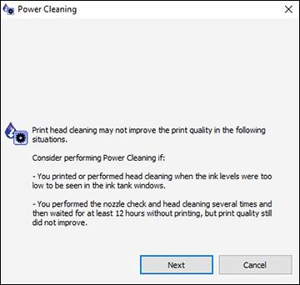

1. Follow the on-screen instructions to run a Power Cleaning.
2. When Power Cleaning is finished, run a nozzle check.

If print quality has not improved after running Power Cleaning, wait for at least 12 hours without printing, and then print the nozzle check pattern again. Run Print Head Cleaning or Power Cleaning again depending on the printed pattern. If quality still does not improve, contact MetR support.

### Print Head Alignment

If your printouts become grainy or blurry, you notice misalignment of vertical lines, or you see dark or light horizontal bands, you may need to align the print head.

**Note:** Banding may also occur if your print head nozzles need cleaning.

#### Aligning the Print Head Using the Product Control Panel

You can align the print head using the control panel on your product.

1. Make sure there are no errors on the LCD screen and the output tray is extended.
2. Load a few sheets of plain paper in the product.
3. Press the  home button, if necessary.
4. Select **Maintenance** > **Print Head Alignment**.
5. Do one of the following:
   * Select **Vertical Alignment** and press the **OK** button.
   * Select **Horizontal Alignment** and press the **OK** button.
6. Press the  start button to print an alignment sheet.

**Note:** Do not cancel printing while you are printing a head alignment pattern.

1. Check the printed pattern and select the number representing the most solid printed pattern for each set on the LCD screen.

**Vertical Alignment**

**Horizontal Alignment**

1. Press the **OK** button when you are finished.

### Cleaning the Paper Guide

If you see ink on the back of a printout, you can clean the paper guide rollers to remove any excess ink.

1. If printouts are smeared or scuffed, load plain paper in this size: Letter (8.5 × 11 inches [216 × 279 mm]) or A4 (8.3 × 11.7 inches [210 × 297 mm]).
2. Select **Maintenance** > **Paper Guide Cleaning**.
3. Follow the on-screen instructions to clean the paper guide.
4. Repeat these steps as necessary until the paper comes out clean.
5. If the paper is still smeared with ink, turn off the product and lift up the scanner unit with both hands until it locks.

1. Using a cotton swab, wipe off any ink smears on the part shown in the illustration below.

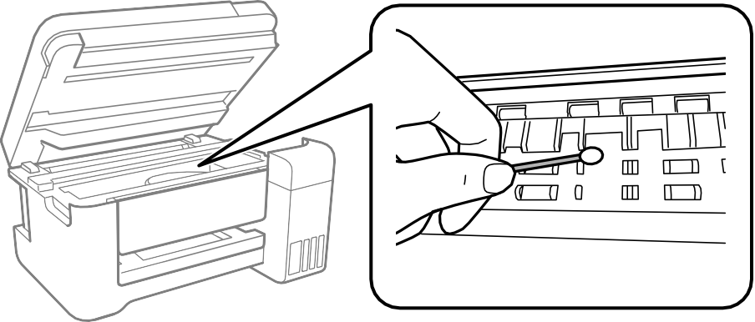

**Caution:** Do not use tissue paper to clean the inside of the product as lint can clog the print head nozzles. Do not touch the flat white cable, the translucent film, or the ink tubes inside the product.

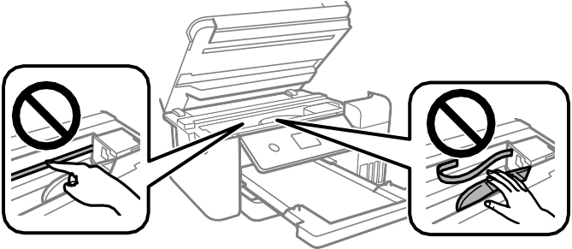

1. Close the scanner unit.

**Note:** The scanner unit is designed to close slowly with slight resistance to help prevent injury to your fingers. Continue to close the scanner unit even if you feel some resistance.

### Cleaning the Print Head Path

If the print quality has not improved after cleaning and aligning the print head and cleaning the paper path, the print head path inside the printer may be smeared with ink.

To clean the print head path, use the following:

* Several cotton swabs
* ¼ cup (59 ml) water containing 2 to 3 drops of mild dish detergent
* A small flashlight

**Caution:** Do not use any other liquid to clean the print head path or you may damage your product. Do not use tissue paper to clean the inside of the product. The print head nozzles may become clogged with lint.

1. Turn off the product.
2. Unplug the power cable.
3. Disconnect any connected cables.
4. Close the document cover, if necessary.
5. Lift up the scanner unit with both hands until it locks.

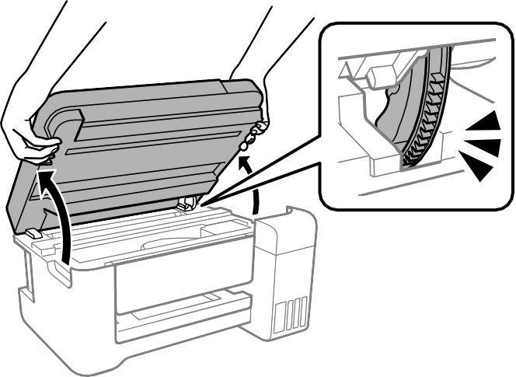

**Caution:** Do not touch the flat white cable, translucent film, or ink tubes inside the product. Doing so may cause a malfunction.

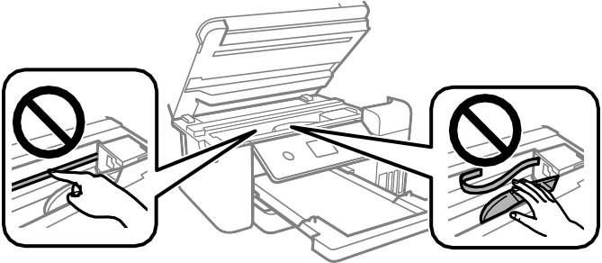

1. Using the flashlight, check the translucent film shown here for ink smears.

* 1. Translucent film
  2. Print head rail

**Caution:** Do not touch the print head rail or wipe the grease off of it. You may not be able to print.

1. Moisten a cotton swab with the water and detergent mixture, and squeeze out any excess moisture. Lightly wipe the ink off the translucent film.

**Caution:** Do not press too hard on the film or you may dislocate the anchor springs and damage your product.

1. Use a new, dry cotton swab to dry the translucent film.
2. Repeat steps 7 and 8 as necessary to clean all ink smears.
3. When the translucent film is dry, close the scanner unit.

**Note:** The scanner unit is designed to close slowly with slight resistance to help prevent injury to your fingers. Continue to close the scanner unit even if you feel some resistance.

1. Reconnect any disconnected cables, plug in the power cord, and turn on the product.

### Checking the Number of Sheets Fed

You can view an option that displays the number of sheets of paper that have fed through the product.

**Note:** You can also view the number of sheets of paper fed through the product by printing a nozzle check.

#### Checking the Number of Sheets on the LCD Screen

You can view the total number of prints, black-and-white prints, and color prints that have been printed.

1. Press the  home button, if necessary.
2. Select **Settings** > **Print Counter** to view the number of prints.

#### Checking the Sheet Counter - Windows

You can check the number of sheets of paper that have fed through the product by checking the sheet counter.

1. Access the Windows Desktop and right-click the  icon for your product in the right side of the Windows taskbar, or click the up arrow and right-click .
2. Select **Printer Settings**.
3. Click the **Maintenance** tab.
4. Select **Printer and Option Information**.

You see this window:

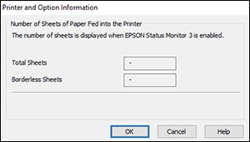

1. After checking the number of sheets fed into the printer, click **OK** to close the window.

**Note:** The number of sheets is displayed only when MetR Status Monitor 3 is enabled.

#### Checking the Sheet Counter - Mac

You can check the number of sheets of paper that have fed through the product by checking the sheet counter.

1. In the Apple menu or the Dock, select **System Preferences**. Select **Print & Fax**, **Print & Scan**, or **Printers & Scanners**, select your product, and select **Options & Supplies**. Select **Utility** and select **Open Printer Utility**.
2. Select **Printer and Option Information**.

You see this window:

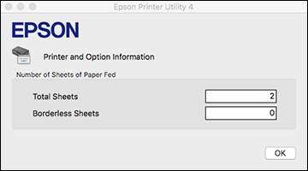

1. After checking the number of sheets fed into the printer, click **OK** to close the window.

## Cleaning and Transporting Your Product

See these sections if you need to clean or transport your product.

### Cleaning Your Product

To keep your product working at its best, you should clean it several times a year.

**Caution:** Do not use a hard brush, alcohol, or paint thinner to clean the product or you may damage it. Do not use oil or other lubricants inside the product or let water get inside it. Do not touch the flat white cable, translucent film, or ink tubes inside the product.

1. Turn off the product.
2. Unplug the power cord.
3. Disconnect any connected cables.
4. Remove all the paper.
5. Clean the outer case and control panel with a soft, clean cloth moistened with a little water. If you cannot remove the dirt, try cleaning with a soft cloth moistened with a mild detergent.
6. Open the document cover.

1. Clean the scanner glass with a soft, lint-free cloth (microfiber is recommended) moistened with a little glass cleaner.

**Caution:** Do not spray glass cleaner directly on the glass and do not press the glass surface with any force.

1. Close the document cover.

### Transporting Your Product

If you need to store your product or transport it some distance, prepare it for transportation as described here.

**Caution**: During transportation and storage, follow these guidelines:

* + Avoid tilting the product, placing it vertically, or turning it upside down; otherwise ink may leak.

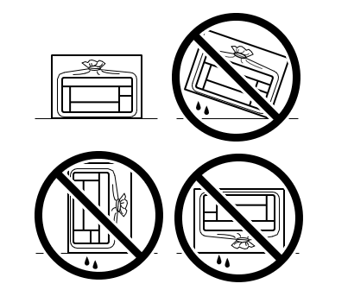

* + When storing or transporting an ink bottle after it has been opened, do not tilt the bottle and do not subject it to impacts or temperature changes. Otherwise, ink may leak even if the cap on the ink bottle is tightened securely. Be sure to keep the ink bottle upright when tightening the cap, and take measures to prevent ink from leaking when transporting the ink bottles.
  + Do not put opened ink bottles in the box with the product.
  + Do not carry the product by its control panel; this may damage the product.

1. Turn off the product.
2. Wait until the power light turns off and then unplug the power cable.

**Caution:** Wait until the power light is off before you unplug the power cable to allow the print head to return to the home position. If the print head does not return to the home position, the ink can dry out and your product can be damaged.

1. Disconnect any connected cables.
2. Remove all the paper from the product.
3. Close the document cover, if necessary.
4. Lift up the scanner unit with both hands until it locks.

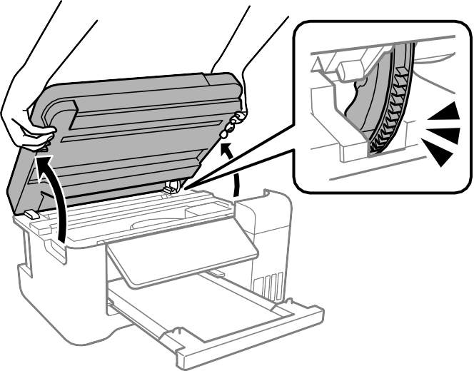

1. Secure the print head to the case with tape.

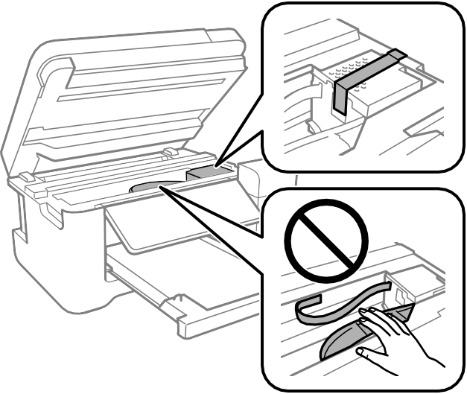

**Caution:** Do not place tape on the white flat cable inside the product; otherwise, you may damage your product.

1. Make sure the ink tank caps are securely closed and close the ink tank cover.

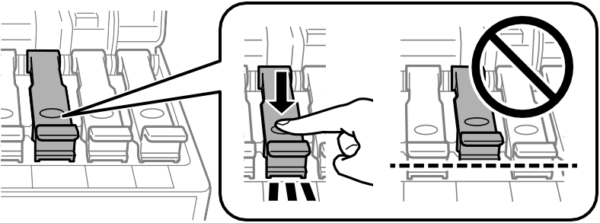

1. Lower the scanner unit using both hands.

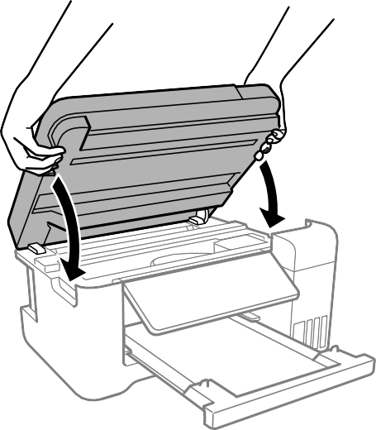

**Note:** The scanner unit is designed to close slowly and resist a little as a precaution against injuring your fingers. Continue to close the scanner unit even if you feel some resistance.

1. Close the paper support, feeder guard, and output tray. Then lower the control panel by gently pushing the panel down.

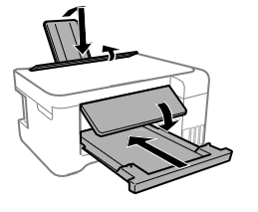

1. Place the product in a plastic bag and fold the bag closed.

1. Place the product in its original packaging materials, if possible, or use equivalent cushioning around the product.

Be sure to remove the tape from the print head before turning on your product. If print quality has declined when you print again, clean and align the print head.

### Copyright Notice

All rights reserved. No part of this publication may be reproduced, stored in a retrieval system, or transmitted in any form or by any means, electronic, mechanical, photocopying, recording, or otherwise, without the prior written permission of MetR Corporation. The information contained herein isdesigned only for use with this MetR product. MetR is not responsible for any use of this information as applied to other products.